1. UJI VALIDITAS
2. KUALITAS

1. HARGA

1. Table

   Description automatically generatedMOTIVASI

1. MINAT

1. KEPUTUSAN
2. UJI RELIABILITAS
3. Table

   Description automatically generatedKUALITAS
4. Table

   Description automatically generatedHARGA
5. Table

   Description automatically generatedMOTIVASI
6. Table

   Description automatically generatedMINAT
7. Table

   Description automatically generatedKEPUTUSAN
8. Table

   Description automatically generatedUJI ASUMSI KLASIK
9. NORMALITAS
10. HETEROKEDASTISITAS

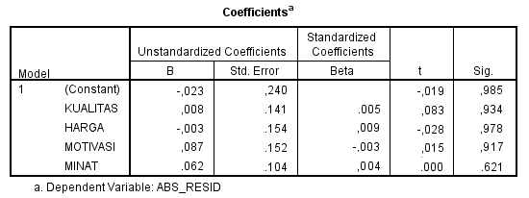

1. 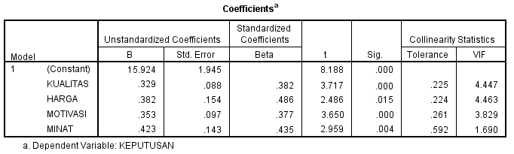MULTIKOLINEARITAS
2. AUTOKOREKASI

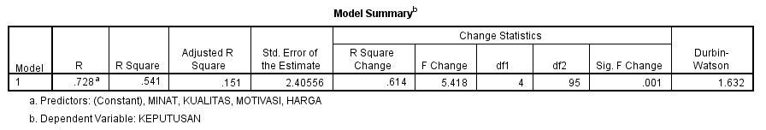

1. ANALISIS REGRESI LINEAR BERGANDA

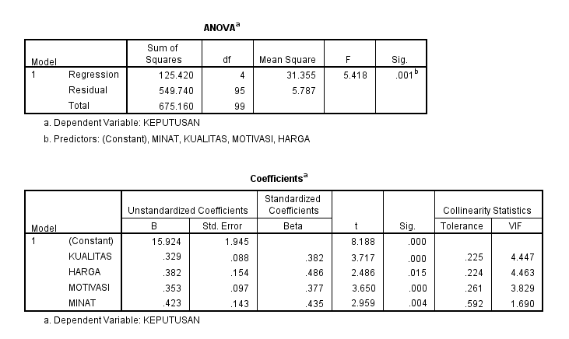

X1 : Variabel bebas (Minat)

X2 : Variabel bebas (Motivasi)

X3 : Variabel bebas (Kualitas)

X4 : Variabel bebas (Harga)

**Keputusan (Y)**

**Harga (X4)**

**Kualitas (X3)**

**Motivasi (X2)**

**Minat (X1)**