# Lampiran

**Lampiran 1. Data Asli**

|  |  |  |  |  |  |  |
| --- | --- | --- | --- | --- | --- | --- |
| No | Kabupaten/Kota | Tahun | Kemiskinan (Y) | Zakat (X1) | PDRB  (X2) | Pendidikan  (X3) |
| 1 | Kulon Progo | 2016 | 1.266948 | 6.40 | 6.6 | 8.50 |
| 1 | Kulon Progo | 2017 | 1.026042 | 1.76 | 7 | 8.64 |
| 1 | Kulon Progo | 2018 | 0.904218 | 2.90 | 7.7 | 8.65 |
| 1 | Kulon Progo | 2019 | 1.000632 | 6.17 | 8.8 | 8.66 |
| 1 | Kulon Progo | 2020 | 1.169381 | 8.28 | 8.4 | 8.86 |
| 1 | Kulon Progo | 2021 | 1.10194 | 9.34 | 8.8 | 9.02 |
| 1 | Kulon Progo | 2022 | 0.841567 | 12.62 | 9.4 | 9.17 |
| 2 | Bantul | 2016 | 0.703098 | 1.72 | 16.4 | 9.09 |
| 2 | Bantul | 2017 | 0.792993 | 1.81 | 17.2 | 9.20 |
| 2 | Bantul | 2018 | 0.774727 | 0.88 | 18.2 | 9.35 |
| 2 | Bantul | 2019 | 0.625938 | 1.50 | 19.2 | 9.54 |
| 2 | Bantul | 2020 | 0.615186 | 5.23 | 18.3 | 9.55 |
| 2 | Bantul | 2021 | 0.806476 | 5.15 | 19.8 | 9.57 |
| 2 | Bantul | 2022 | 0.746688 | 5.95 | 20.8 | 9.59 |
| 3 | Gunung Kidul | 2016 | 1.425515 | 1.17 | 11.7 | 6.62 |
| 3 | Gunung Kidul | 2017 | 1.211941 | 1.03 | 12.3 | 6.99 |
| 3 | Gunung Kidul | 2018 | 1.345472 | 1.57 | 12.9 | 7.00 |
| 3 | Gunung Kidul | 2019 | 0.947789 | 1.19 | 13.6 | 7.13 |
| 3 | Gunung Kidul | 2020 | 0.985817 | 0.75 | 13.5 | 7.21 |
| 3 | Gunung Kidul | 2021 | 1.091923 | 1.46 | 14.2 | 7.30 |
| 3 | Gunung Kidul | 2022 | 0.966984 | 1.48 | 15 | 7.31 |
| 4 | Sleman | 2016 | 0.307485 | 4.22 | 29.6 | 10.64 |
| 4 | Sleman | 2017 | 0.207014 | 4.23 | 31.1 | 10.65 |
| 4 | Sleman | 2018 | -0.0202 | 4.22 | 33.1 | 10.66 |
| 4 | Sleman | 2019 | 0.122218 | 4.76 | 35.3 | 10.67 |
| 4 | Sleman | 2020 | 0.314811 | 6.51 | 33.9 | 10.91 |
| 4 | Sleman | 2021 | 0.231112 | 6.56 | 35.8 | 10.92 |
| 4 | Sleman | 2022 | 0.165514 | 8.44 | 37.6 | 10.94 |
| 5 | Yogyakarta | 2016 | 0.04879 | 3.35 | 23.5 | 11.42 |
| 5 | Yogyakarta | 2017 | 0.457425 | 4.33 | 24.8 | 11.43 |
| 5 | Yogyakarta | 2018 | 0.322083 | 4.24 | 26.1 | 11.44 |
| 5 | Yogyakarta | 2019 | -0.16252 | 4.59 | 27.7 | 11.45 |
| 5 | Yogyakarta | 2020 | 0.173953 | 4.38 | 27 | 11.46 |
| 5 | Yogyakarta | 2021 | 0.067659 | 4.31 | 28.4 | 11.72 |
| 5 | Yogyakarta | 2022 | -0.22314 | 6.64 | 29.9 | 11.89 |

**Lampiran 2. Hasil Penelitian**

**Uji Asumsi Klasik**

**Uji Normalitas**

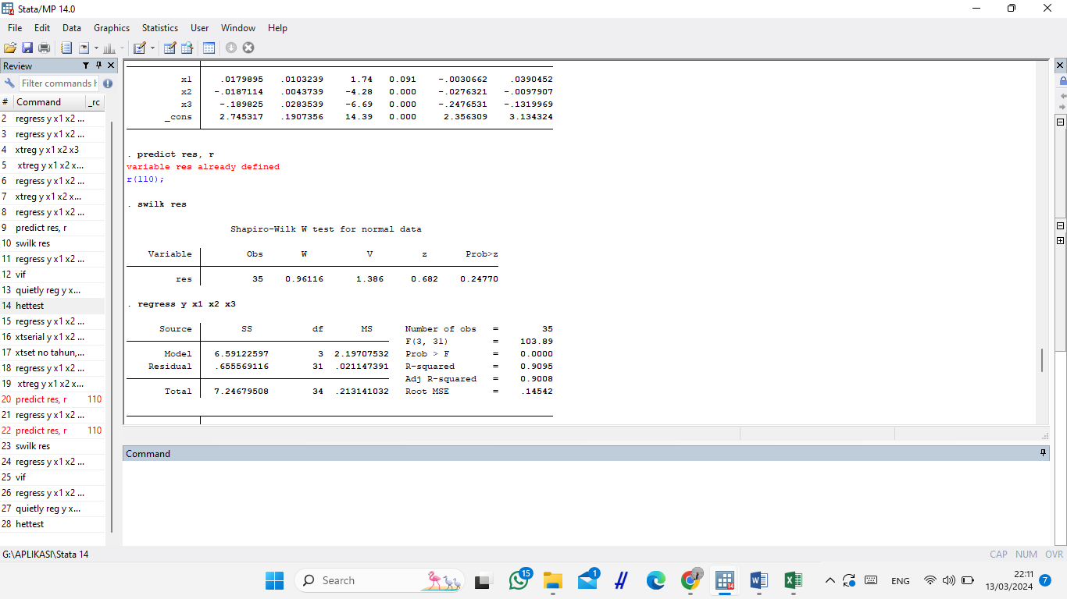

**Uji Multikolinearitas**

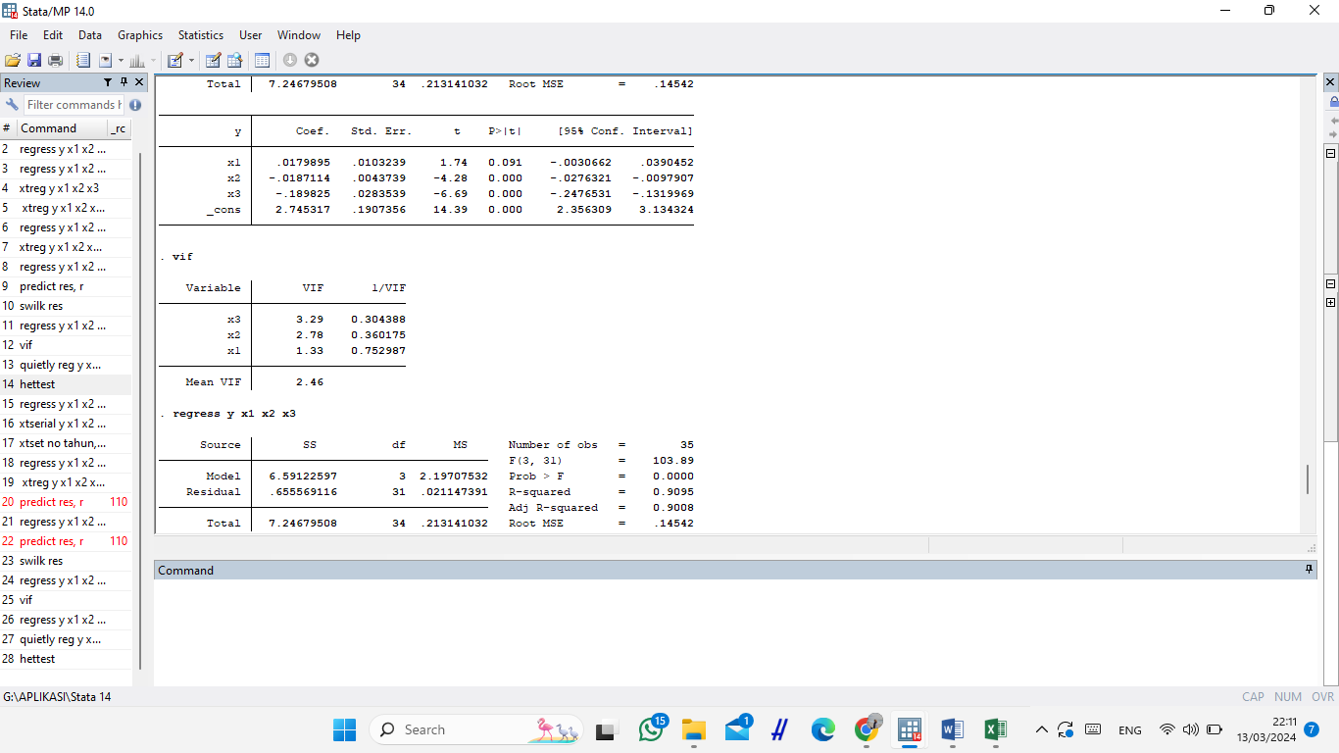

**Uji Heteroskedastisitas**

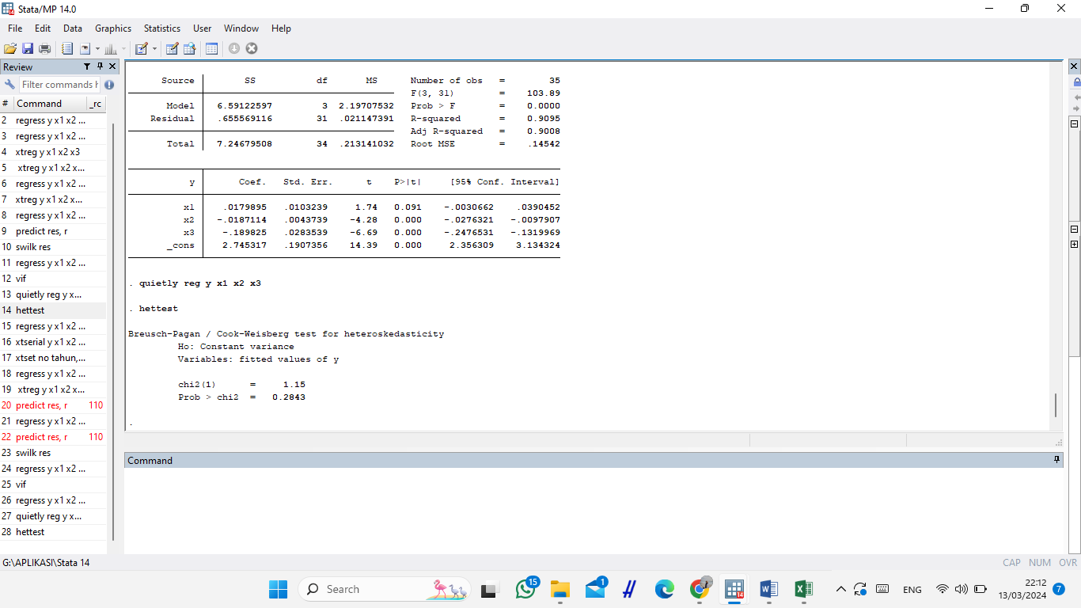

**Uji Data Panel**

**Pemilihan Model**

**Uji Chow**

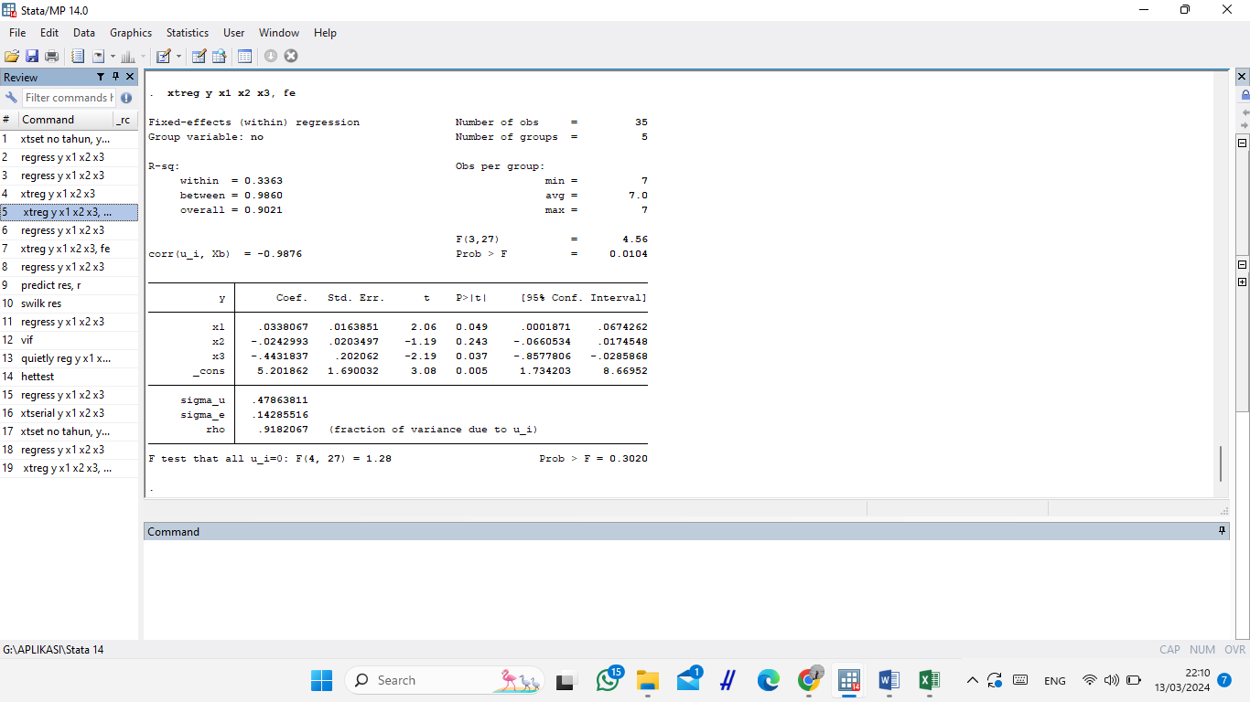

**Uji Hausman**

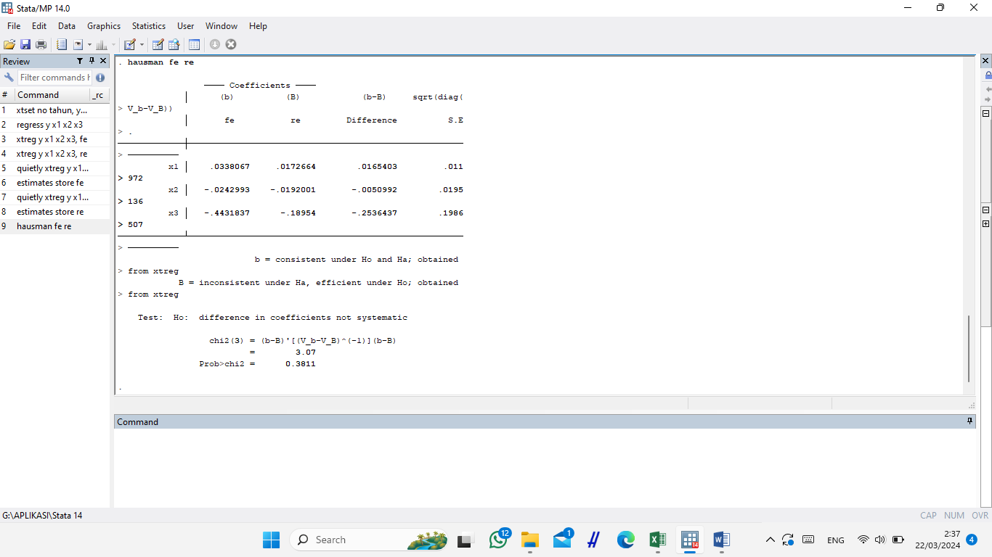

**Uji Lagrange Multiplier**

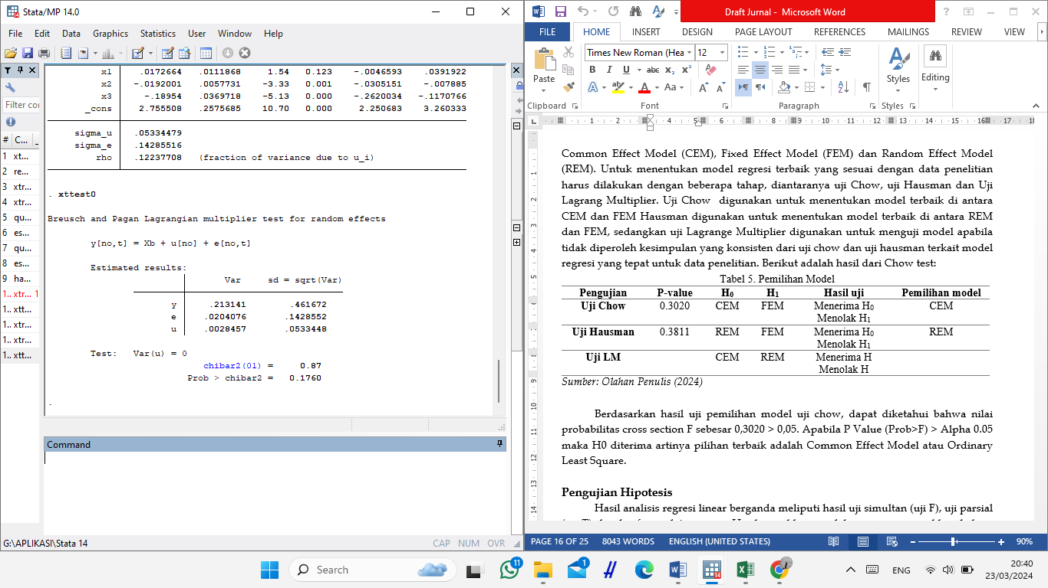

**Pengujian Hipotesis**

**Uji Simultan (Uji F)**

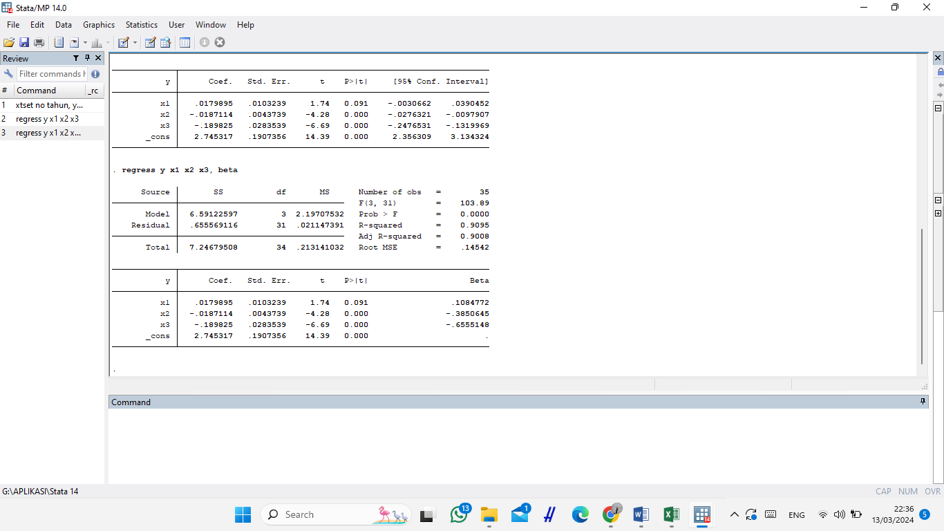

**Uji Parsial (Uji Statistik T)**



**Uji *Adjusted R Square* (Koefisien Determinasi)**



**Lampiran 3. Hasil Analisis**

**Laporan Akhir Tahunan BASNAZ Provinsi Yogyakarta**

|  |  |  |
| --- | --- | --- |
| Tahun | Prioritas Penyaluran Dana Zakat | Total Presentase |
| 2016 | **-** | **-** |
| 2017 | **-** | **-** |
| 2018 | **Fakir Miskin** | **72%** |
| 2019 | **Fakir Miskin** | **72%** |
| 2020 | **Fakir Miskin** | **68,31%** |
| 2021 | **-** | **-** |
| 2022 | **Fakir Miskin** | **64,32%** |

**Laporan Akhir Tahunan BASNAZ Provinsi Yogyakarta Tahun 2022**

|  |  |
| --- | --- |
| Penyaluran Dana Zakat Berdasarkan Program | Total Presentase |
| DIY Peduli | **68,98%** |
| DIY Sehat | **5,24%** |
| DIY Sejahtera | **1,96%** |
| DIY Takwa | **4,1%** |
| DIY Cerdas | **19,71%** |

**Data PDRB Kabupaten/Kota di Provinsi Yogyakarta**

**Struktur PDRB dan Pertumbuhan Ekonomi Provinsi Yogyakarta Tahun 2022**

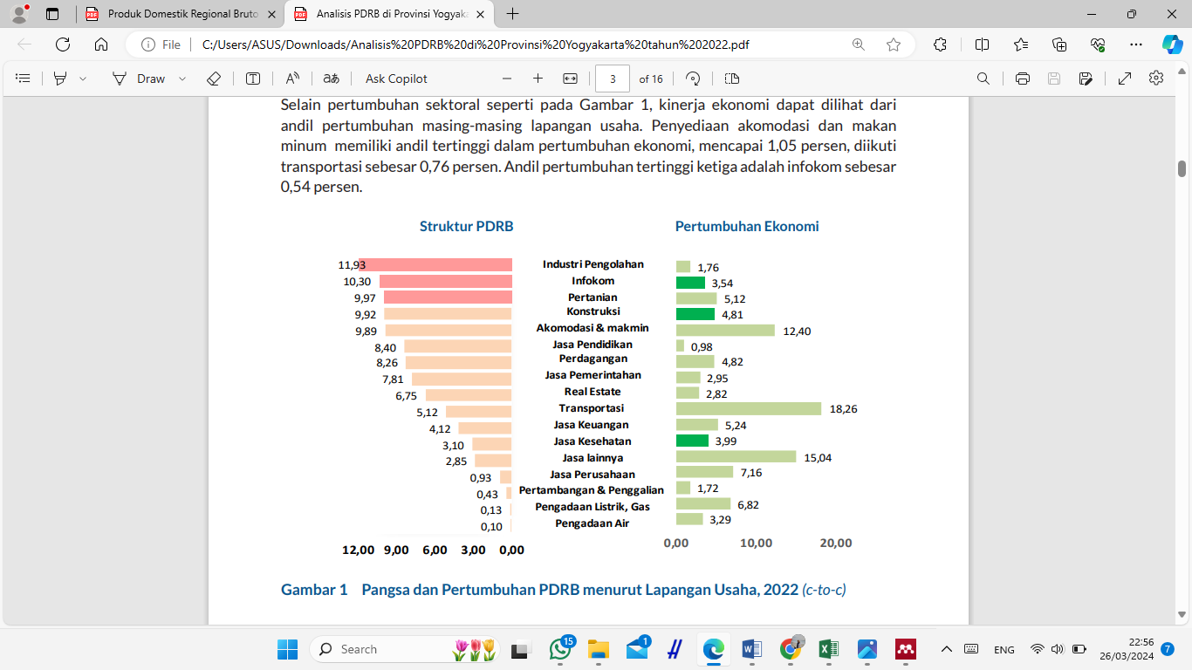

**Grafik Rata-Rata Lama Sekolah Provinsi Yogyakarta**