Lampiran
Lampiran 1. Data Asli
No | Kabupaten/Kota | Tahun | Kemiskinan (Y) | Zakat (X1) | PDRB  (X2) | Pendidikan  (X3)
1 | Kulon Progo | 2016 | 1.266948 | 6.40 | 6.6 | 8.50
1 | Kulon Progo | 2017 | 1.026042 | 1.76 | 7 | 8.64
1 | Kulon Progo | 2018 | 0.904218 | 2.90 | 7.7 | 8.65
1 | Kulon Progo | 2019 | 1.000632 | 6.17 | 8.8 | 8.66
1 | Kulon Progo | 2020 | 1.169381 | 8.28 | 8.4 | 8.86
1 | Kulon Progo | 2021 | 1.10194 | 9.34 | 8.8 | 9.02
1 | Kulon Progo | 2022 | 0.841567 | 12.62 | 9.4 | 9.17
2 | Bantul | 2016 | 0.703098 | 1.72 | 16.4 | 9.09
2 | Bantul | 2017 | 0.792993 | 1.81 | 17.2 | 9.20
2 | Bantul | 2018 | 0.774727 | 0.88 | 18.2 | 9.35
2 | Bantul | 2019 | 0.625938 | 1.50 | 19.2 | 9.54
2 | Bantul | 2020 | 0.615186 | 5.23 | 18.3 | 9.55
2 | Bantul | 2021 | 0.806476 | 5.15 | 19.8 | 9.57
2 | Bantul | 2022 | 0.746688 | 5.95 | 20.8 | 9.59
3 | Gunung Kidul | 2016 | 1.425515 | 1.17 | 11.7 | 6.62
3 | Gunung Kidul | 2017 | 1.211941 | 1.03 | 12.3 | 6.99
3 | Gunung Kidul | 2018 | 1.345472 | 1.57 | 12.9 | 7.00
3 | Gunung Kidul | 2019 | 0.947789 | 1.19 | 13.6 | 7.13
3 | Gunung Kidul | 2020 | 0.985817 | 0.75 | 13.5 | 7.21
3 | Gunung Kidul | 2021 | 1.091923 | 1.46 | 14.2 | 7.30
3 | Gunung Kidul | 2022 | 0.966984 | 1.48 | 15 | 7.31
4 | Sleman | 2016 | 0.307485 | 4.22 | 29.6 | 10.64
4 | Sleman | 2017 | 0.207014 | 4.23 | 31.1 | 10.65
4 | Sleman | 2018 | -0.0202 | 4.22 | 33.1 | 10.66
4 | Sleman | 2019 | 0.122218 | 4.76 | 35.3 | 10.67
4 | Sleman | 2020 | 0.314811 | 6.51 | 33.9 | 10.91
4 | Sleman | 2021 | 0.231112 | 6.56 | 35.8 | 10.92
4 | Sleman | 2022 | 0.165514 | 8.44 | 37.6 | 10.94
5 | Yogyakarta | 2016 | 0.04879 | 3.35 | 23.5 | 11.42
5 | Yogyakarta | 2017 | 0.457425 | 4.33 | 24.8 | 11.43
5 | Yogyakarta | 2018 | 0.322083 | 4.24 | 26.1 | 11.44
5 | Yogyakarta | 2019 | -0.16252 | 4.59 | 27.7 | 11.45
5 | Yogyakarta | 2020 | 0.173953 | 4.38 | 27 | 11.46
5 | Yogyakarta | 2021 | 0.067659 | 4.31 | 28.4 | 11.72
5 | Yogyakarta | 2022 | -0.22314 | 6.64 | 29.9 | 11.89

Lampiran 2. Hasil Penelitian

Uji Asumsi Klasik
Uji Normalitas
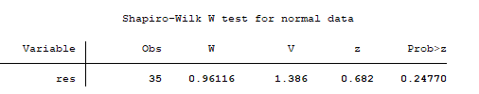

Uji Multikolinearitas
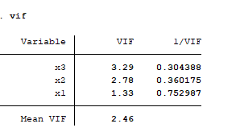
Uji Heteroskedastisitas
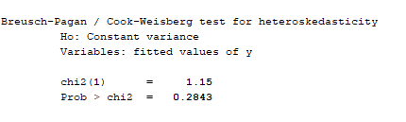
Uji Data Panel
Pemilihan Model
Uji Chow
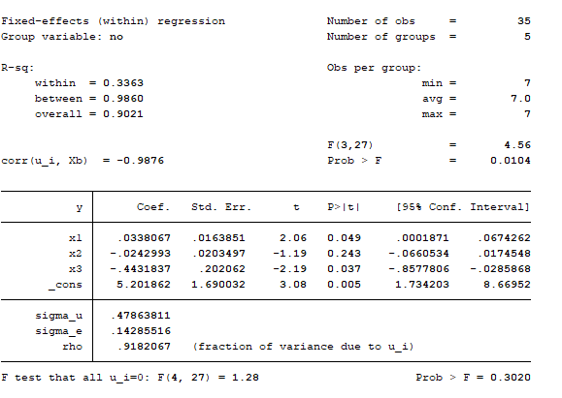
Uji Hausman
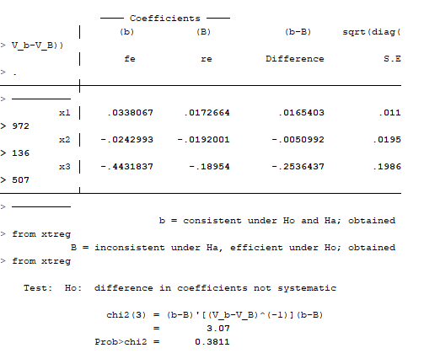
Uji Lagrange Multiplier
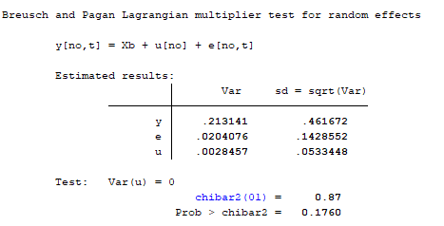

Pengujian Hipotesis
Uji Simultan (Uji F)
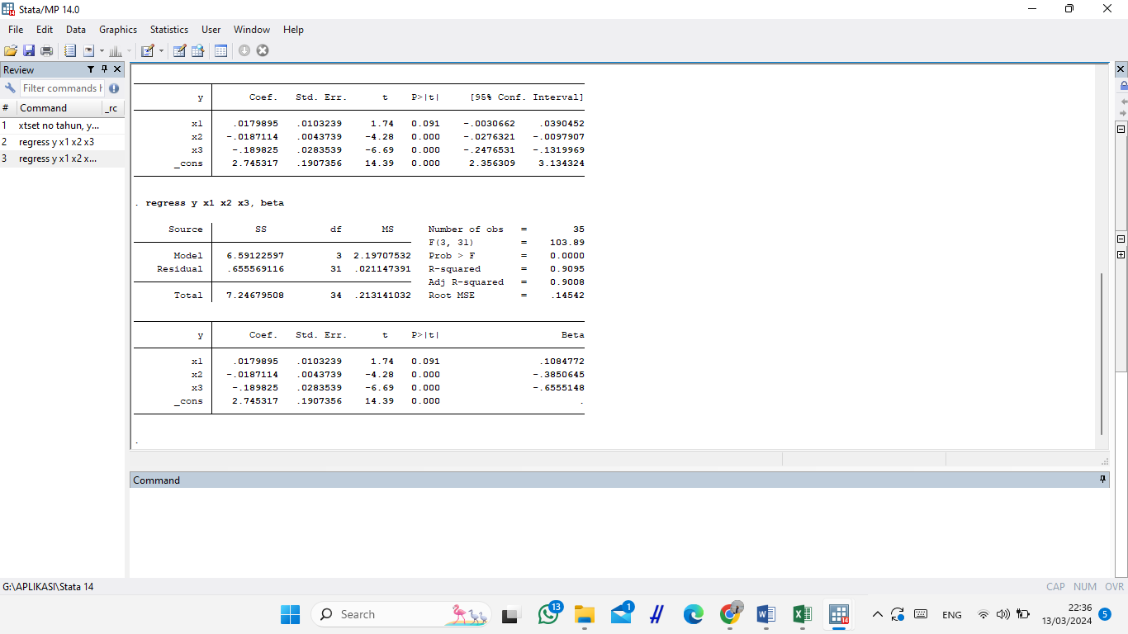

Uji Parsial (Uji Statistik T)
Uji Adjusted R Square (Koefisien Determinasi)

Lampiran 3. Hasil Analisis

Laporan Akhir Tahunan BASNAZ Provinsi Yogyakarta
Tahun | Prioritas Penyaluran Dana Zakat | Total Presentase
2016 | - | -
2017 | - | -
2018 | Fakir Miskin | 72%
2019 | Fakir Miskin | 72%
2020 | Fakir Miskin | 68,31%
2021 | - | -
2022 | Fakir Miskin | 64,32%

Laporan Akhir Tahunan BASNAZ Provinsi Yogyakarta Tahun 2022
Penyaluran Dana Zakat Berdasarkan Program | Total Presentase
DIY Peduli | 68,98%
DIY Sehat | 5,24%
DIY Sejahtera | 1,96%
DIY Takwa | 4,1%
DIY Cerdas | 19,71%

Data PDRB Kabupaten/Kota di Provinsi Yogyakarta

Struktur PDRB dan Pertumbuhan Ekonomi Provinsi Yogyakarta Tahun 2022
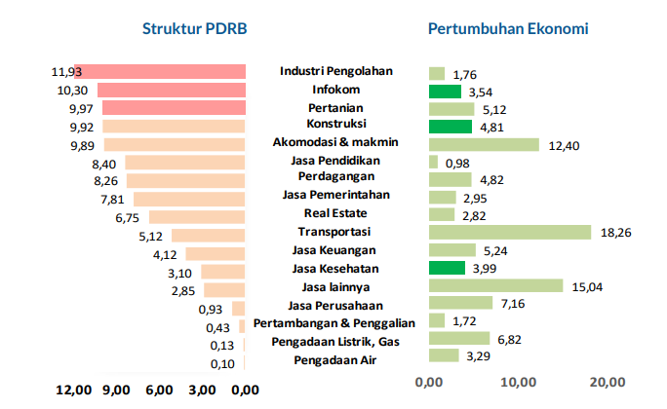

Grafik Rata-Rata Lama Sekolah Provinsi Yogyakarta

