**Regression**

|  |  |  |
| --- | --- | --- |
| **Notes** | | |
| Output Created | | 22-JUN-2023 22:56:51 |
| Comments | |  |
| Input | Active Dataset | DataSet0 |
| Filter | <none> |
| Weight | <none> |
| Split File | <none> |
| N of Rows in Working Data File | 107 |
| Missing Value Handling | Definition of Missing | User-defined missing values are treated as missing. |
| Cases Used | Statistics are based on cases with no missing values for any variable used. |
| Syntax | | REGRESSION  /DESCRIPTIVES MEAN STDDEV CORR SIG N  /MISSING LISTWISE  /STATISTICS COEFF OUTS R ANOVA COLLIN TOL  /CRITERIA=PIN(.05) POUT(.10)  /NOORIGIN  /DEPENDENT Y  /METHOD=ENTER X1 X2 X3  /SCATTERPLOT=(*SRESID ,*ZPRED)  /RESIDUALS DURBIN HISTOGRAM(ZRESID) NORMPROB(ZRESID)  /SAVE RESID. |
| Resources | Processor Time | 00:00:00,69 |
| Elapsed Time | 00:00:00,67 |
| Memory Required | 1956 bytes |
| Additional Memory Required for Residual Plots | 896 bytes |
| Variables Created or Modified | RES_1 | Unstandardized Residual |

|  |  |  |  |
| --- | --- | --- | --- |
| **Descriptive Statistics** | | | |
|  | Mean | Std. Deviation | N |
| Profitabilitas | 184.7570 | 409.62772 | 107 |
| struktur kepemilikan | 67.2430 | 20.99364 | 107 |
| struktur modal | 98.1402 | 106.19770 | 107 |
| pertumbuhan penjualan | -88.6916 | 2474.78013 | 107 |

|  |  |  |  |  |  |
| --- | --- | --- | --- | --- | --- |
| **Correlations** | | | | | |
|  | | profitabilitas | struktur kepemilikan | struktur modal | pertumbuhan penjualan |
| Pearson Correlation | profitabilitas | 1.000 | .010 | -.072 | .334 |
| struktur kepemilikan | .010 | 1.000 | -.057 | .103 |
| struktur modal | -.072 | -.057 | 1.000 | .023 |
| pertumbuhan penjualan | .334 | .103 | .023 | 1.000 |
| Sig. (1-tailed) | profitabilitas | . | .457 | .232 | .000 |
| struktur kepemilikan | .457 | . | .279 | .146 |
| struktur modal | .232 | .279 | . | .406 |
| pertumbuhan penjualan | .000 | .146 | .406 | . |
| N | profitabilitas | 107 | 107 | 107 | 107 |
| struktur kepemilikan | 107 | 107 | 107 | 107 |
| struktur modal | 107 | 107 | 107 | 107 |
| pertumbuhan penjualan | 107 | 107 | 107 | 107 |

|  |  |  |  |
| --- | --- | --- | --- |
| **Variables Entered/Removeda** | | | |
| Model | Variables Entered | Variables Removed | Method |
| 1 | pertumbuhan penjualan, struktur modal, struktur kepemilikanb | . | Enter |
| a. Dependent Variable: profitabilitas | | | |
| b. All requested variables entered. | | | |

|  |  |  |  |  |  |
| --- | --- | --- | --- | --- | --- |
| **Model Summaryb** | | | | | |
| Model | R | R Square | Adjusted R Square | Std. Error of the Estimate | Durbin-Watson |
| 1 | .345a | .119 | .093 | 390.07506 | 1.816 |
| a. Predictors: (Constant), pertumbuhan penjualan, struktur modal, struktur kepemilikan | | | | | |
| b. Dependent Variable: profitabilitas | | | | | |

1,816

|  |  |  |  |  |  |  |
| --- | --- | --- | --- | --- | --- | --- |
| **ANOVAa** | | | | | | |
| Model | | Sum of Squares | df | Mean Square | F | Sig. |
| 1 | Regression | 2113924.404 | 3 | 704641.468 | 4.631 | .004b |
| Residual | 15672331.278 | 103 | 152158.556 |  |  |
| Total | 17786255.682 | 106 |  |  |  |
| a. Dependent Variable: profitabilitas | | | | | | |
| b. Predictors: (Constant), pertumbuhan penjualan, struktur modal, struktur kepemilikan | | | | | | |

|  |  |  |  |  |  |  |  |  |
| --- | --- | --- | --- | --- | --- | --- | --- | --- |
| **Coefficientsa** | | | | | | | | |
| Model | | Unstandardized Coefficients | | Standardized Coefficients | t | Sig. | Collinearity Statistics | |
| B | Std. Error | Beta | Tolerance | VIF |
| 1 | (Constant) | 258.573 | 134.707 |  | 1.920 | .058 |  |  |
| struktur kepemilikan | -.567 | 1.818 | -.029 | -.312 | .756 | .986 | 1.014 |
| struktur modal | -.313 | .358 | -.081 | -.876 | .383 | .996 | 1.004 |
| pertumbuhan penjualan | .056 | .015 | .339 | 3.645 | .000 | .989 | 1.012 |
| a. Dependent Variable: profitabilitas | | | | | | | | |

|  |  |  |  |  |  |  |  |
| --- | --- | --- | --- | --- | --- | --- | --- |
| **Collinearity Diagnosticsa** | | | | | | | |
| Model | Dimension | Eigenvalue | Condition Index | Variance Proportions | | | |
| (Constant) | struktur kepemilikan | struktur modal | pertumbuhan penjualan |
| 1 | 1 | 2.525 | 1.000 | .01 | .01 | .06 | .00 |
| 2 | 1.000 | 1.589 | .00 | .00 | .00 | .99 |
| 3 | .432 | 2.417 | .02 | .03 | .90 | .00 |
| 4 | .043 | 7.695 | .97 | .95 | .05 | .01 |
| a. Dependent Variable: profitabilitas | | | | | | | |

|  |  |  |  |  |  |
| --- | --- | --- | --- | --- | --- |
| **Residuals Statisticsa** | | | | | |
|  | Minimum | Maximum | Mean | Std. Deviation | N |
| Predicted Value | -93.8088 | 511.6303 | 184.7570 | 141.21856 | 107 |
| Std. Predicted Value | -1.973 | 2.315 | .000 | 1.000 | 107 |
| Standard Error of Predicted Value | 40.945 | 157.907 | 71.960 | 22.687 | 107 |
| Adjusted Predicted Value | -94.6233 | 543.4601 | 188.5950 | 143.01689 | 107 |
| Residual | -958.67816 | 1017.34943 | .00000 | 384.51552 | 107 |
| Std. Residual | -2.458 | 2.608 | .000 | .986 | 107 |
| Stud. Residual | -2.544 | 2.628 | -.005 | 1.009 | 107 |
| Deleted Residual | -1027.35986 | 1033.00098 | -3.83797 | 403.04545 | 107 |
| Stud. Deleted Residual | -2.615 | 2.708 | -.005 | 1.021 | 107 |
| Mahal. Distance | .177 | 16.380 | 2.972 | 2.680 | 107 |
| Cook's Distance | .000 | .261 | .012 | .031 | 107 |
| Centered Leverage Value | .002 | .155 | .028 | .025 | 107 |
| a. Dependent Variable: profitabilitas | | | | | |

**Charts**

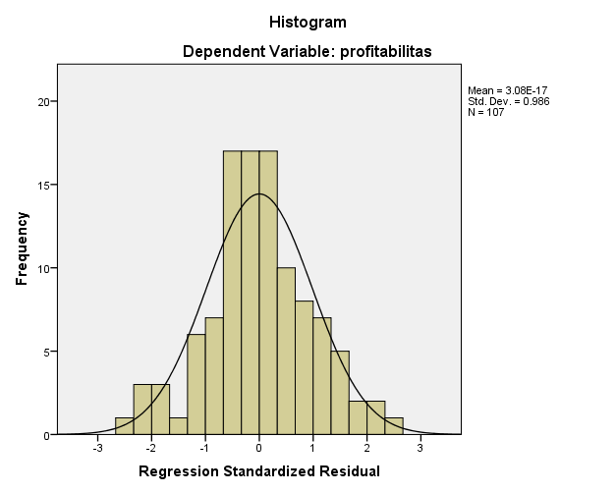

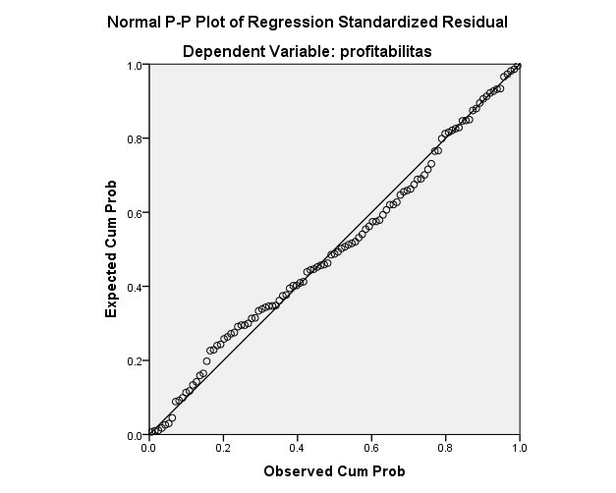

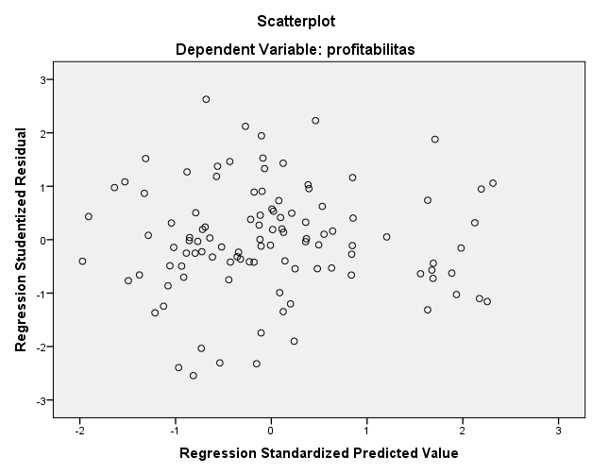

NPAR TESTS

/K-S(NORMAL)=RES_1

/MISSING ANALYSIS.

**NPar Tests**

|  |  |  |
| --- | --- | --- |
| **Notes** | | |
| Output Created | | 22-JUN-2023 22:57:57 |
| Comments | |  |
| Input | Active Dataset | DataSet0 |
| Filter | <none> |
| Weight | <none> |
| Split File | <none> |
| N of Rows in Working Data File | 107 |
| Missing Value Handling | Definition of Missing | User-defined missing values are treated as missing. |
| Cases Used | Statistics for each test are based on all cases with valid data for the variable(s) used in that test. |
| Syntax | | NPAR TESTS  /K-S(NORMAL)=RES_1  /MISSING ANALYSIS. |
| Resources | Processor Time | 00:00:00,00 |
| Elapsed Time | 00:00:00,05 |
| Number of Cases Alloweda | 196608 |
| a. Based on availability of workspace memory. | | |

|  |  |  |
| --- | --- | --- |
| **One-Sample Kolmogorov-Smirnov Test** | | |
|  | | Unstandardized Residual |
| N | | 107 |
| Normal Parametersa,b | Mean | .0000000 |
| Std. Deviation | 384.51551577 |
| Most Extreme Differences | Absolute | .064 |
| Positive | .046 |
| Negative | -.064 |
| Test Statistic | | .064 |
| Asymp. Sig. (2-tailed) | | .200c,d |
| a. Test distribution is Normal. | | |
| b. Calculated from data. | | |
| c. Lilliefors Significance Correction. | | |
| d. This is a lower bound of the true significance. | | |