Coloring Assistance for Increasing Creativity of TPQ Nurul Qoryah's Children

Tira Nur Fitria¹, Dewi Muliasari²
¹²Institut Teknologi Bisnis AAS Indonesia
Email: tiranurfitria@gmail.com¹, dewimuliasari27@gmail.com²

Abstract
This community service activity assists/trains coloring to increase the creativity of TPQ Nurul Qoryah's children. This community service method uses the simulation/demonstration method. This activity is implemented on Saturday, 4 June 2022, and involves 25 children. The process of assistance/training activities is carried out by 1) providing image media (coloring paper). 2) introducing colors. Children can choose and mention colors from existing colored pencils/crayons. 3) direct children to give the right colors according to the picture. It shows that children can choose colors according to the picture's color even though there are still many visible shortcomings, such as a mixture of colors that do not fit the image and many colors that cross the lines in the picture. 4) giving rewards to children. This reward has a positive impact on further activities. It shows that most children could select and identify colors from the available colored pencils. Children can color drawings as a consequence of the training process, even though deficiencies must be addressed, such as a mixture of colors that did not match the image and many colors that crossed the image's lines. The activity was carried out smoothly from the beginning to the end. All the children were enthusiastic during the assistance. From assistance (training) activities, several benefits and obstacles are faced. The benefits are 1) practice handwriting, 2) relaxation, and patience. 3) practice focusing and concentrating. 4) increase knowledge. 5) improve motoric skills. 6) stimulates creativity. 7) express expression and feelings. While the obstacles are assistance/training, media facilities are still lacking. 2) facing the unstable spirit of children. 3) relatively little time where the time used is from 15.30-17.00 WIB. To minimize the activity, the required time is at least two hours in each stage of the assistance/training.

Keywords: coloring, coloring technique, creativity

1. BACKGROUND
Every child has unique characteristics from an early age and is different from one another. Children are given space to express themselves to develop their creativity. Coloring is a very popular activity in early childhood. Drawing and coloring can be a means of expression for children by choosing colors according to their taste, which may be different from other friends. Not only fun, but coloring activities can also be used as a medium to stimulate various aspects of early childhood development such as creativity.
Creativity is an important part of education. A child's success is no longer determined not only by school achievement but also by the child's creativity. Creativity also allows children to express themselves in a way that helps them gain confidence. Kindergarten and elementary school children still love to draw and color. Drawing and coloring activities can increase children's creativity with very good development results (Yuntina, 2017). Thoughts, imagination, and hand gestures blend into one when children draw and color. In the learning environment in the classroom, children can be busy with those two activities. According to Sartika (2021), children's creativity needs to be improved, therefore learning must be interesting and fun for children, one way to attract interests and talents that exist in children is by drawing and coloring pictures. They are the most popular activities for children (Pratama, 2015).
Coloring is one of the most fun activities (Lestari & Dini, 2017; Reza, 2008). We can express what we imagine with the outward appearance of the colors we choose. Coloring is a fun activity as well as useful for training children's motor nerves, creativity, and imagination (Ranuhandoko, 2008). Coloring can increase creativity (Rahayu, 2020; Yahya, 2007). For children, coloring is a very enjoyable and exciting activity (Rozana et al., 2021). It means that through coloring, children's imagination and creativity are sharpened (Tilong, 2016). Coloring pictures can trigger children's creativity in drawing a visual form. Pratitis et al. (2019) state that coloring is an activity to add color or dye (crayon) to an image. Coloring activities have become a skill that should be mastered by children from an early age because they understand colors, children not only recognize various colors but also provide opportunities for children to express themselves.
Coloring photos help children recognize perspective lines, colors, and shapes. They also learn to recognize patterns. This will help children to decide which color to use for our next image. This simple and fun activity is very helpful for children's development because it can stimulate their imagination and give them the opportunity to express themselves. "Skills are obtained from the child's ability to hold hands. This is done repeatedly so that the child can control and direct for longer as needed. Cleanliness is shown by how children color the designated area, and children are accustomed to and good at scratching pigments. Patience is gained by choosing the right composition and, in his opinion, determining the number of colors used to determine the color composition. Continuous efforts to train children's patience. By playing with coloring often, children will be more creative in writing colors (Prima, 2016).
Coloring is a great way for children to communicate their thoughts either verbally or in the signs they make. Lesmana (2007) states that coloring, also requires knowledge of coloring techniques so that images appear more attractive. Therefore, it takes a guide on how to color a good technique. It is supported by Puspitasari & Puspita (2022) With the training can add insight, skills, and knowledge about how to use and combine colors to become a beautiful work. Coloring training can improve children's concentration, stay focused on their work, exercise patience, and train hand-eye coordination. Drawing activities with crayons, cutting paper by following simple patterns, and coloring pictures are types of toys that can hone children's interest in imagination, increase creativity and stimulate development (Febry & Marendra, 2009).
The training or assistance is needed to continue to develop the ability in children to be able to find and develop their talents, potential, and creativity. Yahya (2007) states that by observing nature and the environment and pouring it into the images we color, we have indirectly sharpened our sensitivity and sharpness in thinking. In the world of early childhood education, it is certain that play is an inseparable part of children's daily lives. Playing it has become a need for children so in learning in Kindergarten (TK) learning activities are always associated with play activities (Widnyana et al., 2020).
The use of color in teaching materials has been shown to play an important role in creating different emotional reactions and attracting children's attention (Napitupulu et al., 2021). Coloring can affect learning by manipulating cognition and emotions. Coloring affects children's memory performance and cognitive load, and how color stimulates children's emotions and further motivates children to learn. Color selection practices can be used to help children increase their attention to material and help teachers see the relationship between color, emotion, and cognitive learning. Positive emotions can improve cognitive and affective outcomes.
Likewise, what happened at TPQ Nurul Qoryah, many children were just busy playing from morning to evening, seeing this problem, the service team had the initiative to provide coloring guidance to children in the afternoon by preparing crayons and also drawing media to color by child. Creativity is an important thing for every individual to be more productive. With the creativity of human civilization continues to grow and bring up new ideas that are engraved in civilization. This training and coloring competition aims to increase the productivity of children at TPQ Nurul Qoryah so they don't get lazy while they are at the mosque. It is also to develop the imagination and creativity of each child. After school, children usually only participate in Al-Qur'an activities at the TPQ, without other additional activities, such as art activities. Seeing from the background of the problem, the target to be achieved through community service activities is to develop the creativity of TPQ Nurul Qoryah children by holding training and also coloring competitions. The purpose of this community service activity is to teach coloring techniques to increase the creativity of children at TPQ Nurul Qoryah Pondok Serang, Mulur Sukoharjo.

2. METHOD
This community service method uses the demonstration method. According to Hasibuan et al. (2022), the demonstration method is used to provide direct examples to the trainees on how to do good and correct coloring practices. The demonstration method is a teaching method by demonstrating items, events, rules, and sequences of carrying out an activity, either directly or indirectly (Krisno, 2016). The individual approach method was used to guide the trainees directly during the coloring practice. The realization of the implementation of the community service program activities using drawing paper media that already have pictures and are ready to be colored in size pictures (Wardiningsih et al., 2019). This activity is carried out by providing guidance to TPQ Nurul Qoryah children so that they can have the ability to color pictures that these activities can improve children's skills. This community service is implemented on Saturday, 4 June 2022. The number of children involved in this training is 25 children.

3. IMPLEMENTATION
In conducting training activities in coloring for children, the stages are carried out. This community service activity initially grouped children based on age. The grouping of children based on age is done to make it easier to provide pictures according to age levels because the pictures are simple in nature and also at a higher level. Next, the community servant analyzes the child's abilities. At this stage the child is given simple pictures to color, then the results of the children's work are analyzed as a consideration in giving the next picture. In detail, the steps taken during the guidance process for coloring pictures for early childhood are as follows:
- Preparing pictures to be distributed. At this stage, the selection of pictures that will be given to children is carried out. The selection of images is carried out according to their level, namely by grouping the simplest images into those that are somewhat complex.
- Providing media images. The images that have been provided are then distributed to children according to the activity sessions carried out starting from the simplest images to new ones. which is a bit difficult. In addition to providing drawing media, colored pencils and crayons are also provided which are used by children to color the pictures. Children are given the freedom to choose their own colors.
- Introducing and choosing colors. In this section, an introduction to basic colors is made, and children are given the opportunity to choose colors according to their respective preferences. Color introductions are carried out so that children can adjust the colors used with the image media they want to color.
- Direct children to give colors. In this activity the child is directed to choose a color that is adjusted to the image to be colored. For example, for the leaves, the color chosen is green, the sun is yellow, and so on.
- Giving rewards and praise to children. Children who have completed their work are given praise with words and are motivated to study harder, in addition they are also given candy as a form of reward. This is done so that children feel valued in the guidance process carried out.
Monitoring and evaluation are very important to do to determine the level of child development. In this service activity monitoring and evaluation are carried out in two stages, namely: a. During the activity, when the activity is carried out, observations are made to determine the level of children's ability to color pictures. This activity is carried out when children are drawing, with the aim of knowing the activities, motivations and enthusiasm of children in drawing. This is done as a consideration to provide a higher level image to color. b. Post activity After all the stages of the service activity are completed, an evaluation of the child's results in drawing is carried out. This is done to determine the extent of the child's development in drawing.

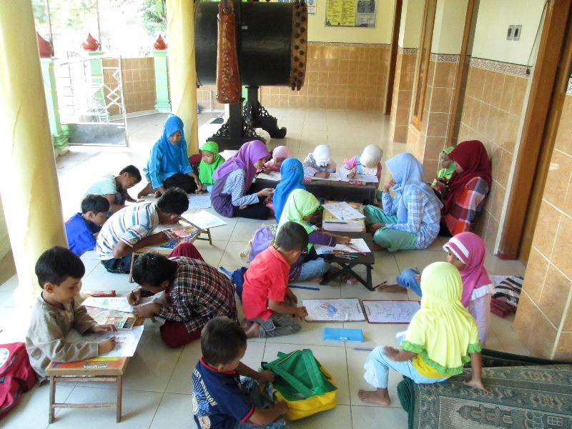 | 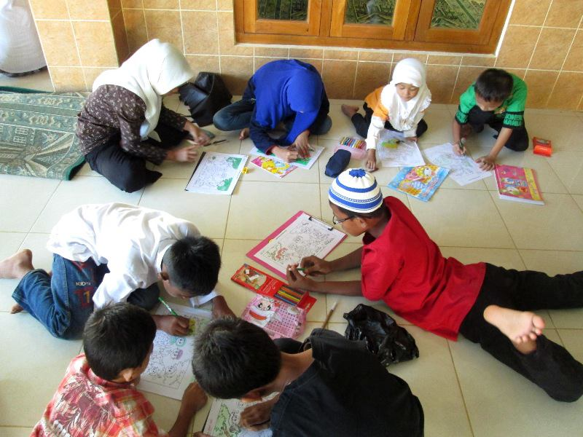
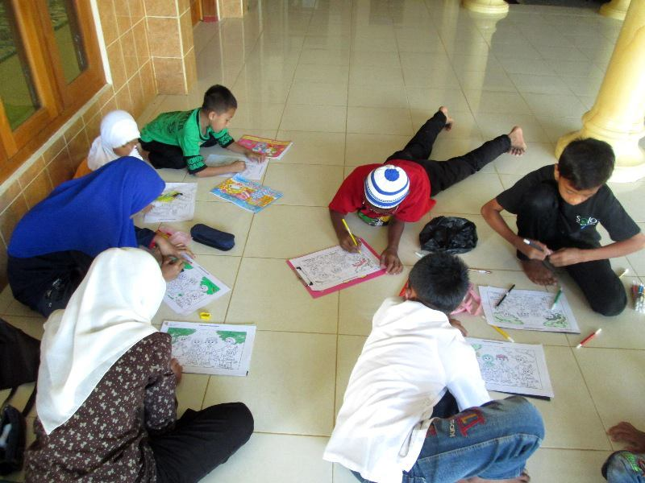 | 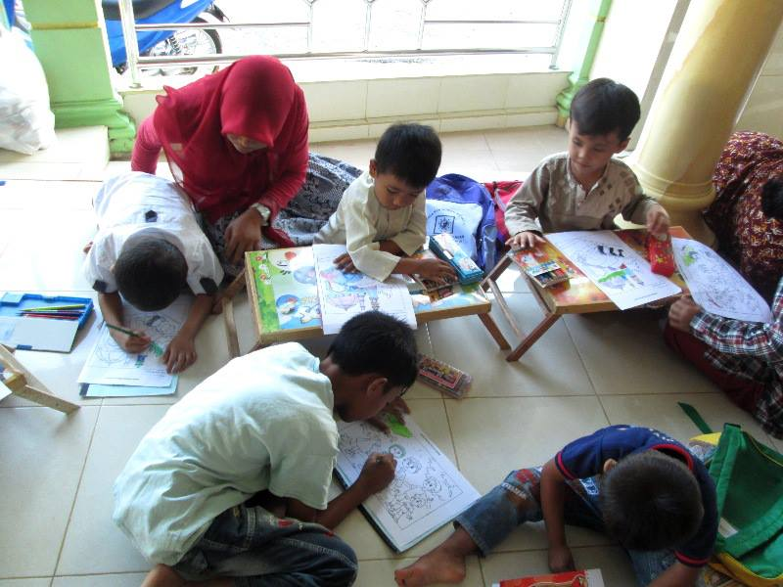
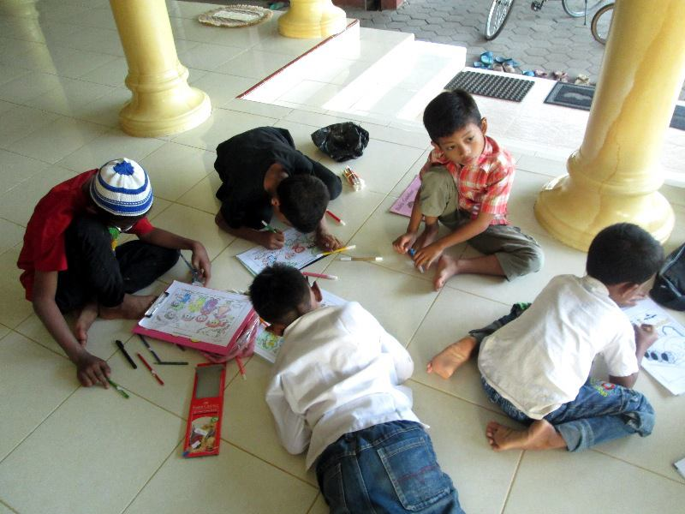 | 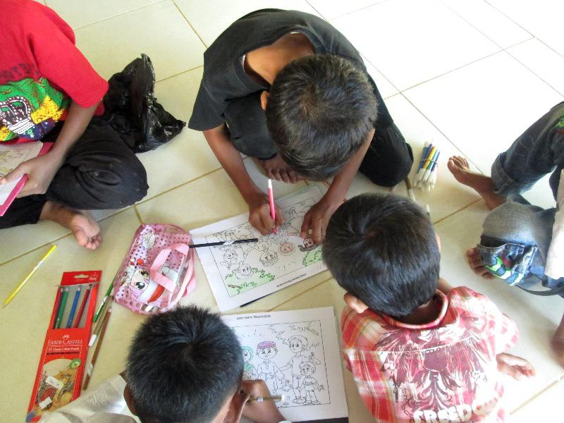
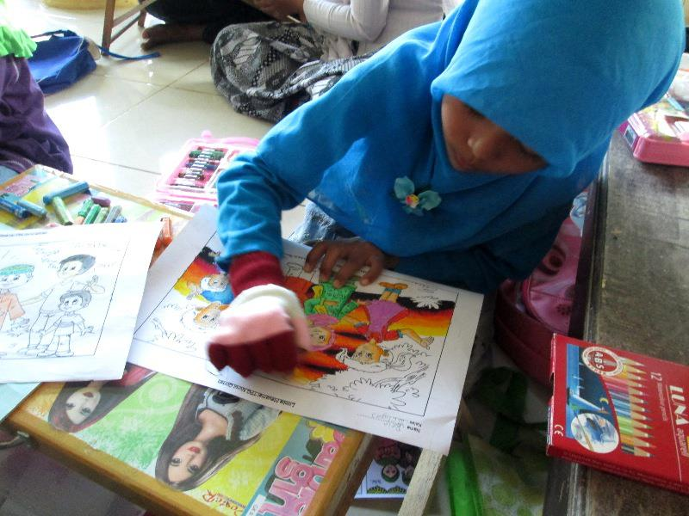 | 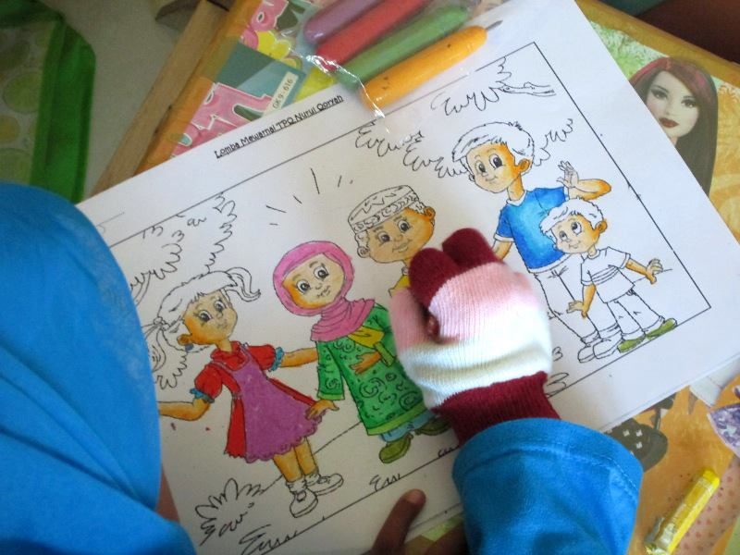
Figure 1. Coloring Assitance to Children TPQ Nurul Qoryah

In the coloring training, the lecturer as a TPQ teacher distributed paper with pictures on it and then asked TPQ Nurul Qoryah's children to be free to color according to their imagination by bringing colored pencils or crayons from their homes. The participants of the competition were children from kindergarten, grade 1 to 3 elementary school. Where at that age children need to get training or learning to hone their creativity. This coloring activity lasted for 90 minutes. At the time of the competition, the children at TPQ Nurul Qoryah looked very happy, enthusiastic and enthusiastic in coloring the calligraphy. This activitiy also run in an orderly and smooth manner until the end of the event. In this training there are several winning candidates who will get prizes. The prizes given are very useful prizes for the winners of the competition.
The activity was carried out smoothly from the beginning to the end of the activity, where all the children were very enthusiastic in participating in the competition, and so were the teacher councils who also participated in the process of implementing the activity. From assistance (training) activities to increase children's creativity through coloring media that has been carried out, there are several benefits and obstacles faced. The benefits of coloring activities are:
- Practice handwriting. Children needs hand strength and dexterity to use a pencil on paper. Working with force can eliminate the possibility of mishandling the pencil. Activities such as coloring paper will help them hold their writing utensil the right way and improve and practice their handwriting.
- Feeling relaxation and patience. Coloring can help children to learn patience skills. This allows toddlers to be relaxed and comfortable while creating art. They can color the shapes and pictures they like. This will give children a sense of accomplishment and satisfaction when they finish coloring the pages.
- Increase focus and concentrate. Focus is one of the important lessons students can learn from coloring acitvity. It has been proven that children who spend their time coloring have better concentration and focus skills.
- Increase knowledge. Coloring pictures can help your little one recognize lines, perspectives, colors and shapes. They will also learn to recognize patterns. This will help the children decide what colors to use in their next drawing.
- Increase mtor skills. Coloring can improve children's motor skills. The movements involved in coloring such as holding a utensil and coloring with crayons can help in the development of the small muscles in his wrists, fingers, and hands. Fine motor skills help them write and use objects. Indirectly, children will be easier to adjust when starting activities at school.
- Stimulates creativity. Coloring gives children one the opportunity to express their creative side. A coloring creates an imaginary world in his mind before drawing a picture on a sheet.
- Express expression and feelings. Through pictures and colors, we can sometimes find out what things are currently feeling. Usually, children will like bright colors for coloring pictures and vice versa. Learning to color can train children to concentrate more. While completing the drawing and coloring, the children will be more focused on completing the activity. Children will be trained not to be easily disturbed even though the surrounding environment is not conducive. This ability will later be useful when children start school. Learning to color can not only train children's cognitive abilities, but can also stimulate their motor skills. By coloring, the performance of the child's hand muscles will be better trained. In addition, this activity will also help children learn to grip, making it easier for them to learn to write in the future.
While, the obstacles during assistance (training) activities to increase children's creativity through coloring media are:
- Training media facilities are still lacking. Lack of facilities is an obstacle in developing children's creativity in this training, where the facilities used are still using simple media in the form of drawing sketches that are printed using a printer, crayons and colored pencils. For its development requires better media, namely being able to use styrofoam and also colored paint.
- Unstable spirit of children. The unstable spirit of students is one of the obstacles in this service process, in which case the goals or targets that have been determined in each stage of the activity are not met perfectly. Thus, it takes tenacity and perseverance to grow children's enthusiasm so they don't get bored quickly during training.
- Relatively little time A short time is an obstacle in this service, where the time used is from 15.30-17.00 WIB. To maximize the activity, the time required is a minimum of two hours in each stage of the activity.
Coloring is a skill program that is liked by children. The children is happy and enthuthiastic in joining the assistance (training) of coloring. So far, it has become a medium for them to allow any imagination and inspiration about anything they might have touched or experienced. Coloring pictures can help children recognize perspective lines, colors, and shapes. They will also learn to recognize patterns. This will help them decide what colors to use in their next drawing. This simple and fun activity can really help a child's development, because coloring can spark their imagination and give them the opportunity to express themselves. Skills are obtained from the child's ability to process hands which is done repeatedly so that the longer the child can control and direct as desired. Neatness is seen from how the child gives color to the places that have been determined the longer the child will be more skilled at scratching the coloring media because he is used to it. Patience also is obtained through choosing and determining the right composition according to his opinion how many colors are used to determine the color composition. Continuous efforts will train children's patience.
Children are able to color drawings as a consequence of the training process, despite the fact that there are still deficiencies that must be addressed. (Ahmad et al., 2022) In this task, the majority of children were able to select and identify colors from the available colored pencils. In this exercise, it was seen that the kid was able to pick colors based on the color of the image, despite several obvious flaws, such as a mixture of colors that did not match the image and many colors that crossed the image's lines.

ACKNOWLEDGMENT
We thank all parties involved in this activity so that this article can be compiled. We thank the children of TPQ Nurul Qoryah who have been actively involved during the activity. With this activity, it is hoped that children will be more active and creative in their work through color.

4. CONCLUSIONS AND SUGGESTIONS
Conclusion
From the results and discussion above, it is known that the process of training activities is carried out by: First, providing image media, the first step is to provide image media in the form of circle and square images. corrected. Second, introducing colors, in this activity it appears that most children can choose and mention colors from existing colored pencils/crayons. Third, direct children to give the right colors according to the picture, in this activity it can be seen that children are able to choose colors according to the color of the picture even though there are still many visible shortcomings, where there is a mixture of colors that do not fit the image and also many colors that cross the lines in the image. Fourth, giving rewards to children, with this reward giving a positive impact for further activities. Children who have been given rewards are more active in drawing activities. Thus, it can be concluded that providing training with drawing media can increase children's creativity. The activity was carried out smoothly from the beginning to the end of the activity, where all the children were very enthusiastic in participating in the competition, and so were the teacher councils who also participated in the process of implementing the activity. From assistance (training) activities to increase children's creativity through coloring media that has been carried out, there are several benefits and obstacles faced.

Suggestion
The follow-up of this program, it is hoped that children can be more imaginative and more creative in the future and can be practiced by children during coloring activities at school and outside school. By doing coloring activities, it can train children's talents and interests, as well as create a generation that has art achievements.

REFERENCES
Ahmad, A., Aprianto, D., Rusandi, H., Hidayah, N., Parihin, P., & Arfa, M. (2022). Mengembangkan Kreativitas Anak Usia Dini Melalui Kegiatan Pelatihan dengan Media Mewarnai. GHIRAH: Jurnal Pengabdian dan Pengembangan Komunitas, 1(1), 23–32.
Febry, A. B., & Marendra, Z. (2009). Menu Sehat & Permainan Kreatif untuk Meningkatkan Kecerdasan Anak. GagasMedia.
Hasibuan, F. A., Subakti, H., Harizahayu, H., Salamun, S., Siallagan, T., Saftari, M., Ritonga, M. W., Suhartati, T., Purba, B., Nasution, Y. A., & Chamidah, D. (2022). Pengembangan Media dan Teknologi Pembelajaran. Yayasan Kita Menulis.
Krisno, A. (2016). SINTAKS 45 Metode Pembelajaran Dalam Student Centered Learning (SCL). UMM Press.
Lesmana, H. (2007). Panduan Praktis Mewarnai dengan Crayon Seri Suasana. WahyuMedia.
Lestari, A., & Dini, Y. (2017). Smart Big Book Membaca Menulis Behitung Mewarnai. Cikal Aksara.
Napitupulu, P. A., Putrawan, B. K., & Sutrisno, S. (2021). Pendampingan Metode Menggambar, Mewarnai, dan Mengecat Pada Guru Dalam Meningkatkan Motorik Anak di PAUD Kemah Kasih Pademangan Barat, Jakarta Utara. Jurnal ABDI: Media Pengabdian Kepada Masyarakat, 6(2), 140–146. https://doi.org/10.26740/ja.v6n2.p140-146
Pratama, R. B. (2015). Panduan Lengkap Menggambar dengan Krayon. Cikal Aksara.
Pratitis, N., Asrul, A., & Hetharia, W. (2019). Meningkatkan Kreativitas Anak Melalui Kegiatan Mewarnai. Abdikarya : Jurnal Karya Pengabdian Dosen Dan Mahasiswa, 3(3). http://jurnal.untag-sby.ac.id/index.php/abdikarya/article/view/3820
Prima, A. (2016). Aneka Permainan Kreatif dan Edukatif untuk Anak: 54 Ragam Permainan Anak untuk di Rumah dan Sekolah. DIVA Press.
Puspitasari, A., & Puspita, A. R. (2022). Pengembangan Kreativitas Anak Usia 6 – 9 Tahun Melalui Kegiatan Mewarnai di Desa Carangrejo. PRODIMAS: Prosiding Pengabdian Masyarakat, 1, 248–263.
Rahayu, L. P. (2020). Smart Kids Membaca, Menulis, Berhitung, Mewarnai. Genta Group Production.
Ranuhandoko, N. (2008). Teknik Dasar Mewarnai Dengan Cat Air Seri Buah-buahan. WahyuMedia.
Reza, D. (2008). Pintar Menggambar Hewan Ternak. AgroMedia.
Rozana, S., Harahap, A. S., Astuti, R., Ubaidillah, Widya, R., Tullah, R., Anwari, A. M., & Mahardhani, A. J. (2021). Strategi Taktis Pendidikan Karakter Anak Usia Dini. EDU PUBLISHER.
Sartika, V. (2021). Meningkatkan Kreativitas Melalui Mewarnai Gambar Dengan Menggunakan Colored Sand Pada Anak Usia 5-6 Tahun di PAUD Melati Sugih Waras Kabupaten Ogan Komering Ilir Tahun Ajaran 2021 [Undergraduate Paper, Universitas Islam Negeri (UIN) Raden Fatah Palembang]. http://repository.radenfatah.ac.id/19000/
Tilong, A. D. (2016). 49 Aktivitas Pendongkrak Kinerja Otak Kanan & Kiri Anak. DIVA Press.
Widnyana, I. G. N., Supir, K., Bargo, P., & Netje, R. (2020). Pelatihan Dan Pendampingan Mewarnai Gambar Bagi Guru TK Di Gugus Mawa Denpasar Selatan. Prosiding Senadimas Undiksha 2020, 5.
Yahya, D. (2007). Mudah Mewarnai dengan Crayon untuk Anak. Kawan Pustaka.
Yuntina, L. (2017). Peningkatan Kreativitas Anak Kelompok Bmelalui Kegiatan Mewarnai Gambar di RA Al Muta A’limin Jati Rahayu Kota Bekasi Tahun Pelajaran 2016/2017. Jurnal CARE (Children Advisory Research and Education), 5(1), 22–28.

