**FOSTERING DIFFERENTIATED INSTRUCTION BY SCHOOL-BASED COMMUNITY SERVICE TO CONTRIBUTE TEACHERS’ PROFESSIONAL DEVELOPMENT**

**Aliva Rosdiana1, Haryanto2, Olyvia Revalita Candraloka3, Hayu Dian Yulistianti4**

1,2,3,4Universitas Islam Nadlatul Ulama (Unisnu) Jepara, Jepara

Alamat Korespondensi : Jl. Taman Siswa No. 09 Tahunan, Jepara, Jawa Tengah, 59427

E-mail: 1)[alivarosdiana@unisnu.ac.id](mailto:alivarosdiana@unisnu.ac.id), 2)[haryanto@unisnu.ac.id](mailto:haryanto@unisnu.ac.id), 3)[olyviarevalita@unisnu.ac.id](mailto:olyviarevalita@unisnu.ac.id), 4)[hayu@unisnu.ac.id](mailto:hayu@unisnu.ac.id)

## Abstrak

***Abstract***

*Differentiated instruction is a new paradigm curriculum especially conducted by teachers of MA Miftahul Huda Bulungan Jepara. Curriculum is innovated to essence independent learning conducted by teachers and students in learning process. School-based community has several opportunities for teachers and students to be innovative in implementing the Merdeka Curriculum Program. This school based-community service activity is aimed at providing knowledge to teachers and stakeholders at MA Miftahul Huda Bulungan Jepara, and training teachers and stakeholders at MA Miftahul Huda Bulungan Jepara by fostering differentiated instruction in order to contribute teachers’ professional development. The activity employed includes expository, Q&A, demonstration, and discussion. The result of school-based community service activity after getting post-test conducted to 17 teachers and stakeholders is that 72% teachers as participants claimed having knowledge and skills improved. Besides, the score average of post-test given was higher than the average score of pre-test of 49. Most teachers expected a sustainable mentoring program as the follow-up of school-based community.*

***Keywords****: differentiated instruction; school-based community service; MA Miftahul Huda Bulungan Jepara; Merdeka Curriculum Program*

1. PENDAHULUAN

Differentiated instruction conceptual model is expected to realize the outcome of Pancasila student profile commonly conducted by teachers in Indonesia as ideal learning for teacher who understand philosophy of progressive education through various activity learning to enable students to pay attention to their well-being and empower them as learners (Hasanah, et al., 2022). Teachers’ problems conducted are commonly having lack understanding and bewildered to adjust Merdeka Belajar curriculum (Hadi, Marniati, Ngindana, Kurdi, & Fauziah, 2023) and instruction to maximize learning process of students (Iskandar, et al., 2023). In other words, they are poor in tailoring lessons as the process to meet students’ interest, needs, strength, choice and flexibility to the way of learning. The solution to overcome the problem is making interactive class by concerning students’ attributes (background of knowledge, readiness, interests, and learning profiles) and teachers’ implementing (content, process, product, and learning environment differentiation) (Melesse & Belay, 2022) (Tomlinson, 2017) (Chaidi & Drigas, 2022). Differentiated instruction meets the needs of teachers’ readiness of implementation influence to the way of how they monitor students’ progress (Kupers, D, Bakker, Jong, & Minnaert, 2023). It becomes teachers’ challenge to implement not only differentiated instruction model but also to understand students’ profile learning whether visual, auditory, or kinesthetic (Suryati, Ratih, & Maryadi, 2023).

Differentiated instruction facilitates teachers’ culture to adapt to heterogeneous and inclusive classroom comprehensively and contextually as conceptual model to better assist students optimally (Shareefa, Moosa, & Rohani Matzin, 2021) (Gheyssens, Coubergs, Griful-Freixenet, Engels, & Struyven, 2022) (Khanna & Bhola, 2023). It is the method utilized by teacher with inquiry-based, interest-based, learner-oriented, and activity-intensive to strategic plan facing variety of students’ aptitudes, needs, personalities, and experiences (Onyishi & Sefotho, 2020). No matter what teachers are teaching, as long as the learning process gives students opportunity to step on the track to achieve goals, students will find their own way to engage material with learning objective and motivates them to be independent learners. Teachers are also demanded to be creative and innovative in literacy (Rosdiana, Widiyono, Milkhaturrohman, & Lailiyah, 2023) to create interesting class. There are five steps to be applied by teachers as strategy in conducting differentiated instruction, namely identifying educational needs, setting differentiated goals for students who have different achievement levels, providing differentiated instruction, providing differentiated tasks, and evaluating progress to analyze students’ work (Geel, Keuning, & Safar, 2022). By differentiated instruction, teachers offer students to employ variety method, and it guides teacher personalize learning to encourage students to work with growth mindset (Tomlinson & Imbeau, 2023).

Universitas Islam Nahdlatul Ulama (Unisnu) lecturer service team were aware that teachers’ challenging in promoting student-centered learning were lack of strategy to bring students become active and enthusiastic in class learning. Full-service community school offered technical assistance and training with different model to make different effect in facilitating lifelong learning teachers (Dryfoos & Mauguire, 2019). Therefore, the team supported teachers of MA Miftahul Huda to liven classroom utilizing differentiated instruction as strategy of how to draw students’ attention and participation actively to focus on material given. The fundamental tenet of this service activity was to socialize, to train, and to accompany teachers to create students-centered learning with involving along the learning process. Teacher will get advantage during the process of differentiated instruction including exploring students’ engagement, creating inclusivity of social and academic, and encouraging students’ confidence. Specifically, lessons design made is students’ learning styles adapted, students are grouped by their interest, topic, and assignments’ ability, formative assessment applied, managing classroom, and adjusting lesson to meet students’ needs (Tursunboevna, 2022).

By school-based community in Jepara, lecturer service team provide knowledge to teachers and stakeholders at MA Miftahul Huda Bulungan Jepara, and training 17 teachers and stakeholders at MA Miftahul Huda Bulungan Jepara by fostering differentiated instruction in order to enhance learning quality with expository, Q&A, discussion, demonstration, and discussion as the method. The result of school-based community service activity denoted enhancement of teachers’ knowledge and skill of differentiated instruction model. It is aimed at contributing teachers’ development to realize the outcome of Pancasila student profile to adjust Merdeka Belajar curriculum that demands cooperative learning as the concept to problem solving (Jayanti, Umar, Nurdiniawati, & Amar, 2022).

2. METODE PELAKSANAAN

The method of this activity was expository, question and answer (Q&A), discussion, demonstration, and discussion. This school-based community service was conducted to 17 teachers of MA Miftahul Huda Jepara. Initially, teachers as partners in this community were explained about differentiated instruction. In Q&A section, then, teachers were given an opportunity to ask to be answered by lecturer-service team who conduct as speaker. After teachers’ partners as participants understand the concept of differentiated instruction through explanation, the activity was continued to demonstration. Lecturer-service team trained teachers through demonstration about the strategy of differentiated instruction practically. One of differentiated instruction trained was two stay-two stray and station rotation. As evaluation, teachers are asked to answer questionnaire instrument to find out the effectiveness of activity. During activities, teachers are given gird instrument to measure the activity (see table 1).

Table 1. gird instrument of the material and instructor provided accuracy

|  |  |  |  |  |  |
| --- | --- | --- | --- | --- | --- |
| Material | 1  (poor) | 2  (fair) | 3  (good) | 4  (very good) | 5  (excellent) |
| The material provided increases the level of skills and knowledge. |  |  |  |  |  |
| The training material is easy to understand and easy to apply in learning. |  |  |  |  |  |
| The material provided can meet the expectations and needs of the scope of work. |  |  |  |  |  |
| Instructor |  |  |  |  |  |
| The instructor masters the material. |  |  |  |  |  |
| The instructor masters it practically. |  |  |  |  |  |
| The instructor explains the material using language easy to understand. |  |  |  |  |  |
| The instructor accompanies participants during the training process. |  |  |  |  |  |
| Material and learning objective is intertwined during activity. |  |  |  |  |  |
| The instructor gives participants the opportunity to ask questions and express opinions during the activity. |  |  |  |  |  |
| The instructor shows exemplary behavior during the activity. |  |  |  |  |  |
| The instructor was able to answer participants' questions well. |  |  |  |  |  |

In addition, questionnaire of pre-test and post-test about teaching techniques with differentiated instruction practically were given to figure out whether the activity of community service was running well (see table 2).

Table 2. Pre-Test and Post-Test Questions

|  |  |
| --- | --- |
| Question | Answer options |
| What is differentiated instruction? | 1. Strategy used in classroom by individual needs to varied modes of instruction and assessment, and leading to higher quality classroom 2. Learning strategy of making students understand by giving them project to conduct individually. 3. Instruction led by teacher to lecture and to get students answering during class. 4. The way to instruct students in getting capability to summarize lecturing during class to submit after class. |
| How to make cooperative learning class to support differentiated instruction? | 1. Sharing answers among class. 2. Students follow teachers’ instruction 3. Teacher provides multiple texts and types of learning materials. 4. Teacher separates groups to be treated or controlled. |
| Give examples of cooperative learning activity | 1. Painting 2. Jigsaw 3. Writing 4. Counting |

3. HASIL DAN PEMBAHASAN

Teachers of MA Miftahul Huda Jepara felt that differentiated instruction model was new paradigm that gave them new knowledge and skill as challenge to implement. Even it is not uncommon for school to provide teacher professional collaboratively (Dulfer, Kriewaldt, & McKernan, 2021) (Ria & Kurniawati, 2023). When questionnaire was given, most of them encountered difficulty to implement differentiated instruction due to lack of knowledge, lack of time to prepare, and lack of training. These teachers’ problems also became reasons for some universities and academics in previous studies conducted community services or research to foster differentiated instruction in aimed at contributing teachers’ professional development (Dubé, Gareau, & Lanoix, 2023) (Bobi & Ahiavi, 2023). Teachers is also expected to realized Pancasila student profile in conceptual model of differentiated instruction in community service activity shown in previous study conducted by academics (Evendi, Rosida, & Zularfan, 2023). This model is relevant to solve teachers’ problems and fulfill teachers’ need in diversity class.

Making interactive class is an effect of interactive instruction made by teacher to students in classroom. Creating cooperative learning classroom using differentiated instruction models is diverse to implement such as two-stay two-stray (Jupri, Mismardiana, Muslim, & Haerazi, 2022), jigsaw (Musriza & Elismawati, 2021), station rotation (Hadiprayitno, Kusmiyati, Lukitasari, & Sukri, 2021), Numbered Head Together (Riska Sari, 2023), reciprocal questioning (Hasibuan & Hasibuan, 2023), Think-Pair-Share (Zulfa, Safari, Damayanti, & Setiawaty, 2022), and group investigation (Basri, Dongoran, Syafitri, Silaban, & Tanjung, 2022). Cooperative learning strategy builds relationship between students and teacher as well as among students since it provides an opportunity for students to learn and demonstrate their skills after teacher gives instruction (Wattanawongwan, Smith, & Vanest, 2021). By school based-community service activity, teachers are motivated and trained through 4 methods, namely expository, question and answer (Q&A), demonstration, and discussion. This activity was held two days, on 15 September 2023 (expository and Q&A) and 16 September 2023 (demonstration and discussion).

Before school based-community service activity conducted, Universitas Islam Nahdlatul Ulama (Unisnu) lecturer service team conducted school-visit to coordinate and to ask for preparation. The steps conducted were as follows:

1. **Expository**

Before expository activity, teachers were identified to figure out their needs through students’ profile learning as students-like in implementing differentiated instruction through ice breaking. Motivation through ice breaking is not only dealt with willingness, attention, and concentration to study (Pranata, Susanti, & Jannah, 2021), but it also dealt to identify students’ profile learning to design different instruction to classroom diversity. Differentiated instruction as the strategy utilized based on auditory-kinesthetic-visual learning style, namely auditory, kinesthetic, is believed determine students’ achievement in improving learning outcome (Utami, Prastiningsih, & Toyyibah, 2023).

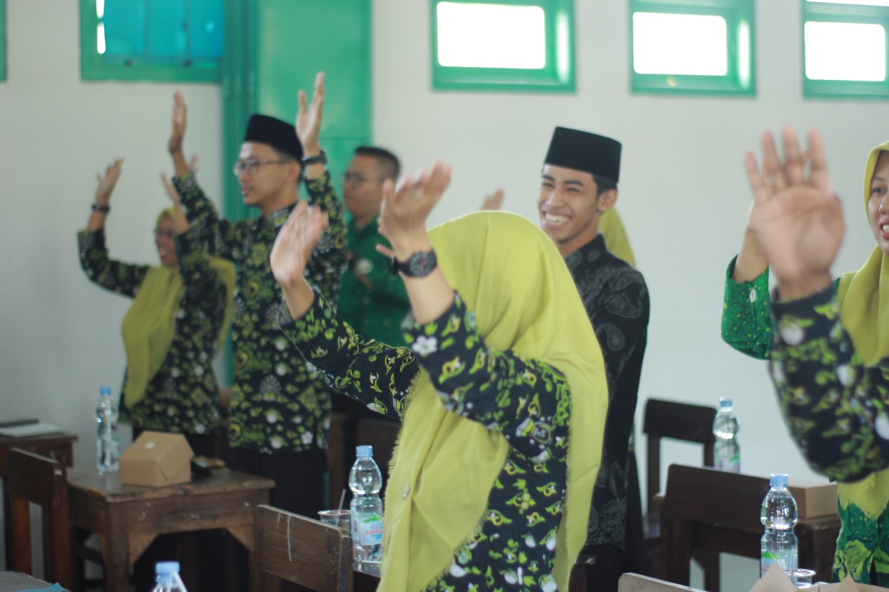

Fig 1. Teachers conducted ice breaking to identify students’ profile learning

School-based community service team coordinated with teachers was conducted to design training plan. Then, lecturer service team transmits information about differentiated instruction as expository strategy. The strategies given are different learning style experiences with different instructions including two stay two stray, station rotation, numbered head together (NHT), and think-pair-share. These ways were expected to develop teachers to be innovative to address students’ needs. Besides, these ways were expected to enhance students’ learning to the goal in addressing students’ needs, to provide opportunities for teachers-facilitated classroom, to provide student-centered classroom, to establish teacher-centered relationship with students, and to provide tiered tasks for students.

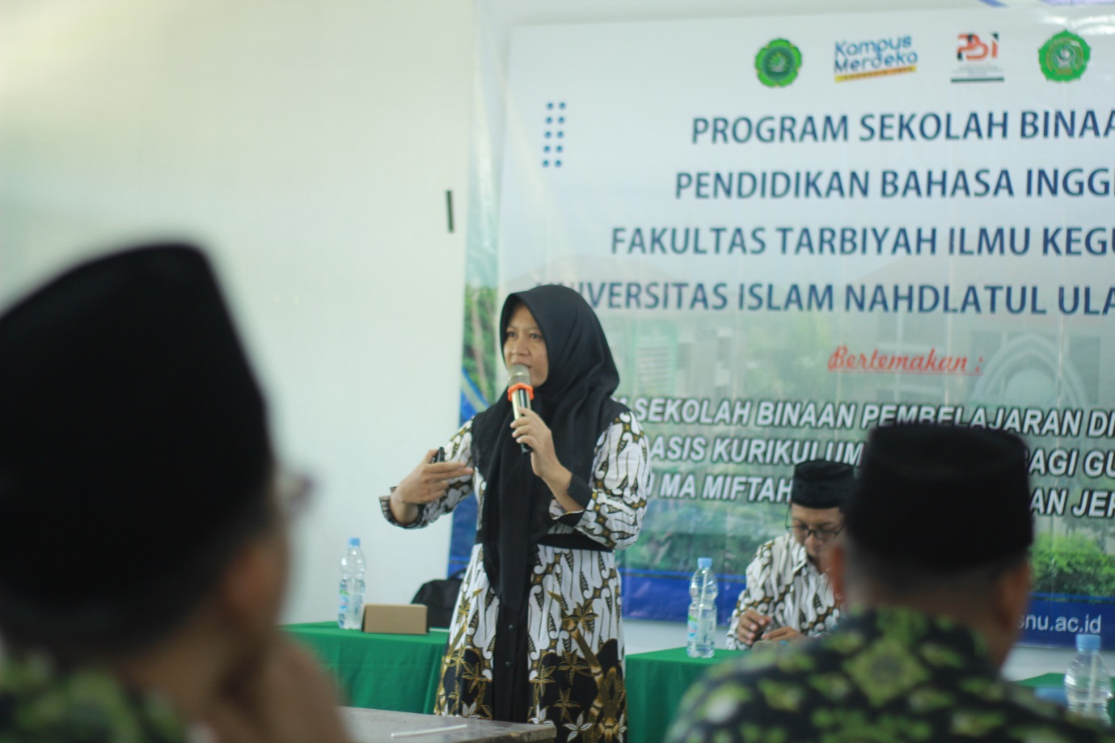

Fig 2. Olyvia Revalita Candraloka, English lecturer of Universitas Islam Nahdlatul Ulama (Unisnu) Jepara, explained differentiated instruction strategy

1. **Question and answer (Q&A)**

Lecturer service team as speaker accumulated questions from teachers as partners to answer. In this activity, it is expected that problems are solved in order to participants are able to continue activity stage to demonstration.

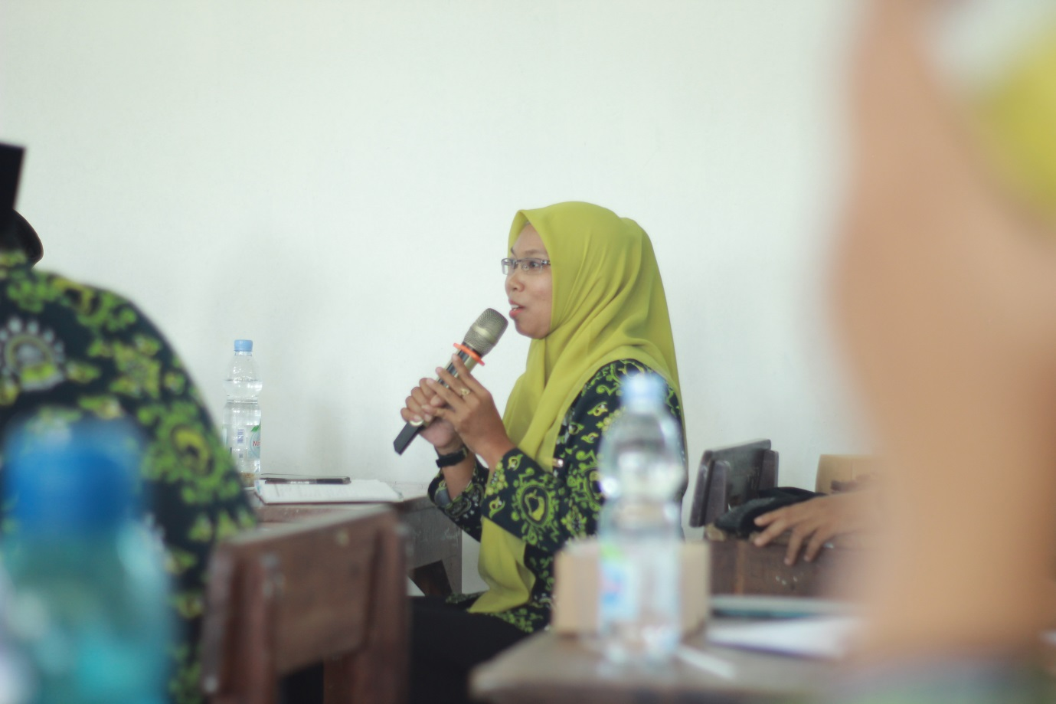

Fig 3 Question & Answer section activity

1. **Demonstration**

Teachers simulated differentiated instruction by communicating their idea using aid of visual either power point, flip chart, video, etc. Teachers concerned four ways to differentiate, namely content (students are allowed to do independent project that they interested it), product (assignment is given differently with the same learning expectation), process (learning process is given using different model mandating students to learn different experiences simultaneously as their journey of education), and environment (individual learning style situation is eager students to interact among them). In this part, lecturer community service team asked teacher to demonstrate two stay two stray as a strategy of differentiated instruction. There are 4 groups all together.

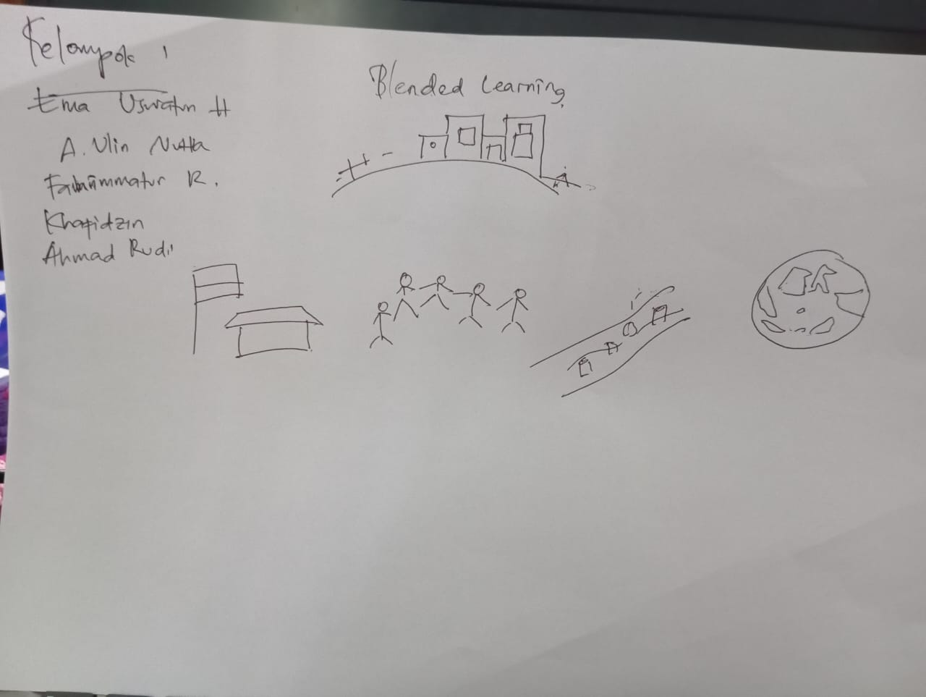

Fig 4 presentation design of two stay two stray strategy

Two stay two stray cooperative learning is the strategy to encourage active participants of using their language skills in reading, speaking, writing, and listening. The role of instructor is not only to lead classroom but also to control it. Groups are made randomly by establishing diverse relation of diverse skills and background knowledge to conduct this strategy. Two stay two stray strategy demands participants to be independent learners so that they have opportunity to peer tutoring among others. By this diversity determined by instructor, it will be easier to manage the class since participants cooperate to solve problems. The division of making group by numbers is:

Member number 1 acts as a leader in discussion of group who leads and ascertain members of group are able to complete a project given punctually.

Member number 2 acts as a note taker of meeting minutes during discussion.

Member number 3 acts to manage material source to analyze.

Member number 4 acts as reflector to control discussion and ascertain that all questions of certain topic discussed have been solved. In the end of discussion, this member reflects discussion which has been conducted and observes dynamic discussion.

1. **Discussion**

Discussion activity is part of evaluation to ascertain teachers gained knowledge, skill, and support to implement effective differentiated instruction. Community service team conducted assessment by rubric provided and questionnaire about training material, interaction and participation among them, Q&A, and feedback.

The activity result was successful as indicated by instrument rubric designed in bar chart below both material and instructor.

Fig 5. The result of the material provided accuracy

Evaluation is conducted through discussion and instrument to ascertain if the community-service activity is successful. Score percentage of gird instrument excellent of 72% and very good 21% from 11 criteria are formulated. The participants claimed that the material provided increases the level of skills and knowledge is 85% excellent and 15% very good, the training material is easy to understand and easy to apply in learning is 70% excellent and 30% very good, the material provided can meet the expectations and needs of the scope of work is 70% excellent and 30% very good. They also claimed the instructor provided is 85% excellent and 15% very good in mastering material, 90% excellent and 10% very good practically in training, 70% excellent and 30% in explaining using easy language, 85% excellent and 15% very good in accompanying participants during training process, 75% excellent and 25% very good intertwine of material and objective, 85% excellent and 15% very good in giving opportunity of asking and sharing during activity, 75% excellent and 25% very good in showing exemplary behavior, 75% excellent and 25% very good in answering participants’ question.

Fig 6. The result of instructor capability

In addition, the team of school-based community service also provided instrument of pre-test and post-test to ascertain participants’ enhancement during activity. The participants chose the correct answers provided to four options of each questions. There are questions provided to each pre-test and post-test to compare. The result of these tests increased after participants conducted the activity (see fig 7). The percentage indicates that average post-test score is 86 higher than average pre-test score of 49. It means that participants’ skill increased significantly shown by score.

Fig 7. Comparison score of pre-test and post-test

The questions given in pre-test and post-test were the same questions. Question number 1 which asked about differentiated instruction is the strategy used in classroom by individual needs to varied modes of instruction and assessment, and leading to higher quality classroom could answer correctly in post-test by 17 participants and pre-test by 10 participants. Question number 2 which asked how to make cooperative learning class to support differentiated instruction is teacher provides multiple texts and types of learning materials could answer correctly in post-test by 13 participants and pre-test by 11 participants. Question number 3 which asked example of differentiated instruction is jigsaw could answer correctly in post-test by 14 participants.

4. KESIMPULAN

Differentiated instruction is a learning strategy used by teacher to lead a class into higher quality classroom concerned with individual needs to varied modes of instruction and assessment. This material is socialized and trained due to lack of knowledge and lack of training. The result of school-based community service indicates that the activity was running well as illustrates from 11 criteria of the material and instructor provided was excellent scored by 72% participants and very good scored by 21% participants as evaluation. Besides, the average score of post-test indicates higher 86 than the average score of pre-test of 49. By fostering differentiated instruction by school-based community service, it contributes teachers’ professional development. Most teachers expected a sustainable mentoring program as the follow-up of school-based community digitally.

# DAFTAR PUSTAKA

Basri, R., Dongoran, P. H., Syafitri, D., Silaban, A. P., & Tanjung, I. F. (2022). Penerapan Model Pembelajaran Group Investigation untuk Meningkatkan Partisipasi Siswa SMA dalam Pembelajaran Biologi. *BIODIK: Jurnal Ilmiah Pendidikan Biologi, 8*(3), 141-148. doi:10.22437/bio.v8i3.19032

Bobi, C., & Ahiavi, M. (2023). Using Differentiated Instruction to Promote Creativity, Critical Thinking and Learning: Perspective of Teachers. *Journal of Education and Practice, 7*(2), 1-30.

Chaidi, I., & Drigas, A. (2022). Digital Learning: Differentiated Teaching Models using e-Twinning - I Communicate With My Neighbor Through Culture And Tradition: e - Twinning Project. *Technium Education and Humanities, 2*(3), 59-77. doi:10.47577/teh.v2i3.7392

Dryfoos, J., & Mauguire, S. (2019). *Inside Full-Service Community Schools.* New York: Simon and Schuster.

Dubé, F., Gareau, M., & Lanoix, S. (2023). Planning and Implementing Collaborative and Differentiated Instruction in Middle School. *International Conference the Future of Education 13th*, (pp. 1-4).

Dulfer, N., Kriewaldt, J., & McKernan, A. (2021). Using collaborative action research to enhance differentiated instruction. *International Journal of Inclusive Education*, 1-15. doi:10.1080/13603116.2021.1992678

Evendi, H., Rosida, Y., & Zularfan, D. (2023). Pembelajaran Berdiferensiasi dalam Pembelajaran Matematika di Kurikulum Merdeka SMPN 4 Kragilan. *Joong-Ki: Jurnal Pengabdian Masyarakat, 2*(2), 181-186. doi:10.56799/joongki.v2i2.1454

Geel, M. v., Keuning, T., & Safar, I. (2022). How teachers develop skills for implementing differentiated instruction:Helpful and hindering factors. *Teaching and Teacher Education: Leadership and Professional Development, 1*, 1-10. doi:10.1016/j.tatelp.2022.100007

Gheyssens, E., Coubergs, C., Griful-Freixenet, J., Engels, N., & Struyven, K. (2022). Differentiated instruction: the diversity of teachers’ philosophy and praxis to adapt teaching to students’ interests, readiness and learning profiles. *International Journal of Inclusive Education, 26*(14), 1383-1400. doi:10.1080/13603116.2020.1812739

Hadi, A., Marniati, Ngindana, R., Kurdi, M. S., & Fauziah. (2023). New Paradigm of Merdeka Belajar Curriculum in Schools. *Al-Ishlah: Jurnal Pendidikan, 15*(2), 1497-1510. doi: 10.35445/alishlah.v15i2.3126

Hadiprayitno, G., Kusmiyati, L. A., Lukitasari, M., & Sukri, A. (2021). Blended Learning Station-Rotation Model: Does it Impact on Preservice Teachers' Scientific Literacy? *Jurnal Penelitian Pendidikan IPA (JPPIPA), 7*(3), 317-324. doi:10.29303/jppipa.v7i3.676

Hasanah, E., Suyatno, Maryani, I., Badar, M. I., Fitria, Y., & Patmasari, L. (2022). Conceptual Model of Differentiated-Instruction (DI) Based on Teachers' Experiences in Indonesia. *12*(10), 650. doi:10.3390/educsci12100650

Hasibuan, N. A., & Hasibuan, A. L. (2023). DEVELOPING STRATEGY BY USING RECIPROCAL QUESTIONING (REQUEST) STRATEGY AS A STRATEGY IN TEACHING READING COMPREHENSION FOR GRADE VIII STUDENTS OF SMPN 3 HALONGONAN TIMUR. *Jurnal Review Pendidikan dan Pengajaran (JRPP), 6*(2), 85-90. doi:10.31004/jrpp.v6i2.17680

Iskandar, S., Rosmana, P. S., Fatimah, A. Z., Fitriani, D., Laksita, E. C., & Ramanda, N. (2023). Problematika Penerapan Kurikulum Merdeka di Sekolah Dasar. *Innovative: Journal Of Social Science Research* , 1594-1602. doi:10.31004/innovative.v3i2.466

Jayanti, M. I., Umar, Nurdiniawati, & Amar, K. (2022). PEMBELAJARAN BERDIFERENSIASI DALAM PERSPEKTIF RICHARD I. ARENDS DAN KILCHER : KONSEP, STRATEGI, DAN OPTIMALISASI POTENSI BELAJAR SISWA. *El-Muhbib, 6*(2), 91-108. doi:10.52266/el-muhbib.v6i2.1215

Jupri, Mismardiana, Muslim, & Haerazi. (2022). Teaching English Using Two Stay Two Stray in Improving Students' English Speaking Skills Integrated with Foreign Language Anxiety. *Journal of Language and Literature Studies (JOLLS), 2*(1), 33-42. doi:10.36312/jolls.v2i1.719

Khanna, P., & Bhola, S. (2023). Designing Integrative and Collaborative Learning for Students with Special Needs and Learning Disabilities in an Inclusive Classroom. In *Sustainable Blended Learning in STEM Education for Students with Additional Needs* (pp. 173-194). Singapore : Springer Nature Singapore.

Kupers, E., D, B. A., Bakker, A., Jong, F. D., & Minnaert, A. (2023). Explaining teachers’ behavioural intentions towards differentiated instruction for inclusion: using the theory of planned behavior and the self-determination theory. *European Journal of Special Needs Education*, 1-10. doi:10.1080/08856257.2023.2263717

Melesse, T., & Belay, S. (2022). Differentiating instruction in primary and middle schools: Does variation in students’ learning attributes matter? *Teacher Education & Development, 9*(1), 2105552. doi:10.1080/2331186X.2022.2105552

Musriza, D., & Elismawati, A.-A. H. (2021). JIGSAW METHOD IN ENGLISH TEACHING AND LEARNING. *Journal Cerdas Mahasiswa, 3*(2), 254-260. doi:10.15548/jcm.v3i2.3522

Onyishi, C. N., & Sefotho, M. M. (2020). Teacher's Perspective on the Use of Differentiated Instruction in Inclusive Classrooms: Implication for Teacher Education. *International Journal of Higher Education, 9*(6), 136-150. doi:10.5430/ijhe.v9n6p136

Pranata, M. S., Susanti, R. A., & Jannah, Q. (2021). The Effectiveness of Ic Breaking to Increase Students' Motivation in Learning English. *IJoEEL: International Journal of English Education, 3*(1), 31-38.

Ria, T. N., & Kurniawati, L. (2023). PELATIHAN PEMBELAJARAN BERDIFERENSIASI BAGI GURU-GURU SMPN 4 DEMAK. *Jurnal Awam, 3*(1), 13-18.

Riska Sari, T. S. (2023). THE EFFECT OF NUMBERED HEADS TOGETHER (NHT) COOPERATIVE LEARNING MODEL AND LEARNING INTEREST ON STUDENT LEARNING OUTCOMES IN ECONOMICS SUBJECT AT SMAN 11 WAJO, TAKKALALLA DISTRICT, WAJO DISTRICT. *Jurnal Eduscience, 10*(1), 87-103. doi:10.36987/jes.v10i1.3874

Rosdiana, A., Widiyono, A., Milkhaturrohman, & Lailiyah, N. N. (2023). Upaya Menulis Kreatif Bagi Guru dalam Gerakan Literasi Guru Menulis (GLGM). *BUDIMAS : JURNAL PENGABDIAN MASYARAKAT, 5*(2), 1-10. doi:10.29040/budimas.v5i2.7880

Shareefa, M., Moosa, V., & Rohani Matzin, N. Z. (2021). Facilitating differentiated instruction in a multi-grade setting: the case of a small school. *1*(5), 127. doi:10.1016/j.tatelp.2022.100007

Suryati, I., Ratih, K., & Maryadi. (2023). TEACHERS’ CHALLENGES IN IMPLEMENTING DIFFERENTIATED INSTRUCTION IN TEACHING ENGLISH AT ONE OF WEST JAVA JUNIOR HIGH SCHOOL. *Eduvest: Journal of Universal Studies, 3*(9), 1693-1708.

Tomlinson, C. A. (2017). Differentiated Instruction. In *Fundamentals of Gifted Education* (p. 14). UK: Routledge.

Tomlinson, C. A., & Imbeau, M. B. (2023). *Leading and Managing a Differentiated Classroom 2nd Ed.* USA: ASCD.

Tursunboevna, N. Z. (2022). VARIOUS EXAMPLES OF DIFFERENTIATED INSTRUCTION IN THE CLASSROOM, ADVANTAGES AND DISADVANTAGES OF DIFFERENTIATED INSTRUCTION. *Eurasian Journal of Academic Research, 2*(12), 315-318. doi:10.5281/zenodo.7439835

Utami, A. A., Prastiningsih, D., & Toyyibah. (2023). Profile of Student Learning Outcomes on Learninh Differentiated on Virus Concepts. *Biodidaktika: Jurnal Biologi dan Pembelajarannya, 18*(2), 65-71. doi:10.30870/biodidaktika.v18i2.19721

Wattanawongwan, S., Smith, S. D., & Vanest, K. J. (2021). Cooperative Learning Strategies for Building Relationship Skills in Students With Emotional and Behavioral Disorders. *Sage Journals, 30*(1), 32-40. doi:10.1177/1074295621997599

Zulfa, L., Safari, R. A., Damayanti, A. N., & Setiawaty, R. (2022). Analisis Model Pembelajaran Kooperatif Tipe Think Pair Share dalam Meningkatkan Kerjasama dan Hasil Belajar Siswa Systematic Literature Review. *Seminar Nasional II LPPM UMMAT 2023.* *1*, pp. 705-719. Mataram: Universitas Muhammadiyah Mataram.