DESIGN INNOVATION IN ADVERTISING OF CAKRAWALA SPARKLING NATURE RESTAURANT AS ENTREPRENEURSHIP
CREATIVITY FOR CUSTOMERS’ SATISFACTION

Dewi Untari¹, Lia Kurniawati², Muhamammad Irsyad Raspati³
Universitas Mandiri
Email: dew11untari@gmail.com¹ , liakurniawati@universitasmandiri.ac.id² , musadrapati@gmail.com³

ABSTRACT

Culinary Business continue to grow significantly. The growth can be seen in the emerging of cafes, restaurants, diners, and other eateries. One of many culinary business in Bandung is Cakrawala Sparkling Nature Restaurant. This restaurant is not only a place for dining but also a place for selfies due to instagrammable place design, that innovatively attract customers. Methods used this research is quantitative research that is data gathering through google observation, documentation, and library research. This research method will produce statistic of 100 google review’s writers by using simple random sampling in the form of bar diagram. The purpose of this research is to analyze the positive impact of interior innovation as entrepreneur’s creativity to attract customers. The building is located in highland area of Punclut, therefore customers can witness the beautiful panorama of Bandung City. The restaurant’s design is so unique as to adopt modern style architecture with skyline concept in every corner, such as rainbows with colorful glass wall that can reflect lights and also galaxy like design where the sunlight will penetrate Atlantis buildings that produce dining under the ocean sensations, with auroras, sun, equator, savanas, rainbow alley, and castle gateway. Every corner area has unique and interesting concept, therefore customers can have instagrammable spot to take selfies. Analysis resulting in positive impact of interior innovations in attracting customers. This means the better the interior design the better the customer’s interest in visiting the restaurant. The conclusion of this research can be used by entrepreneurs as innovation reference in culinary business and design in the purpose of creating customers’ satisfaction.

Keywords : Design, Customers, Instagrammable, Business Innovation

PREFACE
Bandung is one of the cities that has become the destination for culinary leisure. Bandung offers variety of unique atmosphere as it’s strong values. Not only for people from out of the city, it’s own citizen also eager to not being left out from anything newest this city has to offer. This condition thus makes restaurant businesses in Bandung competes to attract attention from their customers by designing and offering unique space themes that can differentiate themselves from their competitors Mahendra (2020).
Cakrawala Sparkling Nature Restaurant is located in Jl. Pagermaneuh No. 57, Pagerwangi, Kec. Lembang, Kabupaten Bandung Barat, Jawa Barat. Thanks to so many positive specials that they are offering, and also the beauty of the location in the highlands of Lembang, Cakrawala Sparkling Nature Restaurant has become recommended eatery with beautiful view in Bandung. In here, customers can enjoy the charm of exotic Bandung with all it’s beauties. The building of Cakrawala Sparkling Nature Restaurant appears to be tall with levels of floors, adding to the castle-like design. From afar it will be appeared as an echanting palace from fairytales. It’s very interesting to visit fpr sure, because we rarely met restaurants that is built in similar concept. Not only it’s building, the veriety of menus available will surely be fascinating.

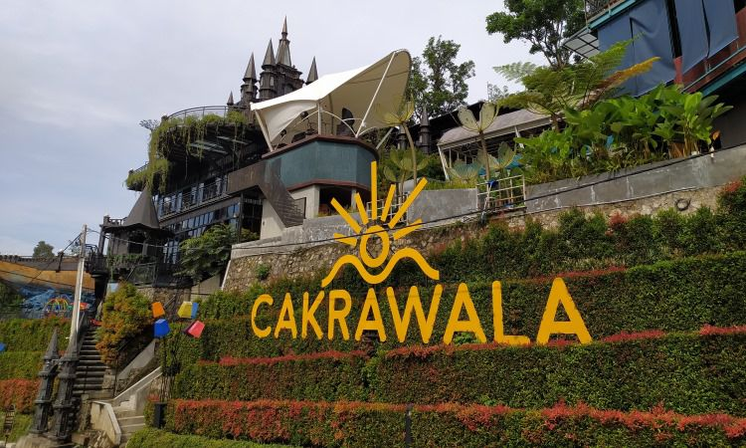
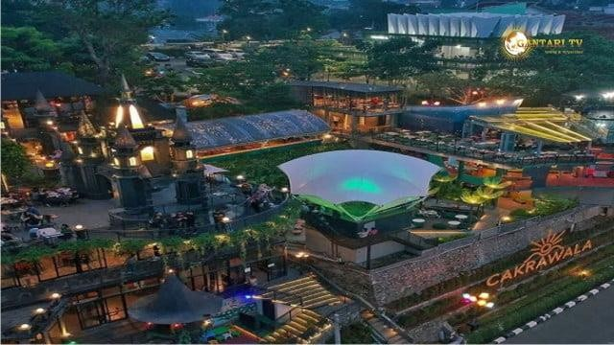

Picture 1 Persperctive Cakrawala Sparkling Nature Restaurant

This research is based on 3 previous research entitled “The Effect of Interior Design to the Customer’s Interest in The Gardern Pantai Indah Kapuk Restaurant”, which analyze and discussing the customer’s interests in interior design. This research was using qusntitative method which collected 130 respondents, processed using SPSS resulting significant values for interior design variable of 0.000 which value is <0.05, with coefficient value of 0.440. This meant that interior design had positive and significant impact to customer’s interest. Therefore the first hypothesis is accepted (Juliana, 2018). The next research is “The Perception of Space in Interior in Donwoori Restaurant Bandung”. The success in implementing Korean Drama Theme apllied using background concept approach that supporting scenes from Korean Drama. The purpose of using this theme is to bring the customers to feel the atmosphere of Korea as shown in the TV series, that is viewed by many teenagers in Indonesia, particularly in Bandung. Mahendra (2020). The last and final references is “Creativity and Innovation has the Effect on Small Scale Business and Entrepreneurship”. The result of this research is coefficient regression and innovation of 0.675, greater than coefficient regression and creativity of 0.267. This indicates that variable of innovation has greater effect to entrepreneurship.
Research Object of this research is the design of Cakrawala Sparkling Nature Restaurant, that is famous for it’s culinary products. This restaurant attracts the customers due to it’s interior and exterior design, the use of material that is instagrammable. The purpose of this research is to analyze the positive impact of interior design to customer’s interest. The design of this restaurants is very unique, because it is adopting modern architecture therefore attracting customers’ interest in dining and enjoying the foods while enjoying Bandung city atmosphere.

Definition of Entrepreneurship.
In general the position of entrepreneur is to place themselves in risks of turbulences in the companies they built. Yaghoobi, Salarzehi, Aramesh, and Akbari (2010) stated that entrepreneur is someone who brave enough to open productive independent activity. Entreprenur took his own financial risks or other’s financial risks that bestowed upon them to start a business venture. He also took the risk of being failed in the venture. On the contrary, managers are more motivated by the goals that the must pursue and the compensation in it (salary and othe benefits). A manager will not tolerate uncertain confusing things, and will not be risk oriented compared to entrepreneur. Manager will be more likely choose salary and safe position in their job. Hadiyati (2011).

Definition of Innovation
A very important character of entrepreneurs is their ability to innovate. Without innovation a company will be unable to sustain. Larsen, P and Lewis, A. (2007). The changes of needs, wants, and customer’s demands is the cause of a company’s constant need for innovation. Customers will not be consuming or using the same products forever. Customers will search for another products from another company that can fullfill their needs. Therefore constant innovation is needed to ensure the company’s sustainability. Innovation is directly related to products, services, or ideas that is new for certain people. Even if an idea is not a new idea, but it can be seen as an innovation for people who see it or understand it for the first time.
Creativity is an initiative related to products or processes that is useful, righteous, exact, and valuable. Creativity is against any tasks that is heuristic that is something that acts as an incomplete guidance, clues, or example that will lead us to understand, to learn, and to find something new. The attributes of creative people are: open for experience, see anything in a different way, persistence, accepting and reconciliate somethings that are contradictive. It is also tolerance towards ambiguous matters, independent in decision making, thinking, and acting, in constant need for autonomy, self confidence, not becoming subject of standardsand group control, willing to take necessary calculated risks, persistence, sensitive towards issues, good ability in generalize ideas, originally flexible, responsive towards feelings, open for unclear phenomenas, motivation, free from fear of failure, thinking in imagination, selective. Hadiyati (2011).
The interior of a building is formed by architecture elements of the structure that consist of columns, walls, floors, and roofs. Those elements are the ones that shape a building, separate it from the outside space, and forming the pattern of interior management. According to Ching (2014), the design of interior space is heavily connected with the space and human dimension. The space dimension includes shapes, scales, and space proportions. Space dimension limits the physical aspect for space layouts, while the type of spaces influence the design of interior space which are structural and functional. Structural dimension or static includes the measurement of body anatomy in standard position. Functional dimension or dynamic includes measurements in work position or through movements.
Restaurants is derived from the Latin word restaurate, in English means a public eating place, which is house for dining or public dining place. Restaurant is a place or building that is commercially organized, which held good services to all guests in the form of dining or drinking. Based on those definitions, we can conclude that the meaning of restaurant is a business place or building that provides foods and beverages that is commercially managed by giving good services to all customers. According to Prasetyo (2016), the cozy atmosphere created by interior design can give special experiences for guests, and when the guests are at their homes, they will share their experience with others.

Customer’s Satisfaction
The word “Instagrammable” is actually a combination of two words, “Instagram” and “able”. Each word has it’s own meaning. “Instagram” means an application and “able” means “can”, capable, and “has the ability”. When those two words are combined, the Instagrammable means something that is good enough to be shared to Instagram profile in the form of pictures or videos. Therefore the word Instagrammable is related to a sitation, products, or places that is worthy of being immortalized and shared in Instagram. Fro example the picture of museum that is currently popular amongst teenagers or a dining place that has it’s own uniqueness. Something that is unique, new, hits, cool, luxurious, creative, upadated, etc. that can make good contents for the Intsagram accounts that is actively increasing it’s brand. According to Bambang, is a smartphone application that is specifically created as a social media that is one of the digital medias that has similar function to twitter, with the differentiation of the ise of pictures of products or places to be shared. Instagram can also become source of inspiration and thus ignite creativity, because instagram has features that can make pictures look more beautiful, mor artistic, and better. Atmko (2012:10).

RESEARCH METHODS

This research is using quantitative method in analyzing the data. Numeric data is presented in bar diagram. Sample is gathered using simple random sampling method in 100 google reviews. Simple random sampling is sample gathering technique that is directly conducted in sampling units. The result then will be summed and divided in percentage in five categories: VERY SATISFIED, SATISFIED, MODERATELY SATISFIED, LESS SATISFIED, and NOT SATISFIED, and then presented in bar diagrams.
Data required in this research is collected in several method: Sekaran and Bougie (2016), (1) Observation, is a method that is used to describe an individual in a systematic and non systematic way. (2) Library research, is conducted to gather secondary data. In this research, library research is conducted through book sources, journals, etc. (3) Documentation of places and interiors as research pictures.

RESULTS AND DISCUSSIONS
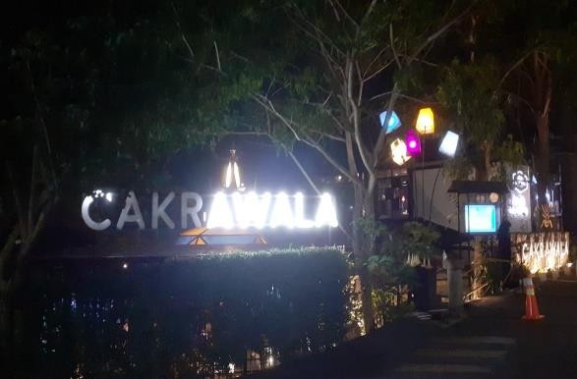  Picture 2 Entrance Gate to Cakrawala Sparkling Nature Restaurant | This picture is the picture of entrance gate to Cakrawala Sparkling Nature Restaurant, whose meaning is interior of innovation of Cakrawala that means Dawn, Sky Foot, or horizon, the line that separate earth and sky. To be more exact, dawn is the line that separate our line of views: the surface of the earth , and the ones above it. Suitable to it’s name the design describe the condition of the sky that consist of rainbows, stars, galaxy, and equator.
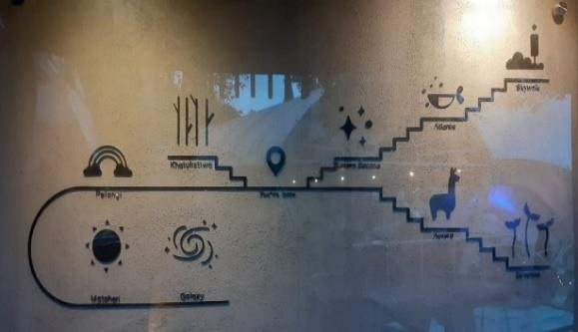  Picture 3 Maps of Cakrawala Sparkling Nature Retaurant | Maps of Cakrawala Sparkling Nature Restaurant area with symbols of icons in every area. This confirms that this area is using Cakrawala concept in every corner of it’s area. Utilizing it’s contoured land this place is worthy to visit.
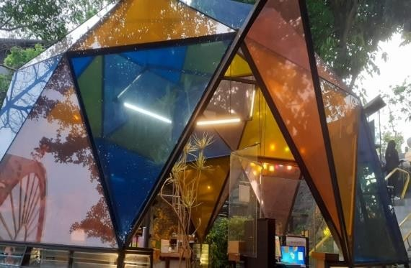  Picture 4 Entrance Cakrawala Sparkling Nature Retaurant | At the entrance door we can see a unique hexagonal transparent rainbow like design, with black frame aluminum materials, and transparent blue acrylic glasses. The color of orange and yellow give the impression of reflection inside the room like reflecting rainbow.
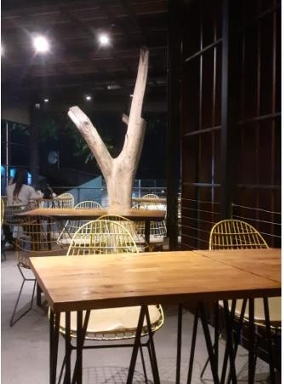  Picture 5 Equator | In this L shape equtor line like area located in the middle of the contour using vertical wooden material with brown and black interior and wooden desk and chair give modern impression adding to the view of Bandung City
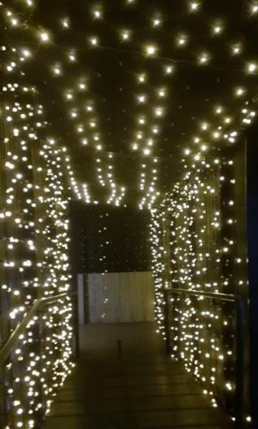  Picture 6 Star Alley Area | Before entering the ouside earth area, customers will walk through the alley of stars that has black background, and filled with yellow lights. Customers can take selfies in this alley that will give the atmosphere of space.
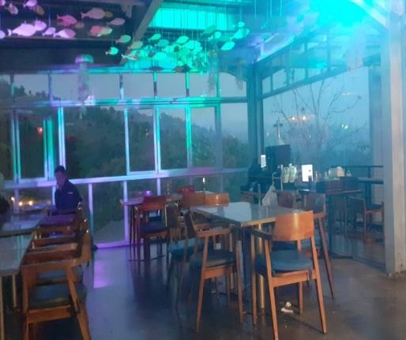  Picture 7 Ocean Area | Escaping the alley of star the customers will be entertained by the decoration of hanging fishes and sea shells. There are outdoor and indoor instagrammable area. At night the interior lights will be blue and purple and uniquely on glass roof there are water flowing like underwater. At outdoor area there is leisure place with Bandung City view. Indoor area is using chair and desk with glass material which makes it easy for customers to enjoy outside view.
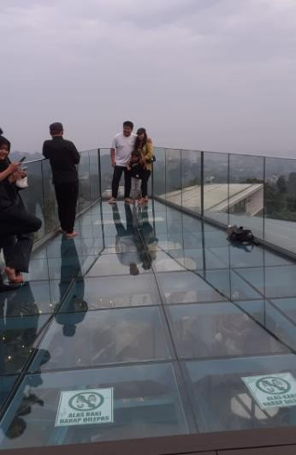  Picture 8 Skywalk Area | In this picture, we can see the top level area with floor and railing made from glass in the shape of triangle like boats. They have cameres placed in this area to be used to capture Bandung view at night.
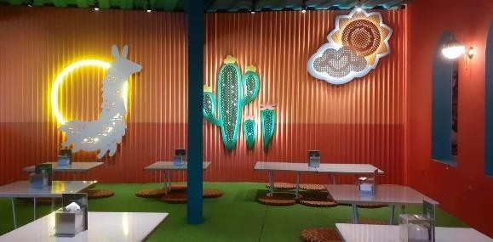  Picture 9 Aurora Area | This picture is one of the most favorite area of the customers especially women due to it’s feminism concept. Pastel color paint of pink, green, purple, and orange are the color of aurora area. Instagrammable interior with aluminum and woods material and also cloud decoration with lamp lighting. This place is divided into two parts, one for kids and the other for teenagers.
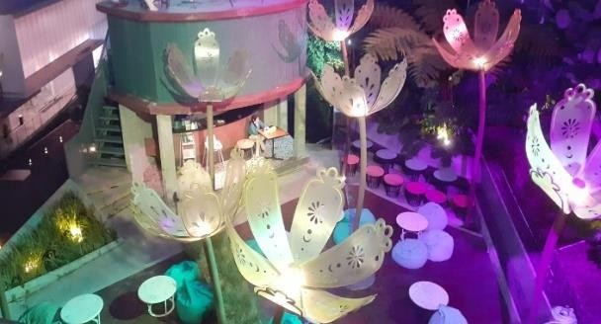  Picture 10 Park Area | This is the picture of the inside of Cakrawala Sparkling Nature Restaurant. There are so many open areas, and one of them is park area located at the center of the area. This park is filled with lamp decoration in the shape of flower and shine at night. With square layout the sitting area is made like café bar.
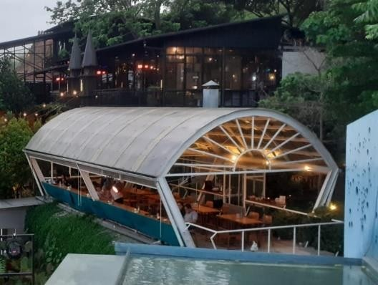  Picture 11 Sun Area | This picture is one of the most iconic area inside Cakrawala Sparkling Nature Restaurant. This area has glass material dining area and fiber transparent roof and also wooden desk and chair. The building is shaped like cylinder, half circle roof with lines like sun shine.
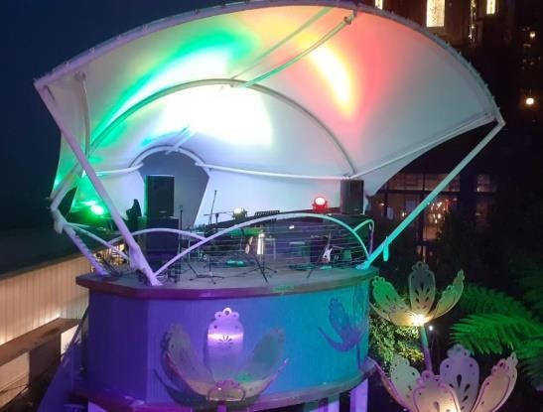  Picture 12 Galaxy Stage | This picture is the last spot, showing sthe stage that looks like galaxy used as main area to watch live music performance, The shape of the roof is like membrane shells.

In this method of analysis, 100 sample is drawn using simple random sampling from google reviews of people who love Cakrawala Sparkling Nature Restaurant, using Bar Diagram.

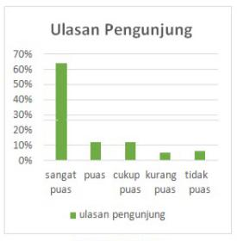

Bar Diagram

From the Bar Diagramm we can conclude that 100 simple random sample of google reviews in five categories we get 64% very satisfied, 13% satisfied, 12% moderately satisfied, 5% less satisfied, and 6% not satisfied. Most of the customers are satisfied with the interior of Cakrawala Sparkling Nature Restaurant wuth all of variety of designs from the nine areas with Cakrawala design.

SUMMARY
Based on analysis result it is discovered that 64% customers are very satisfied and only 6% are dissatisfied. Therefore we can say that there is positive significant effect of interior design to the customers’ interest to Cakrawala Sparkling Nature Restaurant. It means that the better the interior design the higher the customers’ interest will be. Interior design has significant positive effect in customer satisfaction. The significance of this variable is due to the tendency of the customers to pay attention to design in restaurants. The beautiful and relevant design that matched with beautiful views will have significant impact in customer satisfaction.

BIBLIOGRAPHY

Abdi Patria, Syafei Narim. "Restoran." Artikel Bulan Oktober (2011) 2.10 (2011): 1-1.
Atmadi, Tunjung. "Kajian desain interior kantor PT. pupuk sriwidjaja dengan konsep modern minimalis." Narada 4.3 (2017): 303-313.
Atmoko, Bambang Dwi 2012 in Stagram Handbook. Jakarta: Media Kita
Ching, Francis DK. Arsitektur: Bentuk, ruang, dan keteraturan . John Wiley & Sons, 2014.
Hadiansyah, Mahendra Nur, and Alvin Sofyan Hendrawan. "Persepsi Ruang Pada Interior Restoran Donwoori Bandung." Waca Cipta Ruang 6.2 (2020): 42-50.
Hadiyati, Ernani. "Kreativitas dan inovasi berpengaruh terhadap kewirausahaan usaha kecil." Jurnal Manajemen dan kewirausahaan 13.1 (2011): 8-16.
Hidayat, Wahyu, Fauzi Maafuf, and Saeful Bahari. "Perancangan Media Video Desain Interior Sebagai Salah Satu Penunjang Promosi Dan Informasi Di PT. Wans Desain Group." Journal Cerita 2.1 (2016): 35-49.
Juliana, Juliana, Agatha Nirmala, and Felicia Felicia. "Pengaruh Desain Interior Terhadap Minat Pengunjung Di Restoran The Garden Pantai Indah Kapuk." Cakrawala- Jurnal Humaniora 20.1 (2020): 28-34.
Larsen, P. & A. Lewis. 2007. “How Award Winning SMEs Manage The Barriers to Innovation”, Journal Creativity and Innovation Management, page: 141-151.
Prasetyo, S. A. (2016). Kajian desain interior restoran piazza Italia dan brandi pizzeria di Surabaya. Jurnal Intra, 4(1), 7–15.
Putra, Albertus Adi, Adi Santosa, and Poppy Firtatwentyna Nilasari. "Kajian Perbandingan Kenyamanan Ruang Desain Interior Kafe yang Instagramable di Surabaya (Studi Kasus: Carpentier Kitchen dan Threelogy Coffee)." Intra 7.2 (2019): 933-941.
Sekaran, U. dan R. B. (2016). Research Methods for Business. In Edisi Ketujuh. United Kingdom: John Wiley & Sons.
Tjiptono, Fandy. 2014. Strategi Pemasaran Edisi 4. Yogyakarta. Andi.
Yaghoobi, Salarzehi, Aramesh & Akbari, 2010, “An Evaluationaf Independent Entrepreneurship Obstacles in Industrial SME”, European Journal of Social Sciences, pp.33-45.

