UTILIZATION OF DIGITAL APPLICATIONS AS AN EFFORT TO COLLECT APPROPRIATE FINANCIAL STATEMENTS

WITH STANDARDS IN SMALL MICRO BUSINESS

AND MEDIUM IN THE CITY OF DENPASAR

**I Nyoman Sutapa1 , Ni Luh Putu Mita Miati2 ,** **A.A. Pt. Agung Mirah Purnama Sari3 , Ni Putu Riski Martini4**

Warmadewa University1,2,3,4

*E-mail: sutapanym@gmail.com*

**Abstract:**Micro, Small, and Medium Enterprises, hereinafter abbreviated as UMKM in Indonesia, are an important pillar of the economy in Indonesia. One of the principles of empowering UMKM is the realization of transparent, accountable, and fair public policies. However, there are still many UMKM that do not have financial records. Several researchers have researched the phenomenon of recording UMKM financial statements and researchers use these results to develop a research model by trying to explain the use of digital applications as a moderating variable. The purpose of this study was to examine the effect of financial management ability and accounting understanding on the preparation of financial statements according to standards. This study also examines the use of digital applications as a moderating variable. This research method uses the Partial Last square (PLS) model to test the effect of one variable on another with a population of 97,277 UMKM and a sample of 100 respondents is taken. The results of this study state that only the use of digital applications has a positive effect on the preparation of financial statements according to STANDARD AKUNTANSI KEUANGAN UMKM standards, while the digital application variable as a moderator cannot strengthen or weaken the interaction of the independent variables of financial management ability and accounting understanding.

***Keywords:*** *financial management skills, accounting understanding, digital applications, Financial Statements*

# Introduction

The economy in Indonesia is inseparable from Micro, Small, and Medium Enterprises or often shortened to MSMEs. MSMEs are an important pillar in the economy in Indonesia as quoted from the Coordinating Ministry for Economic Affairs of the Republic of Indonesia in press release number HM.4.6/103/SET. M.EKON.3/05/2021 on May 5, 2021, Based on data from the Ministry of Cooperatives and SMEs, the number of MSMEs currently reaches 64.2 million with a contribution to GDP of 61.07% or worth 8,573.89 trillion rupiah. The contribution of MSMEs to the Indonesian economy includes the ability to absorb 97% of the total existing workforce and can collect up to 60.4% of the total investment (Limanseto 2021). MsMEs in BALI Province are no exception, most of whose MSMEs are in Denpasar City, which amounts to 32,000 MSMEs (Bank Data Kota Denpasar 2020)

MSMEs have the goal of growing and developing their businesses to build a national economy based on an equitable economic democracy. One of the principles of MSME empowerment is the realization of transparent, accountable, and fair public policies by the Law of the Republic of Indonesia NUMBER 20 OF 2008 concerning Micro, Small, and Medium Enterprises (Undang Undang Republik Indonesia 2008). To realize transparency, accountability, and equitable MSMEs need to carry out financial records and financial reporting by generally accepted standards.

Financial Statements by standards are useful for MSMEs to find out information about the financial position, financial performance, changes in capital, and knowing the value of changes in cash and distribution (Mandey, Saerang, and Pusung 2018). Other reasons are business planning, Can know the financial position every month, Easy in controlling costs, Easy getting a Loan from the Bank, and calculating the taxes to be paid (Sarah 2021). MSMEs that have good records are one requirement if they want to upgrade as stated by Senior Deputy Governor of Bank Indonesia (BI) Destry Damayanti on Wednesday 10-11-2021 financial recording accountability makes it easier for MSME actors to get funding from banks.

Financial Statement Standards for MSMEs are regulated by the Indonesian Institute of Accountants in the Financial Accounting Standards of Micro, Small, and Medium Entities abbreviated as Financial Accounting Standards EMKM. Financial Accounting Standards EMKM is effective as of January 1, 2018 (STANDARD AKUNTANSI KEUANGAN EMKM 2018) This standard is intended for use by entities that are not or have not been able to meet the accounting requirements set out in the Financial Accounting Standards of Entities Without Public Accountability. Financial Accounting Standards EMKM contains accounting regulations that are simpler than the Financial Accounting Standards of Entities Without Public Accountability purely using history, with the existence of Financial Accounting Standards is expected to make it easier for MSMEs to prepare financial statements and as an effort to support the progress of the Indonesian economy. To make it easier to implement Financial Statements by standards in this digital era, there are digital applications that can help in the recording which are already widely available ranging from free to paid.

The use of this digital application is under the direction of the Senior Deputy Governor of Bank Indonesia (BI) Destry Damayanti encourages MSME players to take advantage of digital bookkeeping applications, because according to data from the Ministry of Cooperatives and Small and Medium Enterprises, as many as 23 million MSME actors in Indonesia do not have access to funding from banks. (Atmoko and situmorang 2021) Using this digital application is expected to help prepare financial reports so that MSMEs have financial recording accountability which makes it easier for MSME actors later to get banking funding. In general, there are several benefits offered by the use of digital finance applications, namely saving time and effort, creating a more efficient accounting system, better management of debt and receivables recording, minimizing the risk of technical errors in recording transactions, and organizing transaction data.

Although there are many benefits obtained when MSMEs record financial statements according to standards, there are still several obstacles, including human resources (HR) in finance, competence level, time, and costs. (Mandey, Saerang, and Pusung 2018). Based on a natural survey of the Ibu Berbagi Bijak program, MSME players who registered admitted that funding and marketing were the two main obstacles in developing their business, 65.7% admitted that they did not have a good financial record, and 83.7% relied more on personal funds to finance their business than getting loans from banks (12.7%), relatives (3%), or investors (0.6%) (sari 2021).

Several previous researchers have conducted studies on this phenomenon, including: (Risal and Kristiawati 2020), (Kusumawardhany 2020), (Mahardika, Agatha Gema; Pramiudi, Udi; Fahmi 2019), (Made Dwi Harisma Dewi and Ni Wayan Yuniasih 2020), (Yenni 2017), (Wiraputra, Sinarwati, and Herawati 2014), which examines the influence of education levels, understanding of accounting reports, and business scale. From the results of previous studies, it can be described how far research on this phenomenon has been studied so that the author will try to complete it.

Based on previous research studies, it can be seen that the ability of financial management can improve MSMEs in preparing financial reports that are by standards. With good financial management capabilities, companies need financial statements that are by standards so that financial statements can be used as the basis for financial management. Preparation of financial statements by the standard which refers to accounting standards, with the increase in accounting capabilities owned, will also improve financial statements by generally accepted accounting standards. The use of digital can make it easier for users to prepare financial reports by making special applications so that financial management capabilities and accounting capabilities coupled with the support of digital applications can make financial statements more by generally accepted standards, in this case, Financial Accounting Standards EMKM.

Based on the description of the background above, the researcher formulates the formulation of the problem in the form of questions as follows; What is the level of preparation of MSME financial statements in Denpasar City? Does the ability to manage finance have a significant effect on the preparation of financial statements that are by the standards for MSMEs in Denpasar City? Does accounting understanding have a significant effect on the preparation of financial statements that are by the standards for MSMEs in Denpasar City? Does the use of digital applications strengthen the influence of financial management capabilities on the preparation of financial reports that are by the standards for MSMEs in Denpasar City? Does the use of digital applications strengthen the influence of accounting understanding on the preparation of financial statements that are by the standards for MSMEs in Denpasar City?

Stakeholder theory is the basis used in understanding the company's business practices, including MSMEs. This theory views the relationship/correlation between interested parties that influence each other in the company. According to Freeman (2018), stakeholder theory is any group or individual who can affect or is affected by the achievement of the organization's objectives. Meanwhile, Huang and Kung (2010) stated that stakeholder theory is an activity carried out by a company influenced by individual / group interests. This theory states how shareholders and managers create value. Associated with this research, stakeholder theory is very appropriate in explaining the function of financial statements in MSMEs as a source of accounting information. Stakeholders have the right to obtain information related to company activities carried out by management. The stronger the stakeholder relationship, the better the company's business will be. Without the support of interested parties, the company cannot develop continuously. For this reason, accounting information is needed in the company as a solution to instilling trust in interested parties so that a good relationship is established between the company's management and interested parties. Sufficient accounting information regarding past and future changes and the emergence of problems and problems are very important for the company's planning process and decision-making. Based on the background description of the problem, the researcher formulates the hypothesis as follows

H1: Financial management ability has a significant positive effect on the preparation of financial statements that are by standards

H2: Understanding accounting has a significant positive effect on the preparation of financial statements that are by standards

H3: The use of digital applications strengthens the influence of accounting understanding on the preparation of financial statements by standards

H4: The use of digital applications strengthens the influence of financial management capabilities on the preparation of financial statements that are by standards

# Research Method

The data collection method in this study is a questionnaire collection technique which is divided into 2 (two) main parts, namely: data on the general description of the preparation of MSME financial statements in Denpasar City. The data in this study are primary data obtained by distributing questionnaires. The population in this study is MSMEs in Denpasar regency as many as 97,277 (Badan Pusat Statistik Bali 2019). The number of samples in this study refers to the results of research from Gay, LR, and Diehl, PL (1992) which said the study is correlation or related, then the sample size is at least 30 sample unit subjects, then in this study will take a sample of 100 respondents by dividing the sampling equally based on the number of sub-districts in Denpasar City. The following is presented a table of the division of the number of samples based on the sub-districts in Denpasar City.

**Table 1**

**Number of Samples Based on Subdistricts in Denpasar City**

|  |  |
| --- | --- |
| **District** | **Number of Samples** |
| Denpasar Barat | 25 Responden |
| Denpasar Selatan | 25 Responden |
| Denpasar Timur | 25 Responden |
| Denpasar Utara | 25 Responden |
| **Total Sample** | **100 Respondent** |

Source: Processed data, 2022.

The sampling technique used in this study uses random sampling, which is a way of selecting samples by taking sample members from a population that is carried out randomly without paying attention to the strata in a population. This method is done because members of the population are considered homogeneous (Sugiyono, 2017).

Definition of Variables Financial management ability in this study according to (Yusanti 2020) is a money management activity in daily life carried out by individuals or groups that have the aim of obtaining financial welfare. Based on this understanding, the indicators used to measure financial knowledge are as follows. Drawing up a financial draft for the future, Timely bill payment, Allowance for money for savings, Control of expenses costs, Obtaining financial well-being

The definition of accounting understanding variables is a person's mastery in understanding the accounting process until the preparation of financial statements. According to Financial Accounting Standards, the definition of accounting is a process of recording, classifying, summarizing, processing, and presenting data, transactions, and events related to finance so that it can be used by people who use it easily understood for decision-making and other purposes. To find out the understanding related to accounting, the following indicators are made: Proof of financial transactions and supporters have been archived or collected, Knowing the process of identifying evidence that has been archived in the Journal, Knowing all transactions need to be recorded and compiled into financial statements, Knowing financial information such as balance sheets, profit/loss statements, statements of changes in equity, and cash flow statements.

Definition of variables the preparation of financial statements by the standards of EMKM financial accounting standards is the preparation of financial statements by the standards of EMKM financial accounting standards, which consists of statements of financial position and income statements as well as notes to financial statements. Therefore, from this understanding, the indicators of this study are having prepared financial position reports by EMKM financial accounting standards, having prepared income statements by EMKM financial accounting standards, and having prepared records of financial statements by EMKM financial accounting standards.

Variable definition The use of digital applications is how MSMEs use this digital application for accounting records with indicators; has implemented applications for recording and presenting financial statements, Can data system management.

Data Analysis method using Partial Least Square (PLS). PLS data analysis generally consists of 2 parts, namely measurement models and structural models (Barclay et al., 1995) in Santosa (2018; 154). Hypothesis testing is tested with a p-value with the following conditions; Alternative hypothesis accepted p-value < 0.05.

# Results and Discussion

# Results

**Respondent Overview**

From the results of filling out the questionnaire, it can be described in general the respondents from their position, age, and education. Of the respondents' positions, most of them are direct owners, which is 20.2% while the rest are finance and management. Based on age, it can be seen that most of the 77.4% of respondents who answered were ages ranging from 20-30 years. Education Level Most undergraduates

**Validity and Reliability Test Results**

Based on the results of the data processing presented in table 2 with the SMART PLS 3 application, it can be concluded that the data is valid and reliable. Validity was tested by looking at the value of Cronbach's Alpha whose minimum value was 0.7 (George and Mallery. 2003) and reliability by looking at the square root of average variance extracted (AVE) value above 0.5. If the AVE tilapia is above 0.5 then the data is declared valid

**Table 2**

**Validity and Reliability Test Results**

|  |  |  |
| --- | --- | --- |
|  | Cronbach's Alpha | Average Variance Extracted (AVE) |
| Interaction (M*X1>Y) | 1.000 | 1.000 |
| Interaction (M*X2>Y) | 1.000 | 1.000 |
| Financial management capabilities (X1) | 0.740 | 0.556 |
| Understanding accounting (X2) | 0.955 | 0.917 |
| Utilization of digital applications (M) | 0.941 | 0.895 |
| Preparation of financial statements by EMKM financial accounting standards (Y) | 0.988 | 0.976 |

**Source: The data is processed. 2022**

**Hypothesis Test**

This study tests the hypothesis by looking at P Values from the bootstrapping results. The results of the data processing can be presented in table 3 P-Value values from several variable relationships can be included H1, H2, H3, and H4 are rejected because the P values are still above 0.05 but the variable utilization of digital applications P values < 0.05 which means it has a positive effect on the preparation of financial statements according to the standards of EMKM Financial Accounting Standards.

**Table 3**

**Test Results with PLS model**

|  |  |  |  |  |  |
| --- | --- | --- | --- | --- | --- |
|  | Original Sample (O) | Sample Mean (M) | Standard Deviation (STDEV) | T Statistics (|O/STDEV|) | P Values |
| Interaction (M*X1>Y) -> Preparation of financial statements by EMKM financial accounting standards (Y) | -0.023 | -0.028 | 0.089 | 0.260 | 0.795 |
| Interaction (M*X2>Y) -> Preparation of financial statements by financial accounting standards EMKM (Y) | 0.102 | 0.101 | 0.112 | 0.910 | 0.363 |
| Financial management capabilities (X1) -> Preparation of financial statements by financial accounting standards EMKM (Y) | -0.060 | -0.058 | 0.115 | 0.517 | 0.605 |
| Understanding accounting (X2) -> Preparation of financial statements by financial accounting standards EMKM (Y) | 0.298 | 0.309 | 0.154 | 1.936 | 0.053 |
| Utilization of digital applications (M) -> Preparation of financial statements by financial accounting standards EMKM (Y) | 0.627 | 0.613 | 0.113 | 5.566 | 0.000 |

Source: The data is processed. 2022

To clarify the influence of the variables tested, it is presented in figure 1 of the research model design

**Gambar 1**

**Gambar Pengujian Model Pls**

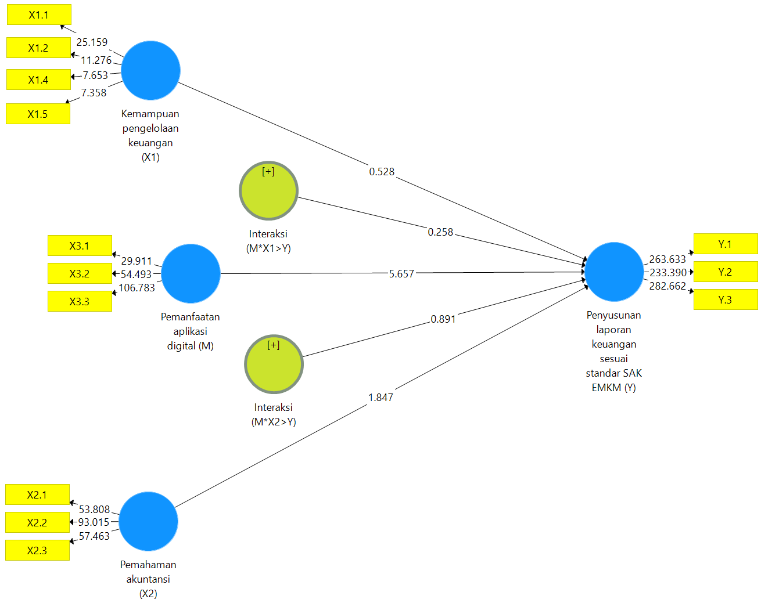

# Discussion

From the results, it can be analyzed that the use of digital applications is not able to moderate the direct influence of financial management capabilities on the preparation of financial statements according to EMKM financial accounting standards, this is likely because many MSMEs still do not know the EMKM financial accounting standards, therefore causing with or without utilizing digital applications cannot strengthen or weaken the preparation of financial statements according to standards EMKM financial accounting standards.

The results also show that the use of digital applications is not able to moderate the influence of accounting understanding on the preparation of financial statements according to EMKM financial accounting standards, this can also be explained due to the possibility of lack of understanding of accounting so that digital applications cannot help optimally.

The ability to manage finance does not affect the preparation of financial statements according to EMKM financial accounting standards, it is likely because MSMEs do not know much about emkm financial accounting standards so even though they have or cannot manage finances does not affect MSMEs to compile financial statements according to the standards of EMKM financial accounting standards.

Understanding accounting does not affect the preparation of financial statements by EMKM financial accounting standards. This can also be explained, which is likely that MSMEs still do not have an interest in preparing financial statements according to the EMKM financial accounting standards. Therefore, having or not understanding accounting does not affect MSMEs to prepare financial statements according to EMKM financial accounting standards.

# Conclusion

From the results of the study, it can be concluded that the ability to manage finances does not affect the preparation of financial statements that are by standards. Understanding accounting does not affect the preparation of financial statements by standards, the use of digital applications is not able to moderate the influence of accounting understanding on the preparation of financial statements that are by standards and the use of digital applications is not able to moderate the influence of financial management capabilities on the preparation of financial statements by standards. Although the variables of the use of digital applications as a coding variable are not able to moderate but have a direct influence, based on this it is recommended for subsequent researchers to use other coding variables that are suspected to be able to strengthen the influence on the preparation of financial statements according to the standards of EMKM financial accounting standards.

# Reference

Atmoko, Citro, and Biqwanto situmorang. 2021. “UMKM Didorong Manfaatkan Aplikasi Digital Dalam Pencatatan Keuangan - ANTARA News.” antaranews.com. https://www.antaranews.com/berita/2515973/umkm-didorong-manfaatkan-aplikasi-digital-dalam-pencatatan-keuangan (November 21, 2021).

Bank Data Kota Denpasar. 2020. “Data UMKM Kota Denpasar.” https://bankdata.denpasarkota.go.id/. https://bankdata.denpasarkota.go.id/?page=Data-Detail&language=id&domian=bankdata.denpasarkota.go.id&data_id=1606876170 (November 24, 2021).

Chen, H., & Volpe, R. P., 1998, An analysis of personal financial literacy among college students. Financial services review, 7(2), 107-128.

Freeman, R. E., Harrison, J. S., & Zyglidopoulos, S. (2018). Stakeholder theory: Concepts and strategies. Cambridge University Press.

Huang, C. L., & Kung, F. H. (2010). Drivers of environmental disclosure and stakeholder expectation: Evidence from Taiwan. Journal of business ethics, 96(3), 435-451.

Kusumawardhany, S. I. (2020). Penerapan Akuntansi pada UMKM Raja Eskrim di Kota Kediri. Jurnal Akuntansi dan Perpajakan, 6(2), 76-81.

Limanseto, H. (2021, May 5). UMKM Menjadi Pilar Penting dalam Perekonomian Indonesia. <Https://Ekon.Go.Id/>. https://ekon.go.id/publikasi/detail/2969/umkm-menjadi-pilar-penting-dalam-perekonomian-indonesia

Made Dwi Harisma Dewi, and Ni Wayan Yuniasih. 2020. “Pengaruh Kemampuan Pengelolaan Keuangan Dan Komitmen Organisasi, Terhadap Laporan Keuangan Dinas Perhubungan Bali Dengan Sistem Pengendalian Intern Variabel Moderasi.” : 754–55.

Mahardika, Agatha Gema; Pramiudi, Udi; Fahmi, Arif. 2019. “PERANAN PENERAPAN SISTEM AKUNTANSI ACCURATE TERHADAP PENYUSUNAN LAPORAN KEUANGAN (Studi Kasus Pada UMKM Toko Textile LEUWI Di Bogor).” Jurnal Ilmiah Akuntansi Kesatuan 7(1): 193–96.

Mandey, Maurenthia J., David P. E. Saerang, and Rudy J. Pusung. 2018. “Studi Kualitatif Tentang Manfaat Dan Kerugian Dalam Penyusunan Laporan Keuangan Pada Ud Mitra Pelita.” Going Concern : Jurnal Riset Akuntansi 13(02): 589–98.

Risal, R, and E Kristiawati. 2020. “Analisis Faktor-Faktor Yang Mempengaruhi Penerapan Pencatatan Laporan Keuangan Pada Umkm Di Kota Pontianak.” Equilibrium: Jurnal Ekonomi-Manajemen. <https://journal.uwks.ac.id/index.php/equilibrium/article/view/916>.

STANDAR AKUNTANSI KEUANGAN EMKM. 2018. IAIglobal.or.id. http://iaiglobal.or.id/v03/files/file_Standar Akuntansi Keuangan/emkm/ (November 24, 2021).

Sarah, Syti. 2021. “UMKM Go Digital, Perlukah Untuk Saat Ini? - Kompasiana.Com.” kompasiana.com. https://www.kompasiana.com/sytisarah/6194b27fc26b7728dd522563/umkm-go-digital-perlukah-untuk-saat-ini (November 21, 2021).

sari, Janlika Putri Indah Sari. 2021. “Pendanaan Dan Pemasaran Kendala Utama Bisnis UMKM - Entrepreneur Bisnis.Com.” 27 agustus 2021. https://entrepreneur.bisnis.com/read/20210827/263/1434636/pendanaan-dan-pemasaran-kendala-utama-bisnis-umkm (November 25, 2021).

Undang Undang Republik Indonesia. 2008. Undang-Undang Republik Indonesia Nomor 20 Tahun 2008.

Wiraputra, Wayan Kusuma, Ni Kadek Sinarwati, and Nyoman Trisna Herawati. 2014. “Pengaruh Pemahaman Standar Akuntansi Pemerintahan Dan Latar Belakang Pendidikan Terhadap Penyusunan Dan Penyajian Laporan Keuangan Pemerintah Daerah (Studi Pada Satuan Kerja Perangkat Daerah Di Kabupaten Klungkung).” e-Journal S1 Ak Universitas Pendidikan Ganesha 2(1): 1–10.

Yenni, Evri. 2017. “Pengaruh Pemahaman Akuntansi Dan Pengalaman Kerja Aparatur Terhadap Penyusunan Laporan Keuangan Daerah.” Jurnal Ekonomi dan Manajemen Teknologi (EMT) 1(2): 91–96.