**IMPLEMENTATION OF SAFETY REQUIREMENTS**

**IN THE CONSTRUCTION INDUSTRY IN LIBYA**

***Master of Business Administration, Faculty of Business Administrative Science, University of Brawijaya Malang***

***Abstract :*** Construction industry is both economically and socially important. The prevention of construction accidents usually entails predicting future accidents and their nature under given circumstances. Due to the fact that accident rates in construction are high when compared to other industries, the construction and projects managers need to be fully prepared to deal with accidents when they occur, undertaking proper investigations and reporting procedures afterwards. Therefore the evaluation of the workplace safety can be conducted by evaluating all on-site hazard elements. Safety performance of each element can then be measured by evaluating the correspondent on-site hazard factors. The type of research method is used the quantitative method. Construction is noisy, duty, hazardous and sometimes the most uninhabitable work place one can ever be exposed to. It is also an industry that contributes persistently to high accident rates; especially fatalities. Everything that is taboo in the safety practitioner’s book can be found in the construction site. For example, employees are easily exposed to hazardous substances such as paints, thinners, glues, varnishes, asbestos, and also to toxic agents mainly from underground work. Sites can easily accumulate debris which can be a fire hazard or a health hazard. Drilling and excavation work can cause accidental fires or even explosion.

***Keywords : Implementation, Construction Industry, Construction Projects, Construction Company, Safety Requirement.***

1. **Introduction**

The prevention of construction accidents usually entails predicting future accidents and their nature under given circumstances. The making of such predictions is based on knowledge about past accidents. The major causes of accidents in the construction industry are related to the unique nature of the industry, human behavior, difficult work-site conditions, and poor safety management which result in unsafe work methods and procedures. Due to the fact that accident rates in construction are high when compared to other industries, the construction and projects managers need to be fully prepared to deal with accidents when they occur, undertaking proper investigations and reporting procedures afterwards. Accident statistics represent not only terrible human tragedies but also substantial economic costs. This is because accidents cause damage to plant equipment and the loss of productive work time until the normal site working rhythm and morale are restored. Accidents can also cause work disruption and reduce the work rate (Enshassi et.al. 2007). The major causes of accidents are related to the unique nature of the industry, humanbehavior, difficult work site conditions, and poor safety management, which result in unsafe work methods, equipment and procedures. Emphasis in both developing and developed countries needs to be placed on training and the utilization of comprehensive safety programs (Farooqui, 2008). Hazard has been defined as a real or potential situation that may cause unintentional injuries or deaths to people; or damage to, or loss of an item or belongings. It can be regarded as the counterpart of safety. Therefore the evaluation of the workplace safety can be conducted by evaluating all on-site hazard elements. Safety performance of each element can then be measured by evaluating the correspondent on-site hazard factors. With the decrease of its potential hazard, its safety performance improves (Fang et al. 2004). Safety has always been a persistent problem in the construction industry. Construction accidents are a major concern for the construction industry and the researchers. In spite of the role of many construction accident causation models in understanding the accident process, one adequately explain the underlying reasons for construction accidents because of their dynamic nature.

To overcome this rest reconstruction, a new advancement in understanding constructionaccidents has been proposed by Halvi hoda, (2011) based on the work of Rasmussen (2007). The model recognizes that organizational and individual forces push workers in to hazardous conditions. These forces overcome efforts to impose safe work rules particularly in a changing work environment such as in construction.

Therefore, this approach emphasizes the need to train workers to be conscious of hazardous work environments through better planning. The focus of this orientation is on construction workers, which in turn leads to the design of worker specific training. Libyans are a mixture of races, with Bedouin origins in the east, Berbers in the mountains to the west, Turkish descendants in the main cites, the sub- Saharan Africans as well as the Touareg (nomads) in the south, however as a classless society ethnic difference sarevery rare. The official language of the country is Arabic; all correspondence with government ,Foreign companies and the international community and the most widely understood foreign language by the locals, however a large number of the old population speak Italian ,Taken from the days when the country was an Italian colony.

Islam is the religion of the State ;all Libyans are Sunni Moslems. Islam is "Society's Constitution". Although not all Islamic laws are enforced but some are, such as forbidding the sale of alcohol and gambling. Although there is a fair degree of segregation between males and females in society, local women are customarily seen in public.

1. **Literature Review**

The construction industry is one of the most unsafe and serious industries. Wherever reliable records are available, construction is found to be one of the worst, and often the worst industry regarding health and safety criteria. Many construction hazards lead to loss of life, injuries, disease and permanent disability. Also the direct impacts on the worker of such hazards can include loss of working days due to disease or injury and job loss. These effects generally spill over to the family, community and society around the worker , and It is economically important that the safety and health conditions should be improved in the construction industry. Poor safety and health performance is costly and can impact negatively on an industry and also reflect on the economy. It is estimated that the costs of accidents account for about four percent of the global Gross Domestic Product (GDP), Global Construction Safety and Health Practices Construction is a risky business with 13 workers per 100,000 being killed in construction as against 5 per 100,000 in all-sector average and also expose workers to a wide range of health problems ranging from asbestosis to back pain, handarm vibration syndrome to cement burns . In most countries, the rates of accidents and injuries prevailing in the industry are higher that what prevail in other industries; For developed countries that the United States of America construction industry currently accounts for, there are over 22% of all occupational fatalities in the entire United States of America (USA) even though it employs less than 7% of the country's workforce The injuries and the health problem associated with construction show that the industry is the most hazardous occupation and high-risk environment in the world, where workers face a greater risk of work-related fatality or injury, due to poor safety and health practices. Therefore, it is considered one of the dangerous and unsafe businesses that is related to the unique nature of the industry, human behavior, difficult work site conditions, and poor safety management, which result in unsafe work methods, equipment and procedures. reported that 256 people were fatally injured in the Australian Construction Industry; Statistics revealed that the fatality rate was 10.4 per 100,000 workers. their study revealed that 3,000 construction workers are killed in work related accidents each year. In comparison, 10 construction workers in every 1,000 suffer an injury in a year in Japan, and the figure is around 50 for the United Kingdom. In Arabic region, construction safety conditions resemble those in developing countries that deal with safety problems. In the construction industry, the working environment is constantly changing, sites exist for a relatively short time and the activities and inherent risks change daily. The accident rate in construction is highest when compared with other industries. Statistics have remained reasonably constant over the past six years, it features that the construction industry generally accounts for nearly 20% of all industrial injuries. The construction industry, because its nature, is susceptible to potentially dangerous conditions that affect the safety of all personnel working on construction projects and the company. Thus, there have been quite a high number of accidents, deaths and injuries. Therefore, construction industry is the critical and high-risk environment in the world and need to improve the safety and health implementation by investigate factors that affecting on it in construction sites.

1. **Methodology**

This chapter discusses the method which is used in this research. The method in this research included, respondent’s questionnaire design, data source data analysis, and the method of processing and analyzing the data, questionnaire content. The type of research method is used the quantitative method. The type of research method is used for to realize the real safety problems and danger of injuries that occur in the Tripoli city, to investigate safety procedures, regulations, policies, and accident prevention methods related to the construction projects in the Tripoli city, to provide methods and suggestions to improve the safety . The data source in this study is both primary and secondary data. Primary data was collected by survey and investigation. Secondary data was collected from the annual reports of the related companies.

In this study, data sources used in the report, has been through survey with international managers, I've prepared some questions related to issues of subject and was sent to my friend in Tripoli name is Mohammed Ertaimi the CEO of Alraedaliby for construction and real estat investment, then we prepared for the visiting of 5 construction projects in Tripoli .

1. **Results**

Participated in the questionnaire are three types of the respondents in the Tripoli city Owners, contractors, and consultants. 40 questionnaires have been distributed and the response rate is 75%. 33 %( 10) of the owners, and the 33 %( 10) of contractors, and the 33 %( 10) of the consultants show (figure 5.1) response rate among respondents. All the Type of the respondents executed many projects at the last five years.

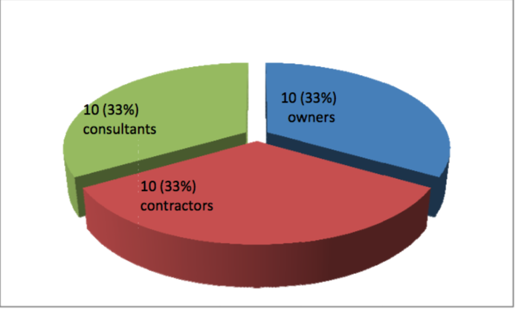

**Source: , Primary data 2015**

The results presentation the serious bad situation where 21(70%) of the participants in the survey had accidents in their construction projects during the last five years (Figure 5.2) Accidents occurred in 80% (8) of contractors’ construction sites, 60 %( 6) of the responding consultants, and 70% (7) of the responding owners stated that accidents occurred during working with projects were supervised or owned by them.

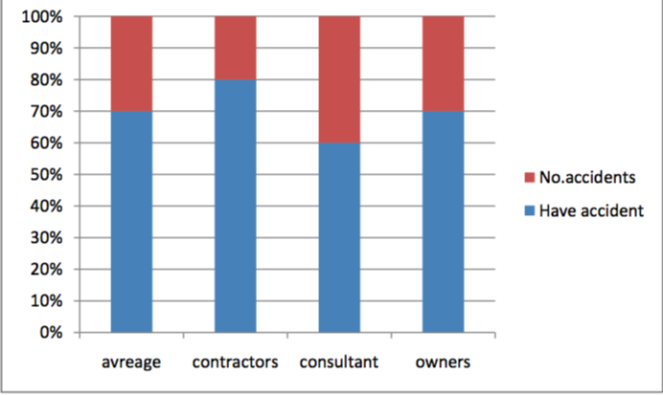

**Source: Primary data 2015**

1. **Discussion**

The results highlighted the serious bad situation where 21(70%) of the participants in the survey had accidents in their construction projects during the last five years. Accidents occurred in 80% (8) of contractors’ construction site.60 % (6) of the respondents consultants and 70 % ( 7) of the responding owners stated that accidents occurred during working with projects were supervised or owned by them (see figure 5.2), In general, the result in Tripoli city) very high accidents, due to the respondents during the last five years executed so many projects with the different size and the different nature of the projects during the last five years. That is why the number of the accidents it’s so high with the respondents to other respondents, it is also the results in Tripoli city seem convergent and very high when compared with other countries. A study of Hassouna (2005) in Gaza strip which found out 75% (62) among the (83) respondents had accidents in their construction projects during the five years.

1. **Conclusion**

The results in the Tripoli city highlighted the bad safety situation where most of the respondents in the survey had accidents in their construction projects during the last five years. Accidents rate mentioned by the contractors (80%) was higher than with the other respondents i.e., the consultants (60%) and owners (70%). This was attributed to the fact that the contractors execute projects with size and values more than the owners and consultants.

There was no detailed record for the size and number of accidents, as the data available only showed the real injuries. Regarding the cost of the construction safety, the majority of the respondents agreed that the cost of safety less than 3 % during the last five years. There were many potential hazards in the sites which can lead to many injures, or disease among the works on the construction sites.

On the existing safety procedures, regulations, policies, and accidents prevention methods related to the construction projects; there was a consensus among the respondents that implementation of safety regulation helps in reducing accidents. Construction professionals should play more active roles in sustaining construction safety and in improving safety culture for construction workers. There was also a consensus between the respondents that responsibility for safety and health was only confined to construction work on site.

The respondents agreed that the main cause of accidents on site during the last five years all was that because the workers were lacking of safely knowledge. The majority of the respondents also agreed that consultants carried both a moral responsibility and duty of care for building demolition workers and public in general. The respondents agreed that design engineer should be responsible for the building ability and safe construction working and they should have regular site visits to ensure safe constriction as specified, while for the owners, subject of safety should be included in the construction bid entry. The majority of respondents who were consultants and owners agreed that contractor was responsible for the cases of accident and that the contractor should be stopped when making safety violations,

There was a consensus among the respondents that special government institutions should increase their effort and participation in improving safety by organizing safety-training course for workers. All the respondents disagreed on the matters such as whether the contractors had a good knowledge of the current regulations regarding construction site, whether the ministry of labor gave adequate information about the current safety regulations for contractors, and whether the current regulations were adequate and applicable to the local construction sites. On the other hand the respondents agreed on the notion that delegation from the ministry of labor should visit the construction sites to follow up safety performance, and for the insurance companies to visit the sites for the insured projects. During the last five years the respondents agreed that implementation of total Quality management could help reduce the number of accidents on the construction site.