**Regression**

|  |  |  |  |
| --- | --- | --- | --- |
| **Variables Entered/Removeda** | | | |
| Model | Variables Entered | Variables Removed | Method |
| 1 | LDR, EPS, DER, AGE, CAR, EAT, SIZEb | . | Enter |
| a. Dependent Variable: HRD | | | |
| b. All requested variables entered. | | | |

|  |  |  |  |  |  |
| --- | --- | --- | --- | --- | --- |
| **Model Summaryb** | | | | | |
| Model | R | R Square | Adjusted R Square | Std. Error of the Estimate | Durbin-Watson |
| 1 | .882a | .779 | .752 | 5.27279 | 2.421 |
| a. Predictors: (Constant), LDR, EPS, DER, AGE, CAR, EAT, SIZE | | | | | |
| b. Dependent Variable: HRD | | | | | |

|  |  |  |  |  |  |  |
| --- | --- | --- | --- | --- | --- | --- |
| **ANOVAa** | | | | | | |
| Model | | Sum of Squares | df | Mean Square | F | Sig. |
| 1 | Regression | 5578.728 | 7 | 796.961 | 28.665 | .000b |
| Residual | 1584.733 | 57 | 27.802 |  |  |
| Total | 7163.462 | 64 |  |  |  |
| a. Dependent Variable: HRD | | | | | | |
| b. Predictors: (Constant), LDR, EPS, DER, AGE, CAR, EAT, SIZE | | | | | | |

|  |  |  |  |  |  |  |  |  |
| --- | --- | --- | --- | --- | --- | --- | --- | --- |
| **Coefficientsa** | | | | | | | | |
| Model | | Unstandardized Coefficients | | Standardized Coefficients | t | Sig. | Collinearity Statistics | |
| B | Std. Error | Beta | Tolerance | VIF |
| 1 | (Constant) | -28.901 | 12.713 |  | -2.273 | .027 |  |  |
| AGE | -.023 | .032 | -.061 | -.726 | .471 | .542 | 1.844 |
| SIZE | 2.890 | .958 | .509 | 3.016 | .004 | .136 | 7.335 |
| DER | 1.485 | .402 | .341 | 3.698 | .000 | .457 | 2.187 |
| EAT | 1.085 | .715 | .250 | 1.518 | .134 | .144 | 6.966 |
| EPS | .005 | .004 | .131 | 1.351 | .182 | .415 | 2.407 |
| CAR | .270 | .104 | .225 | 2.594 | .012 | .516 | 1.938 |
| LDR | .088 | .047 | .121 | 1.850 | .069 | .900 | 1.111 |
| a. Dependent Variable: HRD | | | | | | | | |

|  |  |  |  |  |  |  |  |  |  |
| --- | --- | --- | --- | --- | --- | --- | --- | --- | --- |
| **Coefficient Correlationsa** | | | | | | | | | |
| Model | | | LDR | EPS | DER | AGE | CAR | EAT | SIZE |
| 1 | Correlations | LDR | 1.000 | .109 | .129 | -.090 | .170 | .007 | -.096 |
| EPS | .109 | 1.000 | .153 | .153 | -.093 | -.318 | -.209 |
| DER | .129 | .153 | 1.000 | -.432 | .468 | .245 | -.268 |
| AGE | -.090 | .153 | -.432 | 1.000 | -.208 | -.287 | -.022 |
| CAR | .170 | -.093 | .468 | -.208 | 1.000 | -.018 | .247 |
| EAT | .007 | -.318 | .245 | -.287 | -.018 | 1.000 | -.739 |
| SIZE | -.096 | -.209 | -.268 | -.022 | .247 | -.739 | 1.000 |
| Covariances | LDR | .002 | 1.933E-5 | .002 | .000 | .001 | .000 | -.004 |
| EPS | 1.933E-5 | 1.389E-5 | .000 | 1.839E-5 | -3.601E-5 | -.001 | -.001 |
| DER | .002 | .000 | .161 | -.006 | .020 | .070 | -.103 |
| AGE | .000 | 1.839E-5 | -.006 | .001 | -.001 | -.007 | -.001 |
| CAR | .001 | -3.601E-5 | .020 | -.001 | .011 | -.001 | .025 |
| EAT | .000 | -.001 | .070 | -.007 | -.001 | .511 | -.506 |
| SIZE | -.004 | -.001 | -.103 | -.001 | .025 | -.506 | .918 |
| a. Dependent Variable: HRD | | | | | | | | | |

|  |  |  |  |  |  |
| --- | --- | --- | --- | --- | --- |
| **Residuals Statisticsa** | | | | | |
|  | Minimum | Maximum | Mean | Std. Deviation | N |
| Predicted Value | 40.3073 | 74.8333 | 60.0962 | 9.33636 | 65 |
| Std. Predicted Value | -2.120 | 1.578 | .000 | 1.000 | 65 |
| Standard Error of Predicted Value | .942 | 3.523 | 1.746 | .615 | 65 |
| Adjusted Predicted Value | 35.5552 | 75.0681 | 60.0873 | 9.53926 | 65 |
| Residual | -9.66863 | 10.63313 | .00000 | 4.97609 | 65 |
| Std. Residual | -1.834 | 2.017 | .000 | .944 | 65 |
| Stud. Residual | -1.911 | 2.244 | .001 | 1.003 | 65 |
| Deleted Residual | -10.50101 | 14.44483 | .00887 | 5.65284 | 65 |
| Stud. Deleted Residual | -1.958 | 2.330 | .002 | 1.017 | 65 |
| Mahal. Distance | 1.057 | 27.581 | 6.892 | 6.114 | 65 |
| Cook's Distance | .000 | .309 | .018 | .040 | 65 |
| Centered Leverage Value | .017 | .431 | .108 | .096 | 65 |
| a. Dependent Variable: HRD | | | | | |

**Charts**

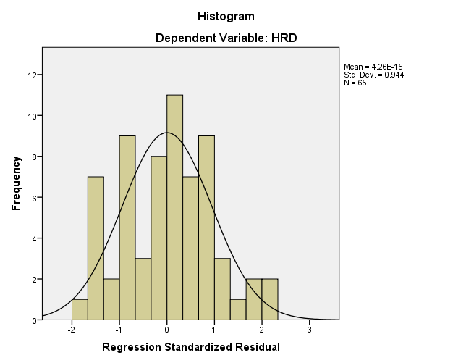

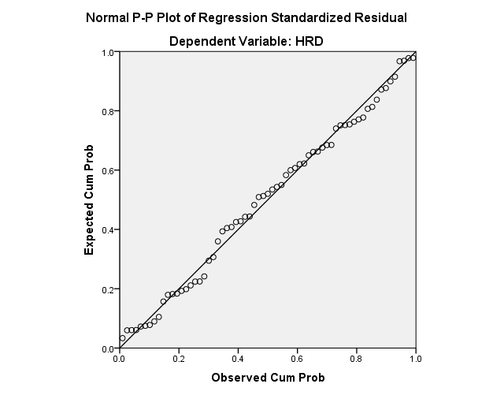

**Heteroskedasticity Test:**

|  |  |  |  |
| --- | --- | --- | --- |
| **Variables Entered/Removeda** | | | |
| Model | Variables Entered | Variables Removed | Method |
| 1 | LDR, EPS, DER, AGE, CAR, EAT, SIZEb | . | Enter |
| a. Dependent Variable: Lne2 | | | |
| b. All requested variables entered. | | | |

|  |  |  |  |  |  |
| --- | --- | --- | --- | --- | --- |
| **Model Summaryb** | | | | | |
| Model | R | R Square | Adjusted R Square | Std. Error of the Estimate | Durbin-Watson |
| 1 | .366a | .134 | .028 | 2.06978 | 1.822 |
| a. Predictors: (Constant), LDR, EPS, DER, AGE, CAR, EAT, SIZE | | | | | |
| b. Dependent Variable: Lne2 | | | | | |

|  |  |  |  |  |  |  |
| --- | --- | --- | --- | --- | --- | --- |
| **ANOVAa** | | | | | | |
| Model | | Sum of Squares | df | Mean Square | F | Sig. |
| 1 | Regression | 37.788 | 7 | 5.398 | 1.260 | .286b |
| Residual | 244.187 | 57 | 4.284 |  |  |
| Total | 281.975 | 64 |  |  |  |
| a. Dependent Variable: Lne2 | | | | | | |
| b. Predictors: (Constant), LDR, EPS, DER, AGE, CAR, EAT, SIZE | | | | | | |

|  |  |  |  |  |  |  |  |  |
| --- | --- | --- | --- | --- | --- | --- | --- | --- |
| **Coefficientsa** | | | | | | | | |
| Model | | Unstandardized Coefficients | | Standardized Coefficients | t | Sig. | Collinearity Statistics | |
| B | Std. Error | Beta | Tolerance | VIF |
| 1 | (Constant) | 11.550 | 4.990 |  | 2.314 | .024 |  |  |
| AGE | .014 | .013 | .180 | 1.076 | .287 | .542 | 1.844 |
| SIZE | -.068 | .376 | -.061 | -.182 | .856 | .136 | 7.335 |
| DER | -.243 | .158 | -.281 | -1.540 | .129 | .457 | 2.187 |
| EAT | -.239 | .281 | -.277 | -.851 | .398 | .144 | 6.966 |
| EPS | .000 | .001 | .032 | .166 | .869 | .415 | 2.407 |
| CAR | -.077 | .041 | -.322 | -1.878 | .066 | .516 | 1.938 |
| LDR | -.031 | .019 | -.215 | -1.654 | .104 | .900 | 1.111 |
| a. Dependent Variable: Lne2 | | | | | | | | |

|  |  |  |  |  |  |  |  |  |  |
| --- | --- | --- | --- | --- | --- | --- | --- | --- | --- |
| **Coefficient Correlationsa** | | | | | | | | | |
| Model | | | LDR | EPS | DER | AGE | CAR | EAT | SIZE |
| 1 | Correlations | LDR | 1.000 | .109 | .129 | -.090 | .170 | .007 | -.096 |
| EPS | .109 | 1.000 | .153 | .153 | -.093 | -.318 | -.209 |
| DER | .129 | .153 | 1.000 | -.432 | .468 | .245 | -.268 |
| AGE | -.090 | .153 | -.432 | 1.000 | -.208 | -.287 | -.022 |
| CAR | .170 | -.093 | .468 | -.208 | 1.000 | -.018 | .247 |
| EAT | .007 | -.318 | .245 | -.287 | -.018 | 1.000 | -.739 |
| SIZE | -.096 | -.209 | -.268 | -.022 | .247 | -.739 | 1.000 |
| Covariances | LDR | .000 | 2.978E-6 | .000 | -2.115E-5 | .000 | 3.909E-5 | -.001 |
| EPS | 2.978E-6 | 2.140E-6 | 3.518E-5 | 2.834E-6 | -5.549E-6 | .000 | .000 |
| DER | .000 | 3.518E-5 | .025 | -.001 | .003 | .011 | -.016 |
| AGE | -2.115E-5 | 2.834E-6 | -.001 | .000 | .000 | -.001 | .000 |
| CAR | .000 | -5.549E-6 | .003 | .000 | .002 | .000 | .004 |
| EAT | 3.909E-5 | .000 | .011 | -.001 | .000 | .079 | -.078 |
| SIZE | -.001 | .000 | -.016 | .000 | .004 | -.078 | .141 |
| a. Dependent Variable: Lne2 | | | | | | | | | |