Analysis Competence of Village Officials on the Performance of Village Fund Management in Banyumas Regency
KARTIKA DWI CHANDRA SARI^{1*} , ALAN BAYU AJI²

^{kartikadwichandra@uhb.ac.id}
^{1,2} Universitas Harapan Bangsa, Purwokerto, Indonesia

Abstract
Village government has clear objectives and achievements in government administration. Organizational effectiveness is important in the realization of the goals and achievements of the village government. From the perspective of human resources, the effectiveness of an organization can be seen from the competencies possessed by village officials. The purpose of this study was to determine the effectiveness of the use of Village Funds by looking at the average competency and performance of village fund management in the village apparatus of the Banyumas Regency. In this study, the questionnaire has gone through the stages of validity and reliability testing, classical assumption test and multiple regression test. The conclusion is that knowledge and skills do not have a significant effect on village management performance. while the attitude variable has a significant effect on the performance of village management. Suggestions for the village government, in improving the competence of village officials in the Banyumas region in work, it is necessary to have training in accordance with the needs of the Village Apparatus, so that knowledge, insight and skills increase. This is to increase the average number of job analysis skills.
Keywords: Village Government, Competence, Financial Management Performance

preliminary
The Village Government has received recognition in the aftermath of the passing of Law Number 6 of 2014 concerning Villages. This regulation explains the form of State recognition of the existence of Village Government and policies in the management of Village Funds originating from the Central Government State Budget. With the existence of a management system and village government affairs authority, the Village Fund policy should be able to effectively improve the welfare of the community in the village area. With this regulation, the village government can also provide the widest possible opportunity for village communities to actively participate in the implementation of village government, rural economic development, local democracy development and village cooperation development. (Fairus, 2020)
Village funds are APBN funds that are budgeted annually to finance the implementation of village authorities as stipulated. Allocation is made by considering the population, poverty rate, area size and geographic difficulty level. The main purpose of village funds is to improve public services in the village, incubate poverty, advance the village economy, overcome development gaps between villages and strengthen village communities as the subject of development (Utami, 2020).
Thus, the village government has clear objectives and achievements in government administration. Organizational effectiveness is important in the realization of the goals and achievements of the village government. In terms of human resources, the effectiveness of an organization can be seen from the competencies possessed by village officials (Mandagi, et all; 2016). Yusuf (2015) defines Human Resources as individuals who design and produce outputs in order to achieve the strategies and goals set by the organization. Without individuals who have skills or competencies, it is impossible for the organization to achieve its goals. Thus, we can see that the effectiveness of the use of village funds for community health services can be seen from the competencies possessed by village officials.
In achieving the goals of the village government and seeing the large nominal amount of village funds that have been distributed from the central government, village officials must also have a good view of the performance of village fund management. In previous studies, the weak understanding of village officials in village financial management resulted in less effective and efficient performance of village financial management. According to the Financial and Development Supervisory Agency (BPKP), there were 15,100 weaknesses that occurred in the village financial management accountability in 2015 (Munti and Fahlevi, 2017). Performance is the level of achievement of results for the implementation of certain tasks (Simanjuntak, 2005). While according to Sutrisno (2011: 209), determining the level of competence is needed in order to know the level of achievement expected for the good or average category. So, the village government must also look at the performance that has been made by village officials in managing village funds.
As explained above, the level of competence and management performance Village funds must be a concern, because of the high amount of funds that have been received by the village government, especially the Banyumas Regency area. Based on the data we have obtained, the ceiling for village fund receipts is quite high. Of the 50 villages, the table shows the 4 villages with the highest village fund receipts. (Table 1)
No. | Village Name | Village Fund Ceiling
1 | Pair | 1,767,398,000
2 | Gandaapa | 1,790,355,000
3 | Kotayasa | 2,002,787,000
4 | Limpakuwus | 1,723,846,000
Table 1

Research Objectives and Benefits
The purpose of this study was to determine the effectiveness of the use of Village Funds by looking at the average competency and performance of village fund management in the village apparatus of the Banyumas Regency. The benefit of this research is to provide an overview that which parts are expected to be of concern and need to increase in competency development and performance of village fund management in the Banyumas Regency area and to illustrate that there is an influence between competence and the performance of village fund management in the Banyumas Regency area.

Research methods
This research is a quantitative research, the data source used is primary data because it uses a questionnaire. The population of this study were the village fund managers of Banyumas Regency. The total sample in this study was 33 village officials scattered in various villages in the Banyumas Regency area.
Data testing is done by using the validity test and reliability test to assess the validity of the questionnaire. The classical assumption test is also performed as a condition for entry to the Multiple Regression test. With the following research framework (Figure 1)
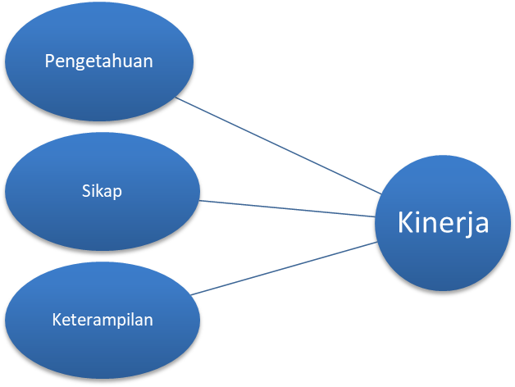

Picture 1

Results and Discussion
In the study, the results obtained an average of 33 exemplars of the questionnaire returned, and all data can be used properly.
Questionnaire Rate
Information | amount | Percentage
Distributed questionnaire | 50 | 100%
Non-returned questionnaire | 17 | 34%
The back questionnaire | 33 | 66%
An unusable questionnaire | 0 | 0%
Questionnaires that can be used | 33 | 100%
Source: Processed data, 2020
Characteristics of respondents taken in this study are data on the gender of the respondent, the age of the respondent, the respondent's latest education and the length of service of the respondent. In more detail, then we will discuss one by one of these characteristics according to the data that has been processed.
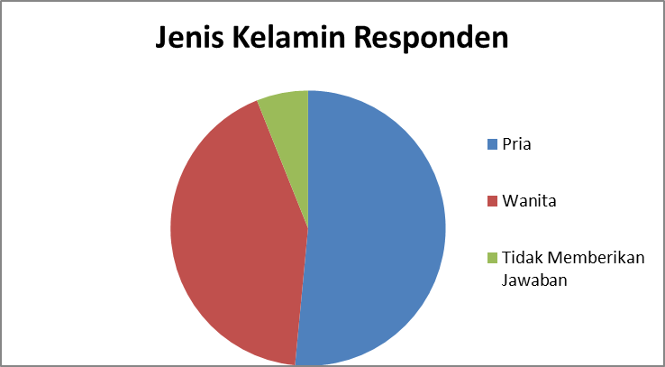
Source: Processed data, 2020
For the gender of the respondents, the results of the questionnaire indicated that the number of male respondents was 17 people or 51.5% of the total respondents, and the number of female respondents was 14 people or 42.4% of the total respondents and 2 of them did not provide information.
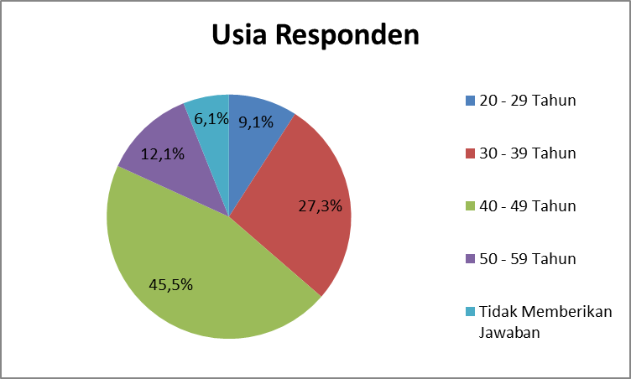
Source: Processed data, 2020
As for the age of the respondents, the results of the questionnaire show that the number of respondents aged 20 to 29 years is 9, 1% of the total respondents, aged 30 to 39 years are 27.3% of the total respondents, those aged 40 to 49 are 45.5% of the total respondents, and those aged 50 to 59 years is 12.1% of the total respondents. From these data, it can be concluded that most of the respondents were 40 to 49 years old.
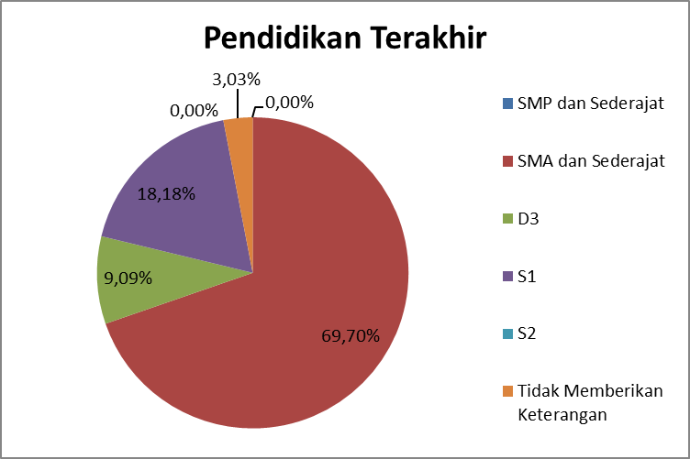
Source: Processed data, 2020
For the education level of respondents, the results of the questionnaire show that the number of respondents whose education level is at the SMA level is 69.70% of the total respondents, whose education level is at the D3 level is 9.09% of the total respondents, whose education level is at the S1 level is 18 , 18% of the total respondents, and there are 3.03% of respondents who did not provide information related to their latest education. From these data it can be concluded that most of the respondents with the latest education level were high school and equivalent.
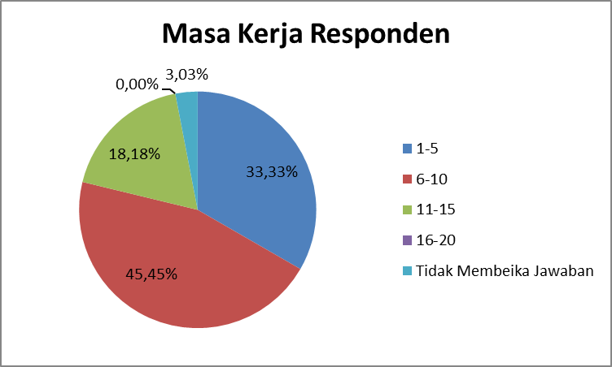
Source: Processed data, 2020
There are 3 working periods for respondents, 03% who did not provide answers related to tenure in the questionnaire. Meanwhile, for the respondent's working period with a time span of 1 to 5 years as much as 33.33%, for the respondent's working period with a time span of 6-10 years as much as 45.45%. Furthermore, for the respondent's working period with a time span of 11 to 15 years is 18.18% and for the respondent's working period with a time span of 16-2o years is 0%. So it can be concluded that most respondents have a work period of 6 to 10 years.
In this study, the questionnaire has also gone through the validity and reliability test stages to provide information that this questionnaire is worthy of being a reference to the description we provide. The results of the validity test for each question get raised above rtabel (0.344), which means that each question is valid. For the results of the reliability test, the Cronhbach alpha number is 0.92, which illustrates that the questionnaire is consistent or reliable.
Kasik Assumption Test
The normality test shows the Kolmogorov-Smirnov Z coefficient value of 0.687 with a significance level of 0.734. This significance value is greater than α 0.05 (0.734> 0.05). This shows that the data in this research variable are normally distributed. (Table 2)

One-Sample Kolmogorov-Smirnov Test
 |  | Unstandardized Residual
N |  | 33
Normal Parametersa, b | Mean | 0E-7
Normal Parametersa, b | Std. Deviation | .19221824
Most Extreme Differences | Absolute | .120
Most Extreme Differences | Positive | .069
Most Extreme Differences | Negative | -120
Kolmogorov-Smirnov Z |  | .687
Asymp. Sig. (2-tailed) |  | .734
a. Test distribution is Normal.
b. Calculated from data.

Multicolinearity test in this study shows that there is no strong correlation between the independent variables. This means that there are no similarities between the independent variables or multicollinearity problems in the regression model studied. This can be seen from the VIF value of all variables between 1-10. (Table 3)

Coefficientsa
Model |  | Unstandardized Coefficients |  | Standardized Coefficients | t | Sig. | Collinearity Statistics
 |  | B | Std. Error | Beta | t | Sig. | Tolerance | VIF
1 | (Constant) | .820 | .447 |  | 1,835 | .077
1 | X1 | -004 | .131 | -004 | -.028 | .978 | .439 | 2,280
1 | X2 | .033 | .141 | .034 | .234 | .816 | .382 | 2,615
1 | X3 | .764 | .173 | .849 | 4,410 | .000 | .222 | 4.505
a. Dependent Variable: Y

The heteroscedasticity test in this study resulted in a significance value of all independent variables greater than 0.05. This means that there is no heteroscedasticity in the study. (Table 4)

Coefficientsa
Model |  | Unstandardized Coefficients |  | Standardized Coefficients | t | Sig.
 |  | B | Std. Error | Beta | t | Sig.
1 | (Constant) | .245 | .293 |  | .836 | .410
1 | X1 | -.063 | .086 | -202 | -727 | .473
1 | X2 | .012 | .093 | .038 | .128 | .899
1 | X3 | .030 | .114 | .103 | .265 | .793
a. Dependent Variable: Abs_RES

By passing the classical assumption test that has been carried out, we are will enter Multiple Regression Analysis with the following formula
Yi = β0 + β1X1i + β2X2i + β3X3i + e
Information :
Yi : Village Fund Management Performance
β0 : Regression coefficient
β1X1i : Knowledge
β2X2i : Skills
β3X3 : Attitude
e : error

The results of the Multiple Regression Analysis obtained in this study are as follows: Y = 0.820 - 0.004X1 + 0.034X2 + 0.849X3 + e. With an R square value of 0.761. This means that the independent variables namely knowledge, skills and attitudes explain 76.1% of the dependent variable, namely the performance of village fund management. The remaining 23.9% is explained by other variables not examined. (Table 6)

Variable Name | Beta | t-count | Sig.
Constant | 0.820 | 1,835 | 0.077
Knowledge | -0.004 | -0.28 | 0.978
Skills | 0.034 | 0.234 | 0816
Attitude | 0849 | 4.4410 | 0.000
Table 6
Knowledge
The results of testing the influence of knowledge on the performance of village fund management showed a significance level of 0.978 (p value> 0.05). This shows that the competence of village fund managers does not have a significant effect on the performance of village fund management. However, according to Gordon in Sutrisno (2010), knowledge is awareness in the cognitive field. In addition, according to Rasman (2018), knowledge that describes the level of understanding and information about the work carried out by the Village Apparatus can be influenced by education and experience. Education is able to equip a person with the basics of knowledge, theory, logic, general knowledge, analytical skills and character and personality development. It is recorded in the results of the study that the village apparatus has met the minimum requirements for high school education. This is in accordance with the requirements stipulated by Government Regulation Number 43 of 2014 Chapter IV Article 65 concerning Village Apparatus concerning Implementing Regulations of Law Number 6 of 2014. Next is work experience, where experience will shape knowledge and in work, thus we can see that the work experience that the respondent has is more than 2 years. This experience will form the right specialization or competence in the effective use of village funds. thus we can see that the work experience that the respondent has is more than 2 years. This experience will form the right specialization or competence in the effective use of village funds. thus we can see that the work experience that the respondent has is more than 2 years. This experience will form the right specialization or competence in the effective use of village funds.

Skills
The results of the test researchers found that the effect of village government skills on the performance of village fund management showed a significance level of 0.816 (p value> 0.05). This shows that the skills of village government in managing village funds do not have a significant effect on the performance of village fund management. Meanwhile, in the dimensions of skills, mastery of technicalities, procedures and regulations related to the field of work owned by employees (Rasma, 2018). In the questionnaire items, there are skills that support a good job execution. Such as how to communicate with colleagues and with superiors, use of office equipment in carrying out routine activities and how to solve challenges or problems that may be faced at work. However, In its development, the need for communication is not only related to colleagues and leaders, the community also requires good communication skills. This is because the village apparatus is an apparatus that is directly related to the community and becomes the liaison between the government in implementing and managing village funds according to the needs of the surrounding environment.
Attitude
The results of testing the effect of attitudes on the performance of village fund management showed a significance level of 0.000 (p value <0.05). This shows that the attitude of village officials has a significant effect on the performance of village fund management. This is in accordance with the conditions that are expected to occur by the village government, because the good attitude of the village apparatus can lead to the goals and achievements of the implementation of village governance. Attitudes are evaluative statements about an object, person or event, both pleasant and unpleasant (Robbins, 2016). In the questionnaire, there are points related to high professionalism and getting a high enough point average answer. This relates to the awareness of village officials about the demands for skills and expertise at work,

Conclusion
Based on the results of research conducted in the Banyumas Regency area, it can be concluded that in research in the Banyumas Regency area:
- Knowledge does not have a significant effect on the performance of village fund managers. The amount obtained in the research results cannot be used because it uses a Likert scale, which gives a better picture of each result either very good or very bad. In knowledge there is a description of the latest work experience and education that one has.
- Skills do not have a significant effect on the performance of village fund managers. The amount obtained in the research results cannot be used because it uses a Likert scale, which gives a better picture of each result either very good or very bad. In terms of skills seen with personal abilities related to technical ways to complete work.
- Attitudes have a significant effect on the performance of village fund managers. In the attitude variable possessed by village officials, especially professionals who give the view that completing tasks is in the public interest rather than personal interest.

Suggestion
- In improving the competence of village officials in the Banyumas region at work, it is necessary to have training in accordance with the needs of the Village Apparatus, so that knowledge, insight and skills increase. This is to increase the average number of job analysis skills.
- In addition, improving good communication skills to colleagues, superiors and the community also needs to be improved, seeing the results from the respondents' questionnaires are not as high as other skills.

Bibliography
Book
Fairus, Adira. (2020). Get to know the Village and the Village Government. Jogjakarta: Pixelindo.
Utami, Rahajeng Dwi. (2020). Complete Book of Village Fund Planning. Jogjakarta: Pixelindo.
Yusuf Burhanuddin. (2015). Human Resource Management in Islamic Financial Institutions. Jakarta: PT. Raja Grafindo Persada.
Simanjuntak, Payaman J. 2005. Management and Performance Evaluation. Jakarta: FE UI.
Sutrisno, Edi. (2011). Human Resource Management. Jakarta: Golden.
Robbins, S. (2016). Organizational behavior. Depok: RajaGrafindo Persada.
Hutapea, Parulian and Nurianna Thoha. (2008). Communication Competencies Plus: Theory, Design, Cases and Applications for HR and Dynamic Organizations. Jakarta: Gramedia Pustaka Utama.
Journal
Munti, F., & Fahlevi, H. (2017). "Determinants of Village Financial Management Performance: A Study in Gandapura District, Bireuen District, Aceh". Journal of Accounting and Investments, 18 (2), 172–182.
Mandagi, et all. (2016). "The Effect of Competency of Apparatus Resources on the Effectiveness of Office Administration in North Minahasa District Health Office". -journal of Sam Ratulangi University.
Tumangkeng, Melisa Rosali. (2020). "Professionalism of Village Apparatus in Government Implementation in Wolaang Village, Langowan Timur District, Minahasa Regency". Sam Ratulangi University e-journal.
Asmawati, Ika., Prayitno, Basuki., Ahmad Rifa'I ,. (2018). "Village Government Performance in Village Fund Management (Study in Dore Village, Palibelo District, Bima Regency)". E-Journal of Accounting at Udayana University Vo ;. 25.3 December (2018): 2379-2401.
Rasman. (2018). "Competency of Village Apparatus in Budong-Budong Subdistrict, Central Mamuju Regency". E-print of System Journal of Makassar State University.
Regulations
Law Number 6 of 2014 concerning Villages;
Government Regulation Number 43 of 2014: Regarding Implementation Regulations of Law Number 6 of 2014.
Internet
E-book: Iqbal, Muhammad. (2015). Multiple Linear Regression. Jakarta: Perbanas Intitute Jakarta. Url:https://dosen.perbanas.id/wp-content/uploads/2015/05/Regresi-Linier-Berganda-SPSS1.pdf

