MANAGING EMPLOYEE ENGAGEMENT IN GENERATION Z

ELDES WILLY FILATROVI^{1*} , KHOIRUL ATTIQ²

eldeswillyfilatrovi@stiebankbpdjateng.ac.id
^{1*,2}Sekolah Tinggi Ilmu Ekonomi, BANK BPD JATENG, Indonesia
Abstract | The purpose of this study was to determine the effect of compensation equity and development opportunities as well as psychological meaningfulness on employee engagement. The study was conducted on 150 generation Z employees in Central Java. Analysis using SEM (AMOS) shows several findings: compensation fairness affects psychological meaningfulness; fairness compensation has no effect on employee engagement; career opportunities for psychological meaningfullness; Career opportunities have no effect on employee engagement; Psychological meaningfullness affects employee engagement ..
Keyword | Compensation Justice; Opportunities for Development; Psychological Meaningfulness; Employee Engagement; Gen Z; Manufacture
INTRODUCNG
Competition in the business world between companies makes companies have to concentrate on a series of processes or activities for creating products and services related to employee performance. Companies want to show their best to gain a competitive advantage. One of them is by recruiting employees who are able to work in accordance with the compensation offered by the company (Kelvin, 2010). Employees are an asset of a company. The productivity and profitability of the company depends on how well the employee is performing. Employees who perform well will contribute more to the organization than employees who perform poorly. Employee performance is influenced by how these employees interpret, contribute, and are involved in their work (Galup, Klein & Jiang, 2008). The problem in this study is that generation Z employees are not able to be managed properly by the company due to a crisis of experience so that employees from generation Z feel unable to develop their careers, eventually many generation Z employees choose to have careers at other companies that are more promising in terms of compensation and career development, but some have survived as a form of commitment to the company. Generation Z employees who remain are what ultimately form an engaged attitude towards the company. The problem in this study is that generation Z employees are not able to be managed properly by the company due to a crisis of experience so that employees from generation Z feel unable to develop their careers, eventually many generation Z employees choose to have careers at other companies that are more promising in terms of compensation. and career development, but some have survived as a form of commitment to the company. Generation Z employees who remain are what ultimately form an engaged attitude towards the company.
This research is supported by a research gap, which according to Anvari et al. (2011) fairness compensation and development opportunities have a positive effect on psychological meaningfulness, Douglas et al. (2014) showed psychological meaningfulness had a positive effect on employee engagement, while Tladinyane et al. (2014) showed psychological meaningfulness had no significant effect on employee engagement.
LITERATURE REVIEW AND HYPOTHESIS RELATIONSHIP
Employee Engagement
Saks (2006) argues that employee engagement is how the employees are physically, cognitively and emotionally displayed. Employee involvement in their performance role with passion for the job role served. The cognitive aspect of employee engagement deals with employees' beliefs about organizational factors such as, how to be led, by whom and the working conditions that exist in the organization. The emotional element deals with how employees have a positive or negative effect on the organization and its leaders. The physical aspect relates to the physical energy used by employees to carry out their organizational roles (Albrecht, 2010).
Psychological Meaningfulness
Psychological meaningfulness is the psychological condition of the engaged person. Skill variety affects the engagement level of an employee. Employees will devote their energies to doing work so that they can contribute to the organization. Thus employees will perceive their work as important and an opportunity for them to develop, be internally motivated, satisfied with work and have quality work. Such conditions will make employees experience psychological meaningfulness (Douglas et al., 2014).
Compensation Justice
Organizations use compensation to motivate their employees. Another problem is that it is compensation that effectively motivates other employees. Basically, working people also want to get money to make ends meet. For this reason, an employee begins to appreciate hard work and increasingly shows loyalty to the company and that's why the company rewards employee work performance by providing fair compensation. One way for management to improve work performance, motivate and improve employee performance is through fairness compensation (Alamzeb et al., 2012).
Development Opportunities
Development opportunities are related to formal and informal training to learn new knowledge / skills / abilities (Milkovich & Newman, 2002). Formal training is often associated with the introduction of a new job, it is also associated with changes in technology or procedures. Formal training can be coordinated and taught by human resource professionals or other professionals within the organization, or workers can be sent for training programs offered by professional associations or universities even assigned to further studies.
The Effect of Compensation Justice on Psychological Meaningfulness
Anvari et al., (2011) one of the objectives of compensation justice is psychological meaningfulness. Fair and proper compensation can maintain and psychological meaningfulness of employees to increase work productivity. Coetzee & Bergh (2009) said that psychological meaningfulness is an important factor that affects how and why people work for an organization and not another.
H1: Fairness of compensation has a positive effect on psychological meaningfulness
The Effect of Compensation Justice on employee engagement
Hedger (2007) states that the results of a survey of the five highest survival factors are: 1) an attractive and challenging work environment, 2) learning and development opportunities, 3) working with good and right people, 4) fair wages , 5) supportive superiors
H2: Compensation has a positive effect on employee engagement
Effect of growth opportunity on Psychological Meaningfulness
Anvari et al., (2011) said that development opportunities need to be provided with the aim of showing an employee's self-actualization ability at work. Meanwhile, Douglas et al., (2014) added strengths that would encourage the development and formation of a career, including (1) ethnicity, (2) gender, (3) peers and (4) age. From here an idea of ​​a career is closely related to the need for self-esteem and the need for self-actualization.
H3: The opportunity to develop has a positive effect on psychological meaningfulness
The influence of development opportunities on employee engagement
The results of research by Nouri & Parker (2013) state that the opportunity to influence employee involvement in organizations is career development. The employee will have a social exchange relationship and complete his obligations to the company. This is supported by research by Smaliukiene et al., (2013) which also provides results that employee competency development through flexible career management provides employees with attitudes to achieve work balance and employee involvement in the organization.
H4: Development opportunities have a positive effect on employee engagement
The effect of Psychological Meaningfulness on employee engagement
Psychological meaningfulness is the psychological condition of the engaged person. Meaningfulness will also be experienced by employees whose work assignments are challenging. The more skills required to do a task will make employees feel challenged. Feeling challenged is an emotional aspect of engagement, this is evidenced by research conducted by Anvari et al., (2011) that challenging work is the main factor that encourages employees to be engaged. Douglas et al., (2014) indicated that psychological meaningfulness had a positive effect on employee engagement.
H5: Psychological meaningfulness has a positive effect on employee engagement

RESEARCH METHODOLOGY
Population is a generalization area consisting of objects or subjects that have certain qualities and characteristics that are determined to be studied and conclusions are drawn (Sugiyono, 2010). The population in this study were all employees of generation Z working in manufacturing companies in Central Java who have worked for less than two years. The sampling design used in this study is nonprobability sampling. Nonprobability sampling is a sampling technique that does not provide equal opportunities or opportunities for each member of the population to be used as samples (Sugiyono, 2008). Nonprobability sampling is used when the size of the elements in the population is unknown. In this study, purposive sampling was used, in which researchers understood that the information needed could be obtained from a particular group that was able to provide the desired information and they had fulfilled the predetermined criteria (Ferdinand, 2014). This technique was chosen because the population is too large. The number of samples is 150 samples.

RESULTS AND DISCUSSION
Picture 1. Framework

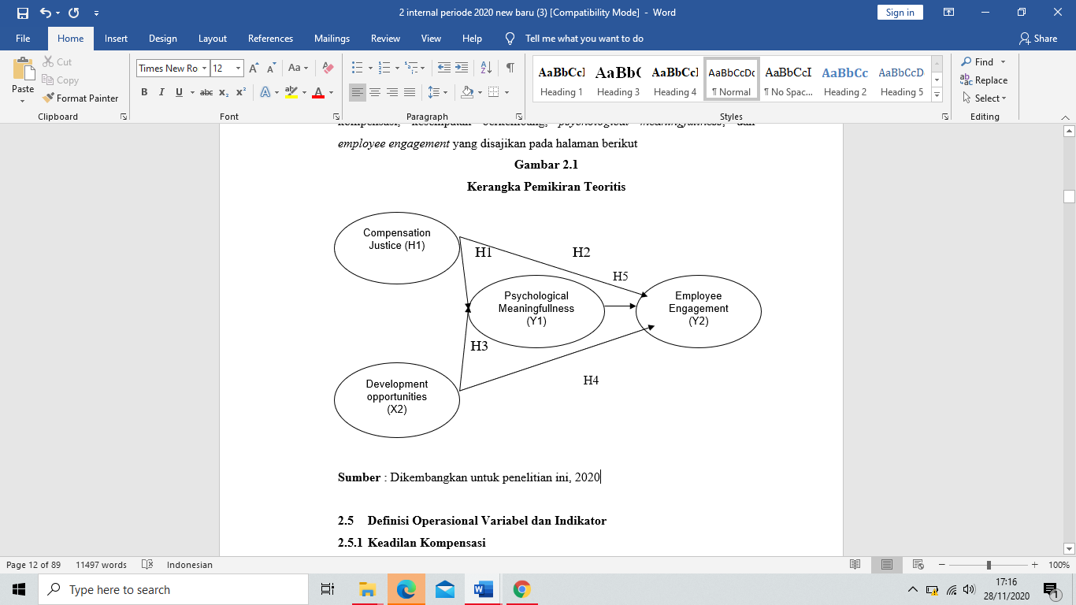
Reliability is a measure of the internal consistency of the indicators of a formation variable which shows the extent to which each indicator shows the same formation variable. There are two ways to test reliability, namely by composite / construction reliability and variance extraction. The cut-off value of the construction reliability is at least 0.70 while the cut-off value for the extracted variant is at least 0.50. The extracted variance shows the magnitude of the variance of the extracted indicator by the developed variable formation. High variance extraction values ​​indicate that the indicators are well represented by the developed variables (Ghozali, 2013).

Table 1. Reliability and Variance Extracted Test
Variable | Reliability | AVE
COMPENSATION JUSTICE | 0,87 | 0,68
DEVELOPMENT OPPORTUNITIES | 0,82 | 0,65
PSYCOLOGICAL MEANINGFULLNESS | 0,90 | 0,70
EMPLOYEE ENGAGEMENT | 0,97 | 0,76

Reliabilitas untuk setiap konstruk ternyata tinggi, semua nilai berada di atas nilai potong 0,70. Hasil perhitungan varians yang dihitung menunjukkan bahwa semua konstruksi memenuhi syarat cut of value minimum 0,50.

Table 2. Hypothesis Measurement

HYPOTHESIS |  |  | Estimate | S.E. | C.R. | P | Label
PSYCOLOGICAL_MEANINGFULLNESS | <--- | DEVELOPMENT_OPPORTUNITIES | ,678 | ,097 | 6,984 | *** | par_5
PSYCOLOGICAL_MEANINGFULLNESS | <--- | COMPENSATION_JUSTICE | ,187 | ,072 | 2,579 | ,010 | par_12
EMPLOYEE_ENGAGEMENT | <--- | PSYCOLOGICAL_MEANINGFULLNESS | 1,583 | ,587 | 2,699 | ,007 | par_7
EMPLOYEE_ENGAGEMENT | <--- | DEVELOPMENT_OPPORTUNITIES | -,515 | ,427 | -1,207 | ,227 | par_9
EMPLOYEE_ENGAGEMENT | <--- | COMPENSATION_JUSTICE | -,133 | ,147 | -,908 | ,364 | par_13

Interpretation of Hypothesis Testing Results 1
The estimated parameter for testing the effect of compensation equity on psychological meaningfulness shows a CR value of 2.579 and a probability of 0.010. The two values ​​obtained meet the requirements for H1 acceptance, namely a CR value of 2.579 which is greater than 1.96 and a probability of 0.010 which is smaller than 0.05. Thus it can be concluded that compensation justice has a significant effect on psychological meaningfulness.
Interpretation of Hypothesis Testing Results 2
The estimation parameter for testing the effect of compensation fairness on employee engagement shows a CR value of 0.908 and a probability of 0.364. The two values ​​obtained did not meet the requirements for H2 acceptance, namely the CR value of 0.908 which is smaller than 1.96 and the probability of 0.364 which is greater than 0.05. Thus, it can be concluded that compensation fairness has no effect on employee engagement.
Interpretation of Hypothesis Testing Results 3
The estimation parameter for testing the effect of development opportunity on psychological meaningfulness shows a CR value of 6.984 and a probability of 0.001. The two values ​​obtained meet the requirements for acceptance of H3, namely the CR value of 6.984 which is greater than 1.96 and the probability of 0.001 which is smaller than 0.05. Thus, it can be concluded that development opportunity has a positive effect on psychological meaningfulness.
Interpretation of Hypothesis Testing Results 4
The estimation parameter for testing the effect of development opportunities on employee engagement shows a CR value of 1.207 and a probability of 0.227. The two values ​​obtained meet the requirements for acceptance of H4, namely the CR value of 1.207 which is smaller than 1.96 and the probability of 0.227 which is greater than 0.05. Thus, it can be concluded that development opportunities have no effect on employee engagement.
Interpretation of Hypothesis Testing Results 5
The estimation parameter for testing the effect of psychological meaningfulness on employee engagement shows a CR value of 2.699 and a probability of 0.007. The two values ​​obtained meet the requirements for acceptance of H5, namely the CR value of 2,699 which is greater than 1.96 and the probability of 0.007 which is smaller than 0.05. Thus, it can be concluded that psychological meaningfulness has a positive effect on employee engagement.
Companies must attract, motivate and retain competent employees. If this can be achieved through a compensation system, then the organization should strive to provide fair compensation. If employees feel that they are being compensated unfairly, they will limit or reduce their work productivity or may even leave the company and look for other jobs. In other words, compensation inequality can lead to poor performance or overall organizational performance. The design and implementation of a compensation system must ensure that there is external justice, internal justice and individual justice through the design and establishment of effective salary structures and appropriate pay levels. Psychological meaningfulness is the psychological condition of the engaged person. Meaningfulness will also be experienced by employees whose work assignments are challenging. The more skills required to do a task will make employees feel challenged. Feeling challenged is an emotional aspect of engagement, this is evidenced by research conducted by Anvari et al., (2011) that challenging work is the main factor that encourages employees to be engaged. Douglas et al., (2014) indicated that psychological meaningfulness had a positive effect on employee engagement.

CONCLUSION

Organizations use compensation to motivate their employees. Another problem is that it is compensation that effectively motivates other employees. Basically, working people also want to get money to make ends meet. For this reason, an employee begins to appreciate hard work and increasingly shows loyalty to the company and that's why the company rewards employee work performance by providing fair compensation. One way for management to improve work performance, motivate and improve employee performance is through fair compensation. The management of manufacturing companies in Central Java is always trying to improve employee welfare by providing salaries and incentives, THR, leave allowances and life / health insurance, this can improve compensation fairness. Central Java company management provides faster promotion opportunities for those who have the potential and skills as a generation Z employee.

REFERENCE

