**Regression: ROA**

|  |  |  |  |
| --- | --- | --- | --- |
| **Variables Entered/Removeda** | | | |
| Model | Variables Entered | Variables Removed | Method |
| 1 | Leverage, GDP, Firmsize, Rate, Inflasib | . | Enter |
| a. Dependent Variable: ROA | | | |
| b. All requested variables entered. | | | |

|  |  |  |  |  |  |
| --- | --- | --- | --- | --- | --- |
| **Model Summaryb** | | | | | |
| Model | R | R Square | Adjusted R Square | Std. Error of the Estimate | Durbin-Watson |
| 1 | .672a | .451 | .411 | 4.18310 | 1.865 |
| a. Predictors: (Constant), Leverage, GDP, Firmsize, Rate, Inflasi | | | | | |
| b. Dependent Variable: ROA | | | | | |

|  |  |  |  |  |  |  |
| --- | --- | --- | --- | --- | --- | --- |
| **ANOVAa** | | | | | | |
| Model | | Sum of Squares | df | Mean Square | F | Sig. |
| 1 | Regression | 977.312 | 5 | 195.462 | 11.170 | .000b |
| Residual | 1189.889 | 68 | 17.498 |  |  |
| Total | 2167.201 | 73 |  |  |  |
| a. Dependent Variable: ROA | | | | | | |
| b. Predictors: (Constant), Leverage, GDP, Firmsize, Rate, Inflasi | | | | | | |

|  |  |  |  |  |  |  |  |  |
| --- | --- | --- | --- | --- | --- | --- | --- | --- |
| **Coefficientsa** | | | | | | | | |
| Model | | Unstandardized Coefficients | | Standardized Coefficients | t | Sig. | Collinearity Statistics | |
| B | Std. Error | Beta | Tolerance | VIF |
| 1 | (Constant) | 15.143 | 3.384 |  | 4.475 | .000 |  |  |
| Rate | .437 | .434 | .123 | 1.006 | .318 | .537 | 1.862 |
| Inflasi | -.200 | .290 | -.091 | -.687 | .494 | .459 | 2.177 |
| GDP | .075 | .066 | .122 | 1.129 | .263 | .697 | 1.434 |
| Firmsize | -.200 | .159 | -.118 | -1.254 | .214 | .909 | 1.100 |
| Leverage | -7.886 | 1.095 | -.682 | -7.205 | .000 | .901 | 1.110 |
| a. Dependent Variable: ROA | | | | | | | | |

|  |  |  |  |  |  |  |  |
| --- | --- | --- | --- | --- | --- | --- | --- |
| **Coefficient Correlationsa** | | | | | | | |
| Model | | | Leverage | GDP | Firmsize | Rate | Inflasi |
| 1 | Correlations | Leverage | 1.000 | .030 | .292 | .001 | -.081 |
| GDP | .030 | 1.000 | -.010 | -.098 | -.383 |
| Firmsize | .292 | -.010 | 1.000 | .017 | .024 |
| Rate | .001 | -.098 | .017 | 1.000 | -.581 |
| Inflasi | -.081 | -.383 | .024 | -.581 | 1.000 |
| Covariances | Leverage | 1.198 | .002 | .051 | .000 | -.026 |
| GDP | .002 | .004 | .000 | -.003 | -.007 |
| Firmsize | .051 | .000 | .025 | .001 | .001 |
| Rate | .000 | -.003 | .001 | .188 | -.073 |
| Inflasi | -.026 | -.007 | .001 | -.073 | .084 |
| a. Dependent Variable: ROA | | | | | | | |

|  |  |  |  |  |  |  |  |  |  |
| --- | --- | --- | --- | --- | --- | --- | --- | --- | --- |
| **Collinearity Diagnosticsa** | | | | | | | | | |
| Model | Dimension | Eigenvalue | Condition Index | Variance Proportions | | | | | |
| (Constant) | Rate | Inflasi | GDP | Firmsize | Leverage |
| 1 | 1 | 5.324 | 1.000 | .00 | .00 | .00 | .01 | .00 | .01 |
| 2 | .311 | 4.140 | .00 | .00 | .01 | .31 | .00 | .41 |
| 3 | .220 | 4.919 | .01 | .00 | .00 | .23 | .06 | .39 |
| 4 | .102 | 7.220 | .01 | .01 | .48 | .45 | .05 | .02 |
| 5 | .030 | 13.281 | .03 | .51 | .41 | .00 | .40 | .06 |
| 6 | .013 | 19.885 | .95 | .47 | .09 | .00 | .49 | .12 |
| a. Dependent Variable: ROA | | | | | | | | | |

|  |  |  |  |  |  |
| --- | --- | --- | --- | --- | --- |
| **Residuals Statisticsa** | | | | | |
|  | Minimum | Maximum | Mean | Std. Deviation | N |
| Predicted Value | -.5685 | 15.4346 | 9.1053 | 3.65894 | 74 |
| Std. Predicted Value | -2.644 | 1.730 | .000 | 1.000 | 74 |
| Standard Error of Predicted Value | .733 | 1.787 | 1.170 | .224 | 74 |
| Adjusted Predicted Value | -1.2296 | 14.1881 | 9.0682 | 3.70116 | 74 |
| Residual | -9.49331 | 11.86536 | .00000 | 4.03731 | 74 |
| Std. Residual | -2.269 | 2.836 | .000 | .965 | 74 |
| Stud. Residual | -2.357 | 3.014 | .004 | 1.006 | 74 |
| Deleted Residual | -10.23616 | 13.39496 | .03707 | 4.38585 | 74 |
| Stud. Deleted Residual | -2.441 | 3.214 | .006 | 1.025 | 74 |
| Mahal. Distance | 1.258 | 12.329 | 4.932 | 2.251 | 74 |
| Cook's Distance | .000 | .195 | .014 | .026 | 74 |
| Centered Leverage Value | .017 | .169 | .068 | .031 | 74 |
| a. Dependent Variable: ROA | | | | | |

**Charts**

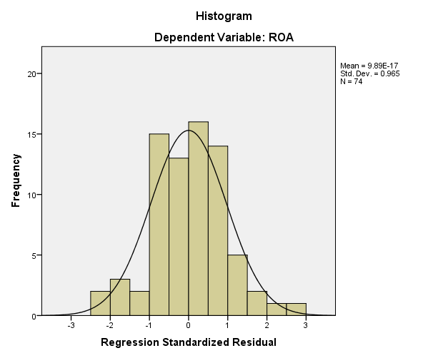

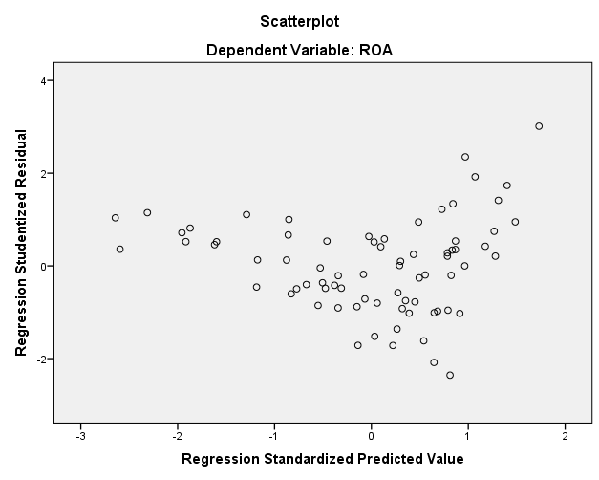

**Regression: ROE**

|  |  |  |  |
| --- | --- | --- | --- |
| **Variables Entered/Removeda** | | | |
| Model | Variables Entered | Variables Removed | Method |
| 1 | Leverage, GDP, Firmsize, Rate, Inflasib | . | Enter |
| a. Dependent Variable: ROE | | | |
| b. All requested variables entered. | | | |

|  |  |  |  |  |  |
| --- | --- | --- | --- | --- | --- |
| **Model Summaryb** | | | | | |
| Model | R | R Square | Adjusted R Square | Std. Error of the Estimate | Durbin-Watson |
| 1 | .469a | .220 | .165 | 6.06230 | 1.856 |
| a. Predictors: (Constant), Leverage, GDP, Firmsize, Rate, Inflasi | | | | | |
| b. Dependent Variable: ROE | | | | | |

|  |  |  |  |  |  |  |
| --- | --- | --- | --- | --- | --- | --- |
| **ANOVAa** | | | | | | |
| Model | | Sum of Squares | df | Mean Square | F | Sig. |
| 1 | Regression | 736.213 | 5 | 147.243 | 4.006 | .003b |
| Residual | 2609.356 | 71 | 36.751 |  |  |
| Total | 3345.569 | 76 |  |  |  |
| a. Dependent Variable: ROE | | | | | | |
| b. Predictors: (Constant), Leverage, GDP, Firmsize, Rate, Inflasi | | | | | | |

|  |  |  |  |  |  |  |  |  |
| --- | --- | --- | --- | --- | --- | --- | --- | --- |
| **Coefficientsa** | | | | | | | | |
| Model | | Unstandardized Coefficients | | Standardized Coefficients | t | Sig. | Collinearity Statistics | |
| B | Std. Error | Beta | Tolerance | VIF |
| 1 | (Constant) | 17.121 | 4.844 |  | 3.535 | .001 |  |  |
| Rate | 1.169 | .617 | .269 | 1.894 | .062 | .546 | 1.833 |
| Inflasi | -.216 | .401 | -.081 | -.539 | .591 | .482 | 2.075 |
| GDP | .019 | .092 | .025 | .204 | .839 | .739 | 1.353 |
| Firmsize | -.327 | .225 | -.158 | -1.452 | .151 | .923 | 1.084 |
| Leverage | -6.030 | 1.554 | -.425 | -3.881 | .000 | .915 | 1.093 |
| a. Dependent Variable: ROE | | | | | | | | |

|  |  |  |  |  |  |  |  |
| --- | --- | --- | --- | --- | --- | --- | --- |
| **Coefficient Correlationsa** | | | | | | | |
| Model | | | Leverage | GDP | Firmsize | Rate | Inflasi |
| 1 | Correlations | Leverage | 1.000 | .008 | .271 | .031 | -.093 |
| GDP | .008 | 1.000 | .010 | -.098 | -.346 |
| Firmsize | .271 | .010 | 1.000 | .048 | -.023 |
| Rate | .031 | -.098 | .048 | 1.000 | -.590 |
| Inflasi | -.093 | -.346 | -.023 | -.590 | 1.000 |
| Covariances | Leverage | 2.414 | .001 | .095 | .030 | -.058 |
| GDP | .001 | .008 | .000 | -.006 | -.013 |
| Firmsize | .095 | .000 | .051 | .007 | -.002 |
| Rate | .030 | -.006 | .007 | .381 | -.146 |
| Inflasi | -.058 | -.013 | -.002 | -.146 | .161 |
| a. Dependent Variable: ROE | | | | | | | |

|  |  |  |  |  |  |
| --- | --- | --- | --- | --- | --- |
| **Residuals Statisticsa** | | | | | |
|  | Minimum | Maximum | Mean | Std. Deviation | N |
| Predicted Value | 5.2649 | 20.4069 | 14.6331 | 3.11240 | 77 |
| Std. Predicted Value | -3.010 | 1.855 | .000 | 1.000 | 77 |
| Standard Error of Predicted Value | 1.062 | 2.554 | 1.665 | .303 | 77 |
| Adjusted Predicted Value | 4.2714 | 19.7832 | 14.5965 | 3.14551 | 77 |
| Residual | -13.43870 | 16.89308 | .00000 | 5.85949 | 77 |
| Std. Residual | -2.217 | 2.787 | .000 | .967 | 77 |
| Stud. Residual | -2.301 | 2.929 | .003 | 1.008 | 77 |
| Deleted Residual | -14.47996 | 18.66899 | .03662 | 6.37361 | 77 |
| Stud. Deleted Residual | -2.375 | 3.102 | .005 | 1.027 | 77 |
| Mahal. Distance | 1.344 | 12.505 | 4.935 | 2.159 | 77 |
| Cook's Distance | .000 | .150 | .015 | .025 | 77 |
| Centered Leverage Value | .018 | .165 | .065 | .028 | 77 |
| a. Dependent Variable: ROE | | | | | |

**Charts**

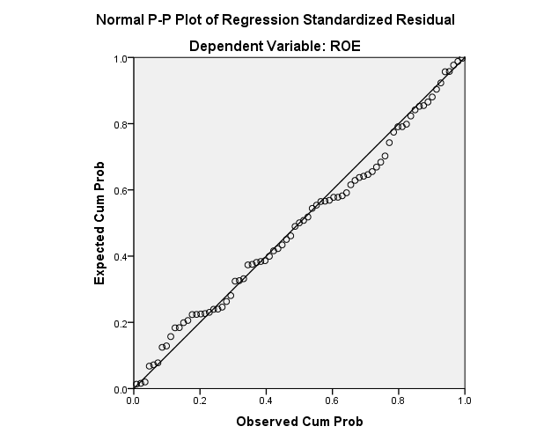

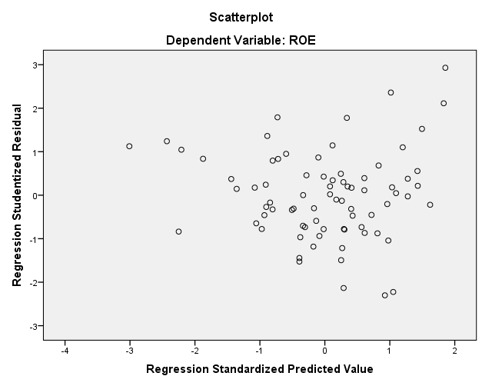

**Regression: NPM**

|  |  |  |  |
| --- | --- | --- | --- |
| **Variables Entered/Removeda** | | | |
| Model | Variables Entered | Variables Removed | Method |
| 1 | Leverage, GDP, Firmsize, Rate, Inflasib | . | Enter |
| a. Dependent Variable: NPM | | | |
| b. All requested variables entered. | | | |

|  |  |  |  |  |  |
| --- | --- | --- | --- | --- | --- |
| **Model Summaryb** | | | | | |
| Model | R | R Square | Adjusted R Square | Std. Error of the Estimate | Durbin-Watson |
| 1 | .652a | .426 | .383 | 3.19533 | 2.005 |
| a. Predictors: (Constant), Leverage, GDP, Firmsize, Rate, Inflasi | | | | | |
| b. Dependent Variable: NPM | | | | | |

|  |  |  |  |  |  |  |
| --- | --- | --- | --- | --- | --- | --- |
| **ANOVAa** | | | | | | |
| Model | | Sum of Squares | df | Mean Square | F | Sig. |
| 1 | Regression | 514.673 | 5 | 102.935 | 10.082 | .000b |
| Residual | 694.287 | 68 | 10.210 |  |  |
| Total | 1208.960 | 73 |  |  |  |
| a. Dependent Variable: NPM | | | | | | |
| b. Predictors: (Constant), Leverage, GDP, Firmsize, Rate, Inflasi | | | | | | |

|  |  |  |  |  |  |  |  |  |
| --- | --- | --- | --- | --- | --- | --- | --- | --- |
| **Coefficientsa** | | | | | | | | |
| Model | | Unstandardized Coefficients | | Standardized Coefficients | t | Sig. | Collinearity Statistics | |
| B | Std. Error | Beta | Tolerance | VIF |
| 1 | (Constant) | 8.635 | 2.473 |  | 3.492 | .001 |  |  |
| Rate | .260 | .332 | .098 | .783 | .436 | .539 | 1.854 |
| Inflasi | -.216 | .218 | -.132 | -.988 | .327 | .474 | 2.110 |
| GDP | .041 | .050 | .088 | .822 | .414 | .734 | 1.362 |
| Firmsize | .116 | .116 | .095 | .998 | .322 | .936 | 1.068 |
| Leverage | -5.362 | .842 | -.610 | -6.366 | .000 | .921 | 1.086 |
| a. Dependent Variable: NPM | | | | | | | | |

|  |  |  |  |  |  |  |  |
| --- | --- | --- | --- | --- | --- | --- | --- |
| **Coefficient Correlationsa** | | | | | | | |
| Model | | | Leverage | GDP | Firmsize | Rate | Inflasi |
| 1 | Correlations | Leverage | 1.000 | .007 | .251 | .003 | -.096 |
| GDP | .007 | 1.000 | .011 | -.097 | -.348 |
| Firmsize | .251 | .011 | 1.000 | .015 | -.024 |
| Rate | .003 | -.097 | .015 | 1.000 | -.593 |
| Inflasi | -.096 | -.348 | -.024 | -.593 | 1.000 |
| Covariances | Leverage | .709 | .000 | .025 | .001 | -.018 |
| GDP | .000 | .003 | 6.679E-5 | -.002 | -.004 |
| Firmsize | .025 | 6.679E-5 | .014 | .001 | -.001 |
| Rate | .001 | -.002 | .001 | .110 | -.043 |
| Inflasi | -.018 | -.004 | -.001 | -.043 | .048 |
| a. Dependent Variable: NPM | | | | | | | |

|  |  |  |  |  |  |  |  |  |  |
| --- | --- | --- | --- | --- | --- | --- | --- | --- | --- |
| **Collinearity Diagnosticsa** | | | | | | | | | |
| Model | Dimension | Eigenvalue | Condition Index | Variance Proportions | | | | | |
| (Constant) | Rate | Inflasi | GDP | Firmsize | Leverage |
| 1 | 1 | 5.335 | 1.000 | .00 | .00 | .00 | .01 | .00 | .01 |
| 2 | .296 | 4.247 | .00 | .00 | .01 | .40 | .00 | .35 |
| 3 | .217 | 4.961 | .01 | .01 | .00 | .21 | .06 | .48 |
| 4 | .106 | 7.086 | .01 | .01 | .50 | .38 | .06 | .01 |
| 5 | .032 | 12.842 | .06 | .44 | .34 | .00 | .47 | .06 |
| 6 | .014 | 19.305 | .92 | .55 | .15 | .00 | .41 | .09 |
| a. Dependent Variable: NPM | | | | | | | | | |

|  |  |  |  |  |  |
| --- | --- | --- | --- | --- | --- |
| **Residuals Statisticsa** | | | | | |
|  | Minimum | Maximum | Mean | Std. Deviation | N |
| Predicted Value | .3555 | 10.9809 | 7.2074 | 2.65524 | 74 |
| Std. Predicted Value | -2.581 | 1.421 | .000 | 1.000 | 74 |
| Standard Error of Predicted Value | .566 | 1.360 | .895 | .166 | 74 |
| Adjusted Predicted Value | .2859 | 10.9001 | 7.1915 | 2.67720 | 74 |
| Residual | -6.43742 | 7.53783 | .00000 | 3.08396 | 74 |
| Std. Residual | -2.015 | 2.359 | .000 | .965 | 74 |
| Stud. Residual | -2.097 | 2.465 | .002 | 1.005 | 74 |
| Deleted Residual | -6.97781 | 8.22702 | .01590 | 3.34441 | 74 |
| Stud. Deleted Residual | -2.153 | 2.563 | .005 | 1.020 | 74 |
| Mahal. Distance | 1.304 | 12.244 | 4.932 | 2.167 | 74 |
| Cook's Distance | .000 | .093 | .014 | .021 | 74 |
| Centered Leverage Value | .018 | .168 | .068 | .030 | 74 |
| a. Dependent Variable: NPM | | | | | |

**Charts**

